# Project:[C]

## Tell me about your recent project? What are the technologies you are using?

My recent project is GBS(Global Billing System), and it’s telecom based project. We are following MVC here, So for **View** we are using AngularJS, for **Controller** we are using Spring and Rest, and for **Model** we are using Hibernate as ORM technologies, and for database we are using Oracle, and for Kenan also, related to telecom based api.

## What is your role and responsibility in your GBS Project?

* Developed Client side Validations through Spring Framework .
* Involved in design and implementation of view layer using AngularJS.
* Involved spring features like dependency injection.
* Responsible for Spring MVC with annotations using multiple Controller.
* Worked on Restful as server side.
* Active core team member in different phase development, support and analysis
* Active team members during the meeting and client call
* Involving the understanding the requirements for the GBS Project
* Providing knowledge transformation about GBS to the new comers

# Design Pattern:[C]

## Singleton Design Pattern:

### 1 When to use Singleton Design Pattern:

It is used where only a single instance of a class is required to control the action throughout the execution. A singleton class shouldn’t have multiple instances in any case and at any cost. Singleton classes are used for logging, driver objects, caching and thread pool, database connections

It is used to provide global point of access to the object. In terms of practical use Singleton patterns are used in logging, caches, thread pools, configuration settings, device driver objects.

### 2 Uses of Singleton Design Pattern:

* Logger : Similarly singleton is a good potential candidate for using in the log files generation. Imagine an application where the logging utility has to produce one log file based on the messages received from the users. If there is multiple client application using this logging utility class they might create multiple instances of this class and it can potentially cause issues during concurrent access to the same logger file. We can use the logger utility class as a singleton and provide a global point of reference.
* Configuration File: This is another potential candidate for Singleton pattern because this has a performance benefit as it prevents multiple users to repeatedly access and read the configuration file or properties file. It creates a single instance of the configuration file which can be accessed by multiple calls concurrently as it will provide static config data loaded into in-memory objects. The application only reads from the configuration file at the first time and there after from second call onwards the client applications read the data from in-memory objects.
* Cache: We can use the cache as a singleton object as it can have a global point of reference and for all future calls to the cache object the client application will use the in-memory object.

### 3 Why can’t we use a static class instead of singleton?

* One of the key advantages of singleton over static class is that it can implement interfaces and extend classes while the static class cannot (it can extend classes, but it does not inherit their instance members). If we consider a static class it can only be a nested static class as top level class cannot be a static class. Static means that it belongs to a class it is in and not to any instance. So it cannot be a top level class.
* Another difference is that static class will have all its member as static only unlike Singleton.
* Another advantage of Singleton is that it can be lazily loaded whereas static will be initialized whenever it is first loaded.
* Singleton object stores in Heap but, static object stores in stack.
* We can clone the object of Singleton but, we can not clone the static class object.
* Singleton can use the Object Oriented feature of polymorphism but static class cannot.

### 4 Can there be multiple instance of singleton using cloning?

That was a good catch! What do we do now? To prevent the another instance to be created of the singleton instance we can throw exception from inside the clone() method.

### 5 What is the impact if we are creating another instance of singleton using serialization and deserialization?

When we serialize a class and deserialize it then it creates another instance of the singleton class. Basically as many times as you deserialize the singleton instance it will create multiple instance. Well in this case the best way is to make the singleton as enum. In that way the underlying Java implementation takes care of all the details. If this is not possible then we will need to override the readobject() method to return the same singleton instance.

### 6 Which other pattern works with Singleton?

There are several other pattern like Factory method, builder and prototype pattern which uses Singleton pattern during the implementation.

### 7 Which classes in JDK uses singleton pattern?

java.lang.Runtime : In every Java application there is only one Runtime instance that allows the application to interface with the environment it is running. The getRuntime is equivalent to the getInstance() method of the singleton class.

### Singleton Design Pattern

Singleton design pattern is the most popular and older design pattern within the design pattern catalog.  
Singleton design pattern is one of the Gangs of four Design Pattern.  
If you create a class as singleton class then an application allow only one instance of that class.  
Generally we create a class as singleton when we want global point of access of that instance.

### How to create a class as singleton

1) Declare the constructor of the class as private.  
2) Declare a static method because After declare the constructor as private no one from outside the class can call the constructor to create the object. The method of the same class can call the constructor to create the object, so in this static method I can write the code to check and return only one object of the class.  
3)Declare a static member of the same class type in that class, In the static method we write the logic for returning only one instance of that class, for tracking the object we assign the object into that static member variable.

**Example Code:**

package com.sjg.pattern;  
public class SingleTon{  
    // Declare a static member of the same class type  
    private static SingleTon instance;  
      
    // Declare the class constructor as private  
    private SingleTon(){  
       // no-op  
    }  
      
    public staticSingleTon getInstance(){  
       if(instance == null){  
           instance = new SingleTon();  
       }  
       return instance;  
    }  
}

Example Screenshot:

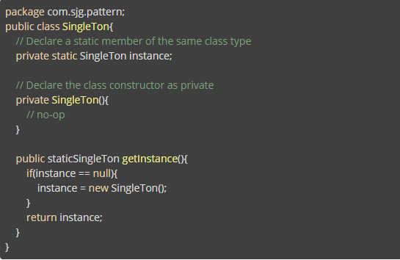

We can write the above singleton code in various different ways

#### **1) Eager instantiation**

It is not recommended, even though we don't want the object then also the object is created. At the time of class is loading into the jvm the object is created. Because static variable is called only once at the time of class loading. If we don't use this object then also we create so the CPU memory is wasted . **Example**

package com.sjg.pattern;  
    class EagerInstantiationSingleton {  
      private static final EagerInstantiationSingleton instance = new EagerInstantiationSingleton();  
        
      //private constructor to avoid someone to create the object of the class  
      private EagerInstantiationSingleton() {  
        //no-op  
      }  
        
      public static EagerInstantiationSingleton getInstance() {  
        return instance;  
      }  
    }

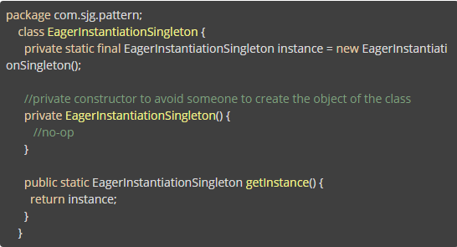

#### 2) Static Block instantiation

It is also same as Eager instantiation, the static block is executed at the time of class loading and the object is created at that time. **Example**

package com.sjg.pattern;  
    class StaticInstatiationSingleton {  
        private static StaticInstatiationSingleton instance;  
          
        //private constructor to avoid someone to create the object of the class  
        private StaticInstantiationSingleton() {  
            //no-op  
        }  
          
        static {  
            instance = new StaticInstantiationSingleton();  
        }  
          
        public static StaticInstantiationSingleton getInstance() {  
            return instance;  
        }  
    }

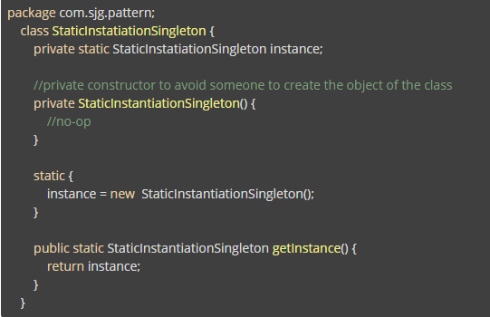

#### 3) Lazy instantiation

It will not work in multi threaded environment because When multiple threads are trying to access the getInstance() method ,if thread switching is happened there may be a chance of creating multiple objects.  
Example

package com.sjg.pattern;  
    class LazyInstantiationSingleton{  
        private static LazyInstantiationSingleton instance;  
        
        //private constructor to avoid someone to create the object of the class.  
        private LazyInstantiationSingleton(){  
             //no-op  
        }  
        public static LazyInstantiationSingleton getInstance(){  
         if(instance == null) {  
                instance = new LazyInstantiationSingleton();  
            }  
          return instance;  
        }  
    }

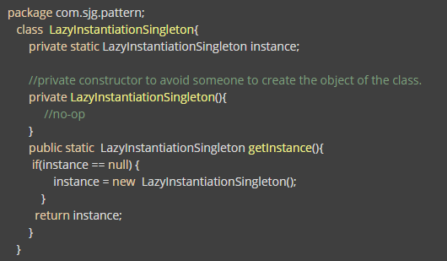

#### 4) Thread Safe Singleton

It will work in multi threaded environment also but the getInstance() method is synchronized performance will be degraded, Means if one thread is accessing the synchronized method all the other threads have to wait until the 1st thread completed it's work.  
**Example**

package com.sjg.pattern;  
    class ThreadSafeSingleton{  
      private static ThreadSafeSingleton instance;  
        
        //private constructor to avoid someone to create the object of the class  
        private   ThreadSafeSingleton() {  
        //no-op  
      }  
    public static synchronized ThreadSafeSingleton getInstance() {  
        if(instance == null) {  
          instance = new ThreadSafeSingleton();  
        }  
      }  
    }

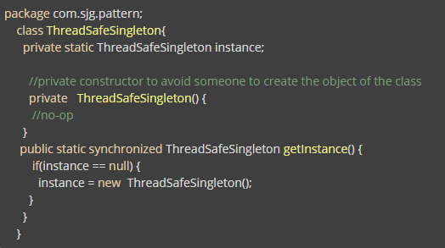

#### [8] 5) Double Checking Process

To overcome the above problems we are using double checked process. In this case we are using synchronization in block level and we are creating the object inside synchronization block. Then we can improve the performance by using double Checking process.  
**Example**

package com.sjg.pattern;  
  class DoubleCheckingSingleton {  
    private static DoubleCheckingSingleton instance;  
      
    //private constructor to avoid someone to create the object of the class  
    private DoubleCheckingSingleton() {  
        //no -arg  
    }  
      
    public static DoubleCheckingSingleton getInstanceUsingDoubleChecking() {  
      if(instance == null) {  
        synchronized(DoubleCheckingSingleton.class) {  
            if(instance == null) {   
              instance = new DoubleCheckingSingleton();  
                }     
            }  
        }  
      return instance;  
    }  
  }

**Test Class for DoubleCheckingSingleton class**

import com.sjg.pattern.DoubleCheckingSingleton;  
    public class SingleTonTest {  
        public static void main(String[] args) {  
            DoubleCheckingSingleton singleTon1 = null;  
            DoubleCheckingSingleton singleTon2 = null;  
            singleTon1 = DoubleCheckingSingleton.getInstanceUsingDoubleChecking();  
            singleTon2 = DoubleCheckingSingleton.getInstanceUsingDoubleChecking();  
            System.out.println("singleTon1 : " + singleTon1.hashCode());  
            System.out.println("singleTon2 : " + singleTon2.hashCode());  
        }  
    }

**Output:**

singleTon1 : 366712642  
    singleTon2 : 366712642  
    (Both the object hashCode is same)

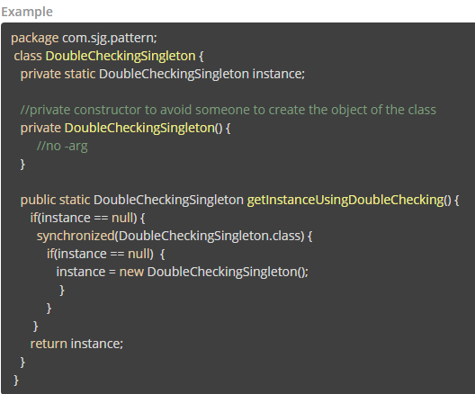

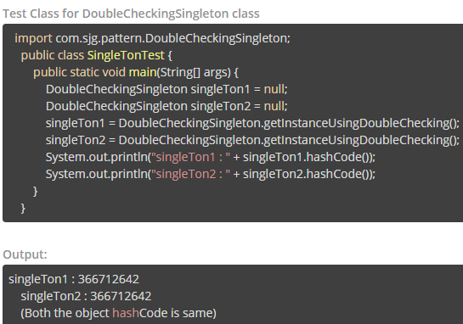

# Telephonic Interview(All in One Core Java except Collection):

## Core Java:

### Diff b/w Jdk and JRE? :4:27

JDK stands for java development kit, JRE stands for Java Runtime Environment, So when we are installing ,if you want to run java program in to your application you need to install JDK, along with this JRE also will be installed, we can say jdk provide collection of Tools, like jdk contains your private jre also, jdk contains java compiler, java interpreter. So these are the component will be available in jdk.

Now JRE folder contains the libraries, jre folder contains the jvm virtually. JRE mainly used to make the environment where your java programs can run. Two types of JRE we have private jre and public jre.

JDK you can install with JDK jre will come, if you want you can install jdk and if you want you can install separate JRE also. ***It means if we have only JRE and some jar files can we run the application?***

Yes, to run the java application JDK not required it is only for development.

### Diff b/w Jar and War? :5:54

JAR means it is Java Archive, WAR means it is Web Archive, means suppose if you want to combine collections of packages into one group that you can place into JAR files, but whenever you are developing web application, that web application may contains thousands of jar files, thousands of jsp, html files, classes, libraries, so if you want to club these all and that you want to deploy on the server, so on server always you have to deploy the WAR file. So war contains the complete web application.

Suppose if you are developing standalone application than that is JAR file, you can create the executable jar file, you can give to the client they can start the application, but for the web application you have to deploy your application on the server, so, that you can do with the help of WAR file.

### Diff b/w application server and web server

The main difference between Web server and application server is that web server is meant to serve static pages e.g. HTML and CSS, while Application Server is responsible for generating dynamic content by executing server side code e.g. JSP, Servlet or EJB.

**Which one should i use?**  
Once you know the difference between web and application server and web containers, it's easy to figure out when to use them. You need a web server like Apache HTTPD if you are serving static web pages. If you have a Java application with just JSP and Servlet to generate dynamic content then you need web containers like Tomcat or Jetty.

While, **if you have Java EE application using EJB, distributed transaction, messaging and other fancy features** than you need a full fledged application server like JBoss, WebSphere or Oracle's WebLogic.

**Example of Web Servers:**

* Apache Tomcat
* Resin

**Examples of Application Server:**

* Weblogic
* JBoss
* Websphere

**Difference between web server and application server:**

|  |  |  |
| --- | --- | --- |
| **S.NO** | **WEB SERVER** | **APPLICATION SERVER** |
| 1. | Web server encompasses web container only. | While application server encompasses Web container as well as EJB container. |
| 2. | Web server is useful or fitted for static content. | Whereas application server is fitted for dynamic content. |
| 3. | Web server consumes or utilizes less resources. | While application server utilize more resources. |
| 4. | Web servers arrange the run environment for web applications. | While application servers arrange the run environment for enterprises applications. |
| 5. | In web servers, multithreading is not supported. | While in application server, multithreading is supported. |
| 6. | Web server’s capacity is lower than application server. | While application server’s capacity is higher than web server. |
| 7. | In web server, HTML and HTTP protocols are used. | While in this, GUI as well as HTTP and RPC/RMI protocols are used. |

### ClassLoader in Java

The **Java ClassLoader** is a part of the [**Java Runtime Environment**](https://www.geeksforgeeks.org/differences-jdk-jre-jvm/) that dynamically loads Java classes into the [**Java Virtual Machine**](https://www.geeksforgeeks.org/jvm-works-jvm-architecture/)**.** The Java run time system does not need to know about files and file systems because of classloaders.

[Java classes](https://www.geeksforgeeks.org/classes-objects-java/) aren’t loaded into memory all at once, but when required by an application. At this point, the **Java ClassLoader** is called by the **JRE** and these ClassLoaders load classes into memory dynamically.

#### Types of ClassLoaders in Java

Not all classes are loaded by a single ClassLoader. Depending on the type of class and the path of class, the ClassLoader that loads that particular class is decided. To know the ClassLoader that loads a class the [***getClassLoader()***](https://www.geeksforgeeks.org/java-lang-class-class-java-set-1/) method is used. All classes are loaded based on their names and if any of these classes are not found then it returns a [**NoClassDefFoundError**](https://www.geeksforgeeks.org/classnotfoundexception-vs-noclassdeffounderror-java/) or [**ClassNotFoundException**](https://www.geeksforgeeks.org/classnotfoundexception-vs-noclassdeffounderror-java/).

A Java Classloader is of **three types**:

1. **BootStrap ClassLoader:** A Bootstrap Classloader is a Machine code which kickstarts the operation when the JVM calls it. It is not a java class. Its job is to load the first pure Java ClassLoader. Bootstrap ClassLoader loads classes from the location ***rt.jar***. Bootstrap ClassLoader doesn’t have any parent ClassLoaders. It is also called as the **Primodial ClassLoader**.
2. **Extension ClassLoader:** The Extension ClassLoader is a child of Bootstrap ClassLoader and loads the extensions of core java classes from the respective JDK Extension library. It loads files from ***jre/lib/ext*** directory or any other directory pointed by the system property ***java.ext.dirs***.
3. **System ClassLoader:** An Application ClassLoader is also known as a System ClassLoader. It loads the Application type classes found in the environment variable ***CLASSPATH, -classpath or -cp command line option***. The Application ClassLoader is a child class of Extension ClassLoader.

**Note**: The ClassLoader Delegation Hierarchy Model always functions in the order Application ClassLoader->Extension ClassLoader->Bootstrap ClassLoader. The Bootstrap ClassLoader is always given the higher priority, next is Extension ClassLoader and then Application ClassLoader.

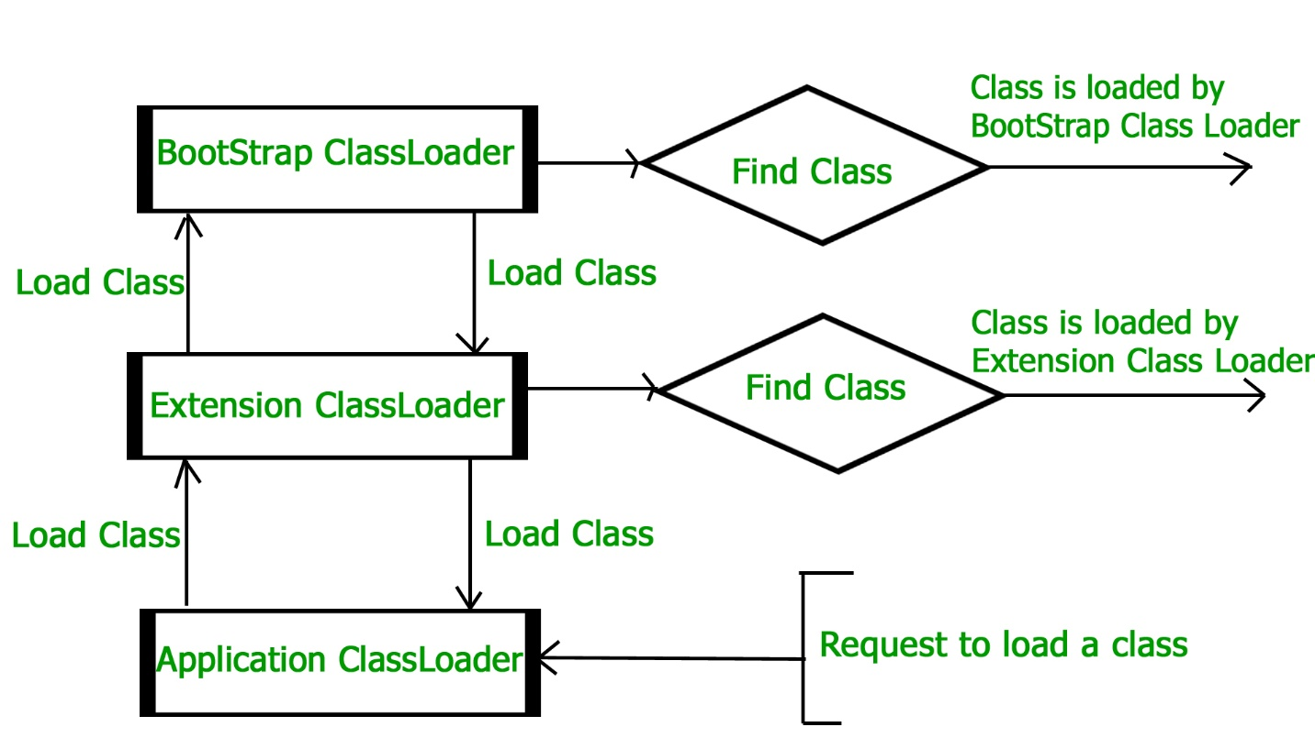

#### Principles of functionality of a Java ClassLoader

Principles of functionality are the **set of rules** or features on which a Java ClassLoader works. There are **three principles of functionality**, they are:

**Delegation Model**: The Java Virtual Machine and the Java ClassLoader use an algorithm called the **Delegation Hierarchy Algorithm** to Load the classes into the Java file.

The ClassLoader works based on a set of operations given by the delegation model. They are:

* ClassLoader always follows the **Delegation Hierarchy Principle**.
* Whenever JVM comes across a class, it checks whether that class is already loaded or not.
* If the Class is already loaded in the method area then the JVM proceeds with execution.
* If the class is not present in the method area then the JVM asks the Java ClassLoader Sub-System to load that particular class, then ClassLoader sub-system hands over the control to **Application ClassLoader**.
* Application ClassLoader then delegates the request to Extension ClassLoader and the **Extension ClassLoader** in turn delegates the request to **Bootstrap ClassLoader**.
* Bootstrap ClassLoader will search in the Bootstrap classpath(JDK/JRE/LIB). If the class is available then it is loaded, if not the request is delegated to Extension ClassLoader.
* Extension ClassLoader searches for the class in the Extension Classpath(JDK/JRE/LIB/EXT). If the class is available then it is loaded, if not the request is delegated to the Application ClassLoader.
* Application ClassLoader searches for the class in the Application Classpath. If the class is available then it is loaded, if not then a **ClassNotFoundException** exception is generated.

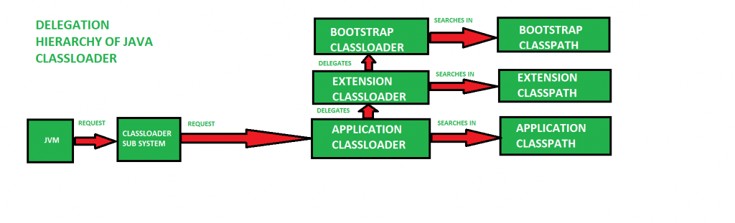

1. **Visibility Principle**: The **Visibility Principle** states that a class loaded by a parent ClassLoader is visible to the child ClassLoaders but a class loaded by a child ClassLoader is not visible to the parent ClassLoaders. Suppose a class GEEKS.class has been loaded by the Extension ClassLoader, then that class is only visible to the Extension ClassLoader and Application ClassLoader but not to the Bootstrap ClassLoader. If that class is again tried to load using Bootstrap ClassLoader it gives an exception ***java.lang.ClassNotFoundException***.
2. **Uniqueness Property**: The **Uniquesness Property** ensures that the classes are unique and there is no repetition of classes. This also ensures that the classes loaded by parent classloaders are not loaded by the child classloaders. If the parent class loader isn’t able to find the class, only then the current instance would attempt to do so itself.

#### Methods of Java.lang.ClassLoader

After the JVM requests for the class, a few steps are to be followed in order to load a class. The Classes are loaded as per the delegation model but there are a few important Methods or Functions that play a vital role in loading a Class.

1. **loadClass(String name, boolean resolve)**: This method is used to load the classes which are referenced by the JVM. It takes the name of the class as a parameter. This is of type loadClass(String, boolean).
2. **defineClass()**: The defineClass() method is a *final* method and cannot be overriden. This method is used to define a array of bytes as an instance of class. If the class is invalid then it throws **ClassFormatError**.
3. **findClass(String name)**: This method is used to find a specified class. This method only finds but doesn’t load the class.
4. **findLoadedClass(String name)**: This method is used to verify whether the Class referenced by the JVM was previously loaded or not.
5. **Class.forName(String name, boolean initialize, ClassLoader loader)**: This method is used to load the class as well as initialize the class. This method also gives the option to choose any one of the ClassLoaders. If the ClassLoader parameter is NULL then Bootstrap ClassLoader is used.

**Example:** The following code is executed before a class is loaded:

|  |
| --- |
| protected synchronized Class<?>  loadClass(String name, boolean resolve)      throws ClassNotFoundException  {      Class c = findLoadedClass(name);      try {          if (c == NULL) {              if (parent != NULL) {                  c = parent.loadClass(name, false);              }              else {                  c = findBootstrapClass0(name);              }          }          catch (ClassNotFoundException e)          {              System.out.println(e);          }      }  } |

**Note**: If a class has already been loaded, it returns it. Otherwise, it delegates the search for the new class to the parent class loader. If the parent class loader doesn’t find the class, **loadClass()** calls the method **findClass()** to find and load the class. The **finalClass()** method searches for the class in the current **ClassLoader** if the class wasn’t found by the parent **ClassLoader**.

### How move you war file from the unix server? : 07:04

**A:** Using the winscp tool we are moving the war file

**A:** putty one tools is there, domain provider also is there.

### What is the diff b/w the abstract class and Interface with some real example scenario? : 08:11

**A:** I will give first general idea then i will come back to the example, in nutsheel i will explain.

Interface is an contract b/w the client and the developer, for example, suppose i have banking application, in banking application i have 4 module

1. saving a/c

2. fixed deposite

3. current a/c

4. lattering deposite a/c

there is a chance that all these module will be developed by different-different developer, or different-different company also, there is a chance. so what i want, i want there are some method, some 20 methods i have, that 20 methods should be same across all the modules, saving a/c customer or developer also has to override the same method, other developer also has to override the same method, implementation may change, but if they want to check balance **getBalance() method** is there it takes accountNo as a parameter, return type is double, **withdraw() method** is there **deposite() method** is there, **printStatement() method** is there, so suppose these method prototype are common among multiple sub-classes, so if you want to centralized common method prototype you can write inside the interface. so interface contains common method prototype, that will be implemented by multiple sub-classes.

now coming to the abstract class, after interface you can write the abstract class, now in abstract class you can write abstract method also, concrete method also, now why to write concrete method, there are some situation where multiple sub-classes have some method behavior is common, suppose **printStatement() method** is there its responsibility to take the accountNo and print the statement, suppose this method behavior is common in all the sub-classes, so why to write the same method body in all the sub-classes which will gives you code duplication problem, in future if you want to change, all the sub-classes you have to modify, so better what we can do, we can write that common method behavior in the abstract class.

So, we can say in one line "Interface contains common method prototype, abstract class contains common method behavior and concrete class contains specific method behavior."

### What is Serialization? 10:56 How You can implement it? :13:10

Serialization means it is the process of saving state of an object to the file. for example, suppose two java application you have, one application is install on one machine, anther application is install on second machine, now I want to invoke the functionality of application which is running on remote machine, means from one machine I want to communicate or I want to invoke the functionality of another machine, so when we are invoking the functionality of remote machine there is a chance you have to pass some data, so if this is primitive type data, you can pass directly value variable that value you can use.

But some time you will get the requirement to pass object as a parameter, object as a data for communication, so when you are passing object reference variable from one machine to another machine, from one application to another application then reference variable contains address of an object, so passing the address of the object from one machine to another machine, we can not access the data there, because suppose one machine is in your windows, another one is in your linux, windows you have ntfs files system, linux you have ext files system, so they can not communicate.

so whenever you have requirements to send the object from one machine to another machine, one application to another application then using serialization you write the data of a object into file, you send the file over the network, and using de-serialization again you type cast again you convert that file into that object, and you can use that data.

So, serialization is the process of saving state of an object to the file.

**How you can implement it?**

Its very simple, you write a class, suppose I have an Account class, so write Account class you define all the variables, next to serialize this you create first FileOutputStream object.

FileOutputStream fos = new FileOutputStream() here you can pass some file name, suppose **account.ser**

Next you create ObjectOutputStream oos = new ObjectOutputStream() pass fileoutstream object as a parameter, next you call oos.write object complete object if you want to write oos.write object of account. Only these three line is enough to serialize your object into file.

### What is the diff b/w the transient and static? :13:59

When we are using transient, generally static members means, serialization means object state will be saved into a file, object state means always instance variable, static data means only one memory will be allocated, it is the class data so it will not participate in serialization.

In the case of transient, like multiple variables we have all are instance type, from that some variable I don’t want to serialized then that we can marked as transient , so whenever we are using transient then that variable will not participant in serialization.

Now you are asking the difference, suppose I have static str = “jdbc”; and next I have transient x=10. Got it, ya, so now I’m serializing this, I serialized, now when I will de-serialized then in the case of static I will get the jdbc because it is class data that you will get at the time of deserialization.

But when you are de-serializing variable x you will get the default value, this is the main difference b/w static & transient. At the time of de-serialization for static you will get the class data but for transient you will get always default value.

### What is the Checked Exception and Unchecked Exception? : 15:45

There are two types of exception checked & Unchecked Exception, if your code inside the method or constructor throwing some exception and if that exception is checked by the compiler, compiler is forcing you to report about the exception by writing try catch block or by using throws keyword, then those exception categories are called as checked exception.

Unchecked Exception means this is also called as Runtime Exception, if some code inside the method throwing exception and compiler is not telling anything whether you want to report or don’t report compiler is not informing anything. so, that is called as unchecked exception.

Now what are unchecked exception, RuntimeException and there all sub-classes are unchecked exception, apart from this all are checked exception like IOException, SQLException, ClassNotFountException, these all are checked exception.

### Why we use Exception Handling? 16:52

Suppose, when we are writing some code, suppose 1000 thousands line of code is there inside the method, ok, from 1000 thousands line of code , first 900 hundred line of code is executed successfully ok, now 901 line (901 to 905) these five lines giving some problem, if some problem occurred in your code, then control will be transferred to the JVM, jvm will analyzed the problem, and it will create some exception related object, and it will throw that object in your program, if you are not handing that object what will happen , jvm will propagate that object to default exception handler, default exception handler will print the error message and your program will be terminated means, here abnormal termination will happen.

But what is my requirement, because of these 5 line giving the problem, I don’t want to terminate the entire program, because of giving these 5 line problem I can use try catch block, so if these 5 line giving the problem these 5 line should not execute. But remaining 900 line should execute, so in this scenario we can use exception handling.

### What is finally block and if you written return statement whether the finally block is executing or not? 18:13

Where you putting return in try or catch, *in try,* ya, if you are putting return statement in try block also, before return control to caller method it has to execute finally block. So, finally block will be execute always without fail, only one scenario it will not execute that is System.exit().

*if you putting return statement in catch block?* Ya it has to execute finally block.

### What is the synchronization in the thread? :18:56

Synchronization means it is the process of enabling the lock of an object, every java object associated with some lock mechanism, by default this lock is disabled, if you want to enable the lock, so that it should work in multi-threaded environment, multiple thread should not entered into critical section at once, so there you can use synchronization.

Just to enable the lock of an object, so that multiple thread should not allow to access that object concurrently.

### What is the diff b/w Runnable and Thread ? :19:30

Runnable is the interface, it is available in java.lang package it has only one abstract method public void run(). Thread is the Concreate class available in java.lang package it is also implementing Runnable interface , Thread class overridden the run() method, they given dummy implementation.

### Which one is better to use Runnable or Thread class? :20:01

We can’t say which one is better to use, it’s depends on the requirement, both are same, both implementations are 100% same, now the difference is, when you are writing your user defined thread class by extending Thread, because java doesn’t support multiple inheritance with classes, So you can not extend any other class.

But if you are writing user defined thread by implementing Runnable interface, then what will happen you have a chance to extend other class also, and you can implement other interface also.

### Which version of java you are using? : 20:40

I’m using java 8, *can you please tell me what are the new features of java 5?*

Java 5 new features I will start from the very basic, enum is the new keyword added in java 5, next they given hexadecimal floating point literal in java 5, next they given enhanced for loop, and next they given variable argument, then they have given generics, scanner class, formatter class, getEnv method in System class.

### What is the AutoBoxing? :21:35

AutoBoxing is also new features of Java 5, up to jdk1.4 you have primitive integer x, you can not store into like Collection, ArrayList object you create you cannot store primitive value, because add() method taking object as a parameter, ok , so whenever you have requirement to get primitive as a object type you have to use the Wrapper class, you have to create the object of Integer class , you have to pass primitive then you can get Wrapper object, So primitive to wrapper, or wrapper to primitive you are responsible to perform up to 1.4 .

But java 5 support AutoBoxing process, that is the process of converting primitive to wrapper, wrapper to primitive automatically.

### What are the new features in java 6 & 7 ? :22:24

Java 6 in core java part they didn’t add much feature, and some compiler related api they have given means, now you can Write Compiler object, means you can create Compiler Object, suppose online if you want to make online compiler, where user can post the java program they can compile and execute the program, So compiler related api they given in java 6, and xml processing they improve, and in jdbc they have given auto driver loading.

*And what are the java 7 features?*

In java 7 very new and very good-good feature they have added, like starting from literal they have given Binary Literal in java 7, up to 1.6 you can represent integer number in three format only decimal, hexadecimal and octal, but from java 7 you can represent Binary number in your java program, next in java they have given in one catch block you can write multiple exception, next they given re-throwing exception with improved type checking, next they have given diamond operator, and next they given wonder full feature try with resource, now you no need to write finally block, to closeup the resources, these are the important features of java 7.

### Do you know about the Design Pattern? :23:46

Ya, mostly we will used Singleton Design Pattern, and Factory method design pattern.

And if you go to JEE you have Front Controller, MVC, DAO these are the design pattern mostly we are using in our projects.

### Diff b/w Overloading & Overriding:

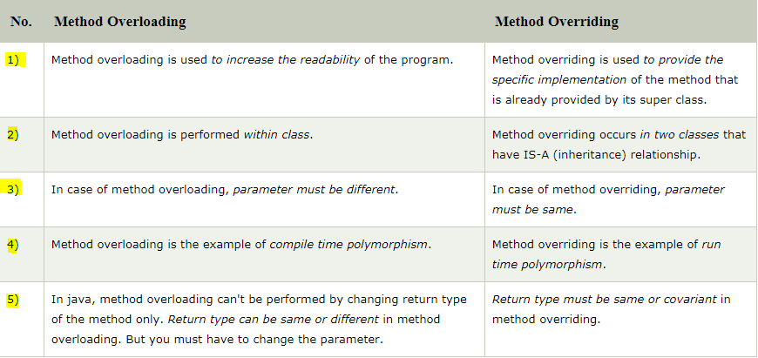

### When to use method overloading?

In Actual Projects, consider an application for them we have written some API that brings the data to the user on the basis of some inputs, So suppose we have a method which is

**getDetails(int id, String name)**

So this is our method, now suppose requirements changes for the newer version of code this code is not required, enhanced version of this code is required, for that programmers needs to change the logic for existing methods, but if this(getDetails(int id, String name)) method is used by other services then we cannot changed it, right because may be some other services may be using it. So we can not remove this method for this reason, programmer can overload this method.

So if requirement is the method

**getDetails(int id, String name, String password)**

So this is how we can overload the methods and problem will get resolve.

### When to use method overriding?

Consider a scenario where Bank is a class that provides a method to get the rate of interest. However, the rate of interest may differ according to banks. For example, SBI, ICICI, and AXIS banks are providing 8.4%, 7.3%, and 9.7% rate of interest.

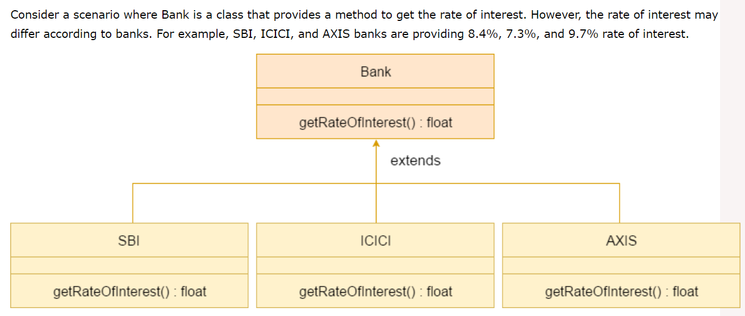

### Diff b/w Interface and Abstract class:

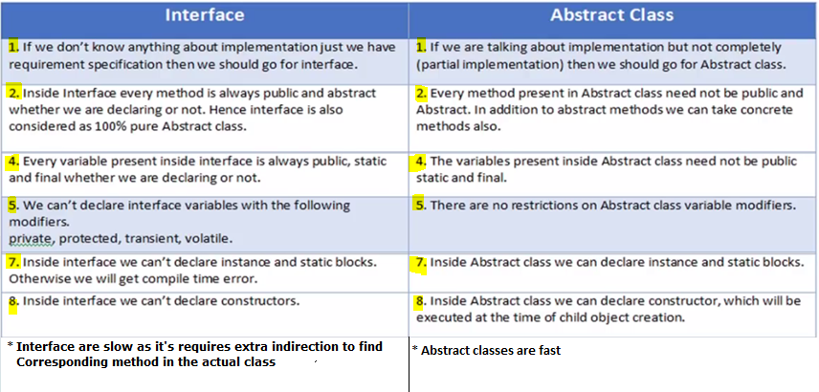

### Diff b/w throw and throws

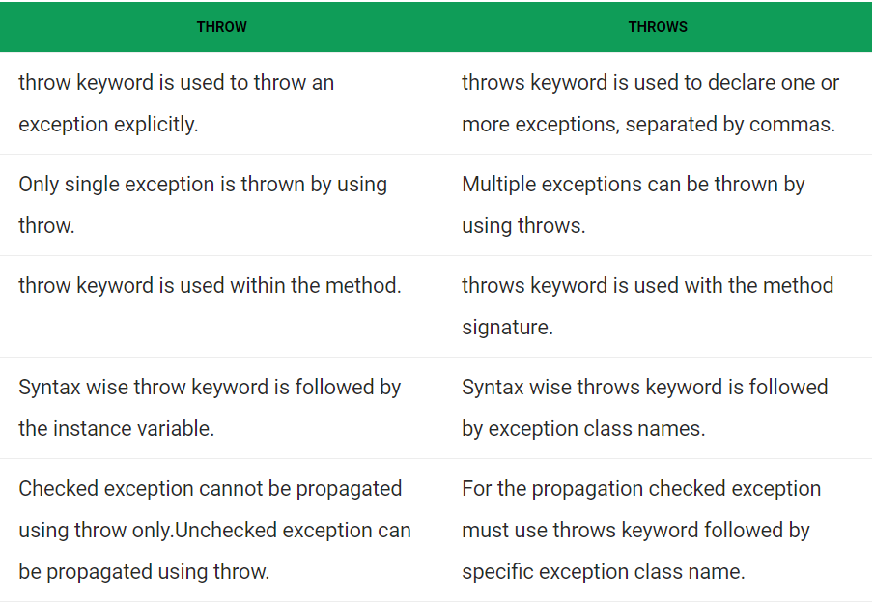

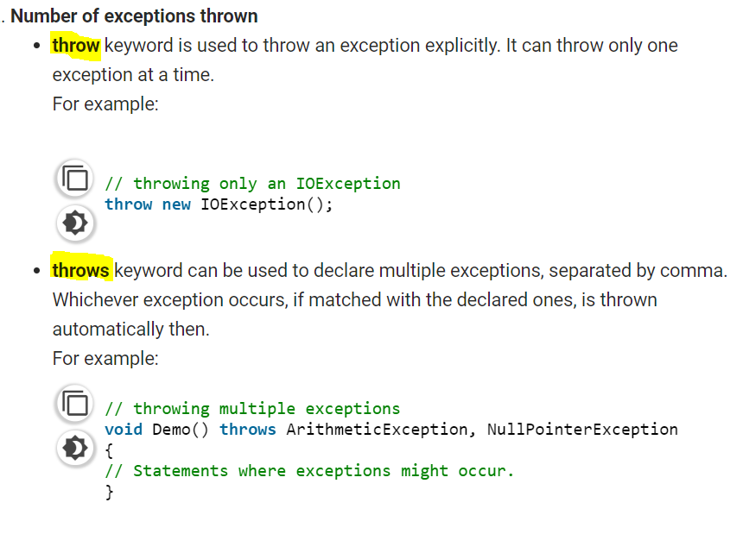

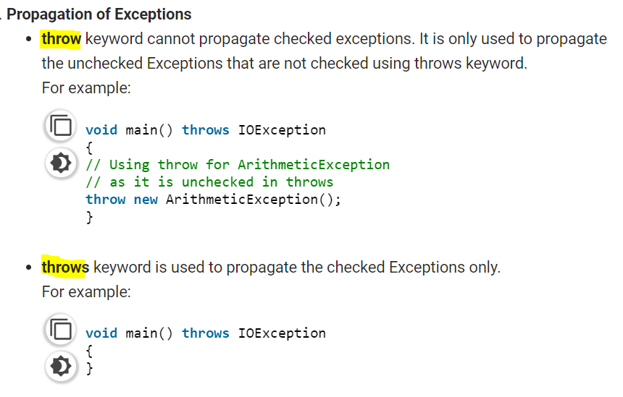

### Diff b/w String,StringBuffer and StringBuilder?

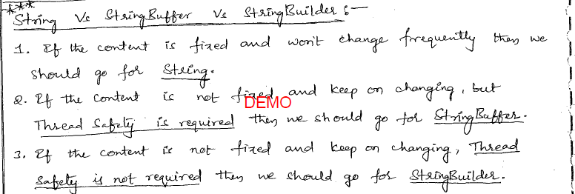

### Diff b/w StringBuffer,StringBuilder

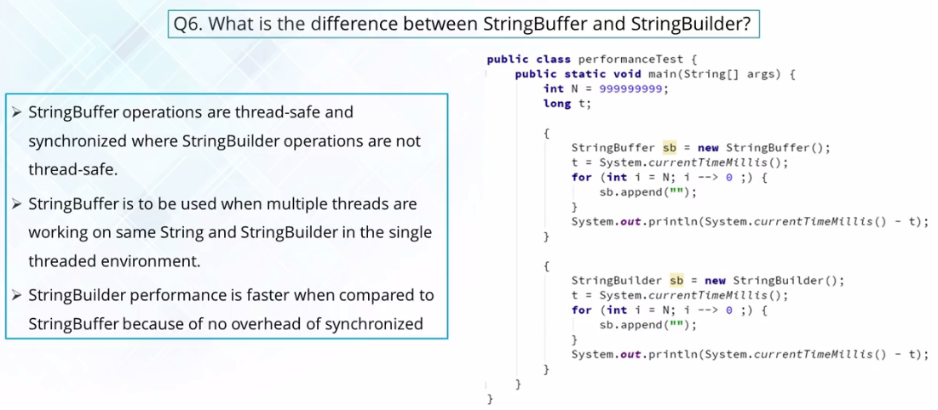

String is ***immutable*** version, where as StringBuffer and StringBuilder they are the ***mutable*** versions.

### Can you write Immutable class in java?

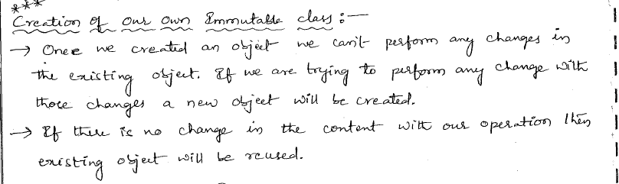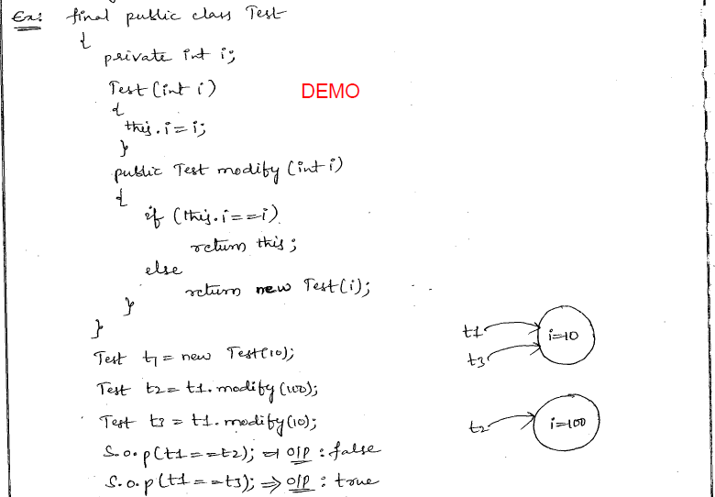

### How to create Custom Exception?

**1.** **To create a custom checked exception, we have to extend the *java.lang.Exception* class.**

**2.To create a custom unchecked exception we need to extend the java.lang.RuntimeException class:**

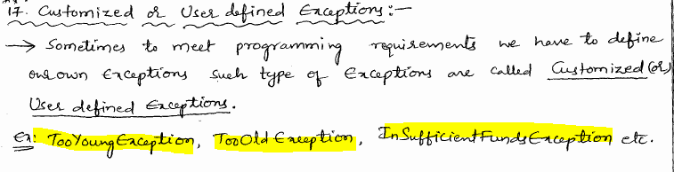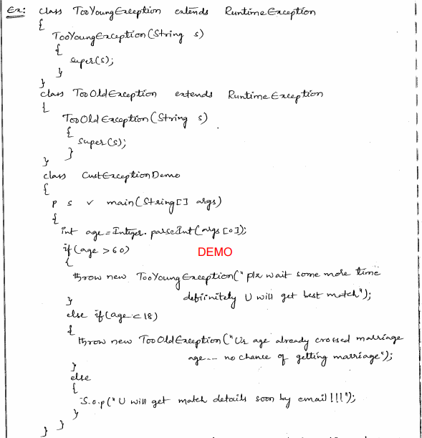

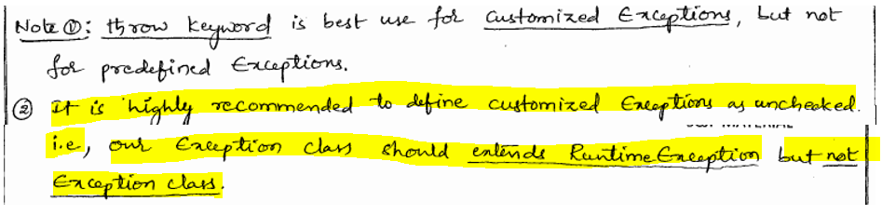

### What is the configuration is required to send the output to the log file?

**Inside log4.xml (SpringBoot)**

<File name=*"LogPath"* fileName=*"/opt/tomcat8/logs/gbs-stub.log"*>

<PatternLayout pattern=*"${LOG_PATTERN}"*/>

</File>

**Inside log4.properties file**

# Direct log messages to a log file

log4j.appender.file=org.apache.log4j.RollingFileAppender

log4j.appender.file.File=${catalina.home}/MyLog/gbs.log

# Basic:[C]

## Special Note:

Refer the below website link:

<https://www.studytonight.com/java/collection-framework>

## 1 JDK,JRE,JVM

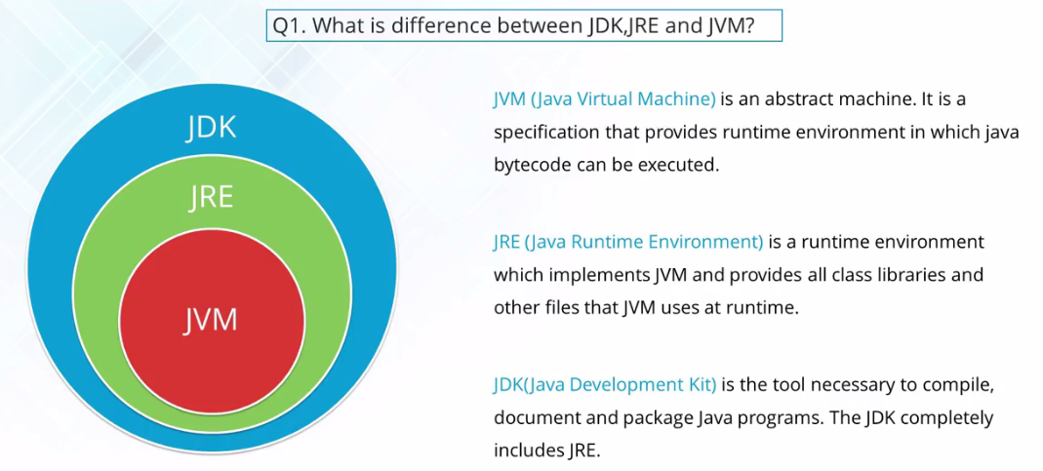

## 2 synchronization

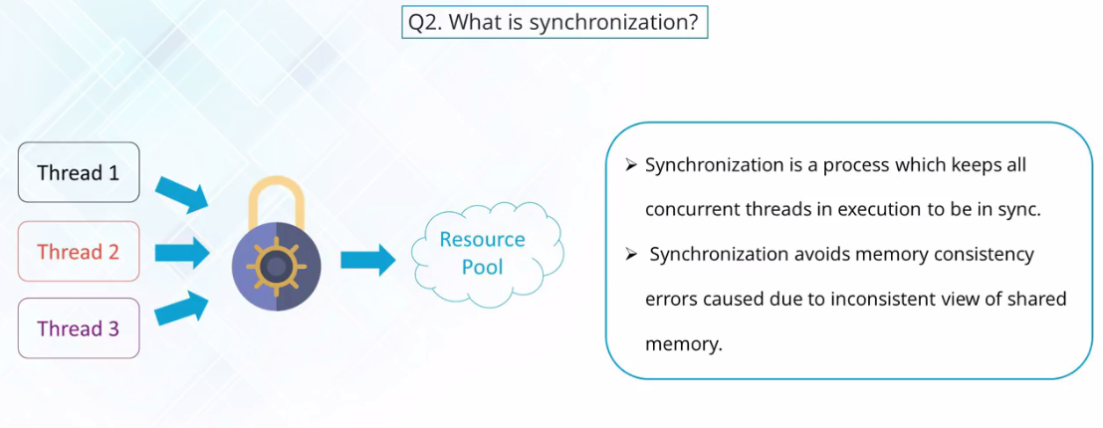

What is synchronization?[5:50-]

Synchronization is something where the multiple threads, if they want to access the same object, Right? So there is only one resource which multiple threads they want to access you need to come up with something is known as synchronization.

So, What is synchronization? So take one example, Lets say we want to book a movie tickets, and it’s gona a one sheet, which has to be booked by multiple people, right? So lets say one corner sheet in the last row has to be book by multiple people, so multiple people over the web will treat them as multiple thread, they are looking on to the single object on a single resource, that’s like the last row last sheet right? So whose ever will first of all try to block that sheet will be given an access and no other person can there after block that sheet.

So synchronization is very much able to inline to this concept. When you got multiple threads which are going to work over the single object you need to use the keyword known as **synchronize** with the help of which you able to acquire the lock on your objects.

So Synchronization is the process which keeps all concurrent threads in execution to be in sync , one after the other. The lock acquisition is gona come up into action. Synchronization will avoid the memory consistency error due to any inconsistency view of the shared memory.

## 3 Processes,Threads

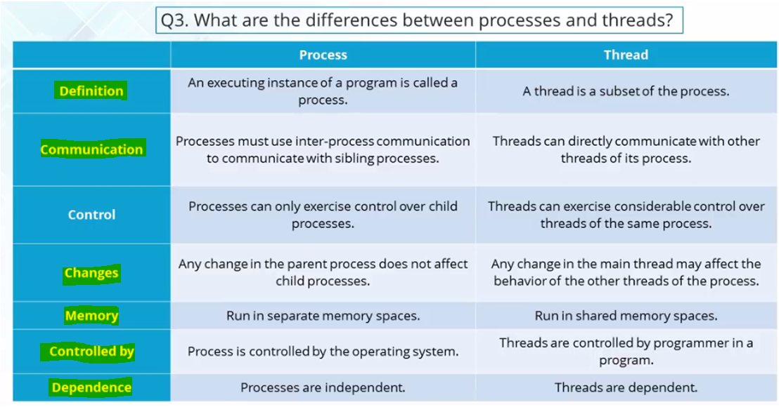

Example:

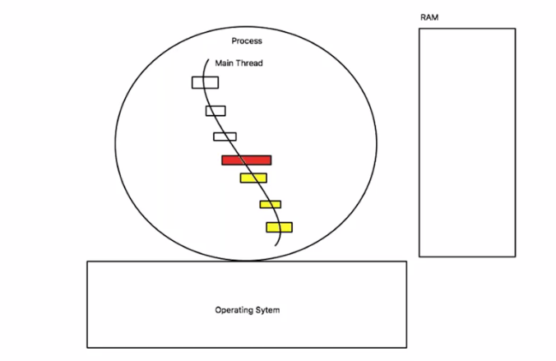

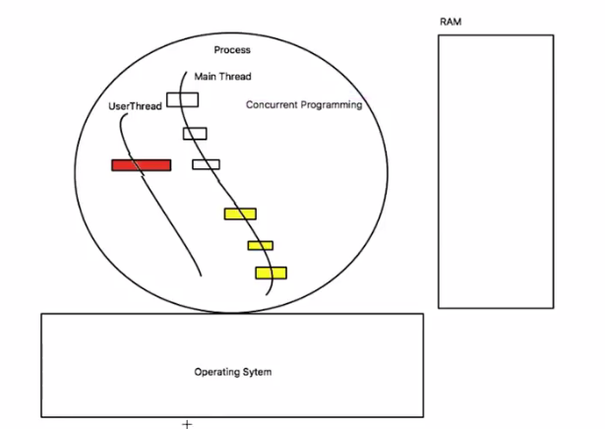

## 4 What is the difference between parseXxx() and valueOf()?

The parseXxx() methods and the valueOf() methods are defined in most of the numeric primitive wrapper classes, such as Integer, Long, Double, FLoat, etc.  
Both methods take a String argument and convert it into the corresponding primitive type with the value that the String represents. The characters in the string must all be decimal digits, except that the first character may be an ASCII minus sign '-' ('\u002D') to indicate a negative value. If the String argument is not properly formed, both throws a NumberFormatException.

The biggest difference between these two methods is that:

* parseXxx() returns the primitive type;
* valueOf() returns a wrapper object reference of the type.

Let's take a look at the following examples:  
int i = Integer.parseInt("100"); // the result is 100  
Integer i = Integer.valueOf("100"); // create a Integer object with value 100  
double d = Double.parseDouble("12.34");  
Double d = Double.valueOf("12.34");

## 5 Wrapper classes

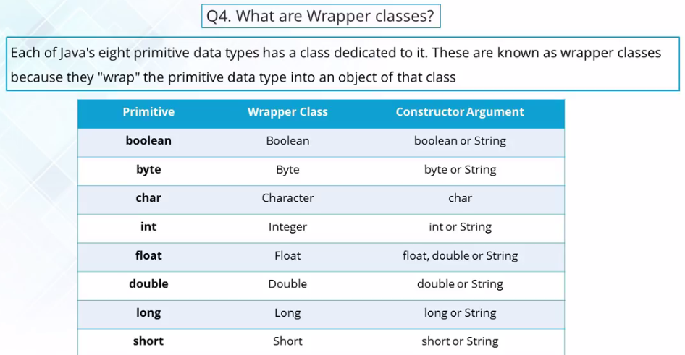

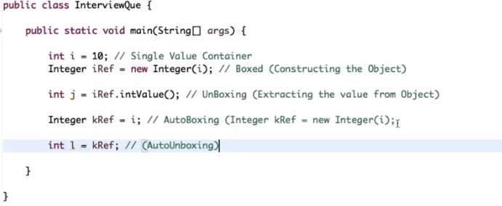

## 6 How many ways can I access static members in a class?

A static member (static method or static variable) can be accessed by using the dot operator on the class name (e.g., Math.max(..);). This is a **standard and right** way to access a static member in a class.  
But Java language also allows you to use an object reference to access a static member. This is **bad** or at least poor form because it creates the impression that some instance variables in the object are used, but this isn't the case. For example,

//Access static member from within the same class

class MyObject1 {

  static int staticVariable = 10;

  void m() {

    MyObject1 o = null;

    int i1 = staticVariable;

    int i2 = this.staticVariable;

    int i3 = MyObject1.staticVariable;

    int i4 = o.staticVariable;

  }

}

//Access static member from outside the class

class MyObject2 {

  void m() {

    MyObject1 o = new MyObject1();

    int i5 = MyObject1.staticVariable;

    int i6 = o.staticVariable;

  }

}

When we access a static member on an object reference, what the value of the object reference is (point to an instance or null). Only the type of the object reference matters. That is why int i4 = o.staticVariable; will not throw a NullPointerException.  
It's best practice to always invoke static member using the class name rather then an object reference of the class.

## 7 final,finally,finalize

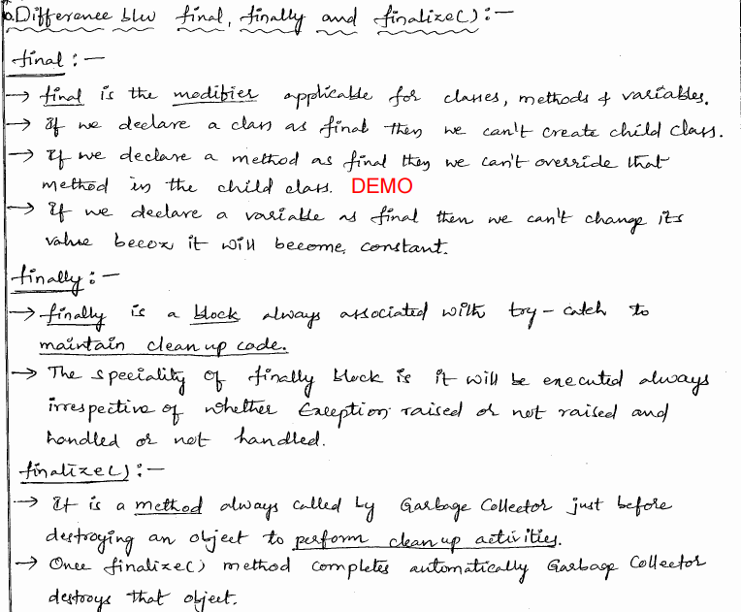

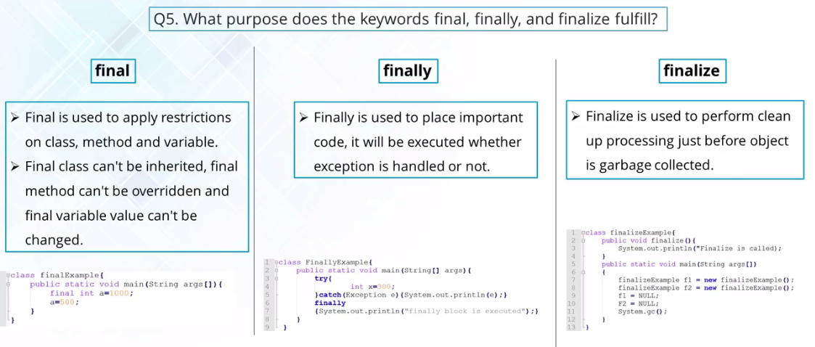

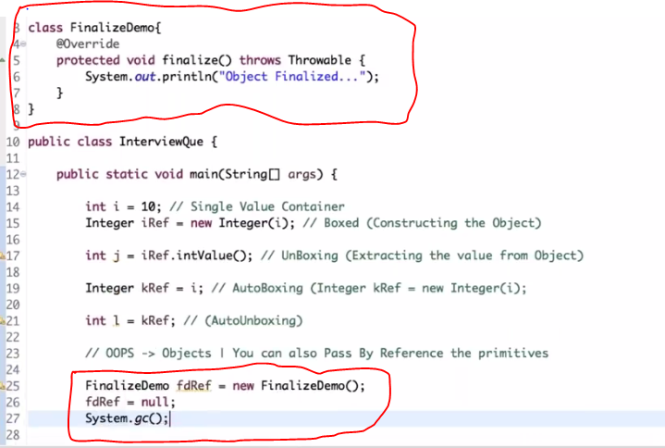

## 8 StringBuffer,StringBuilder



String is ***immutable*** version, where as StringBuffer and StringBuilder they are the ***mutable*** versions.

## 9 Heap,Stack Memory

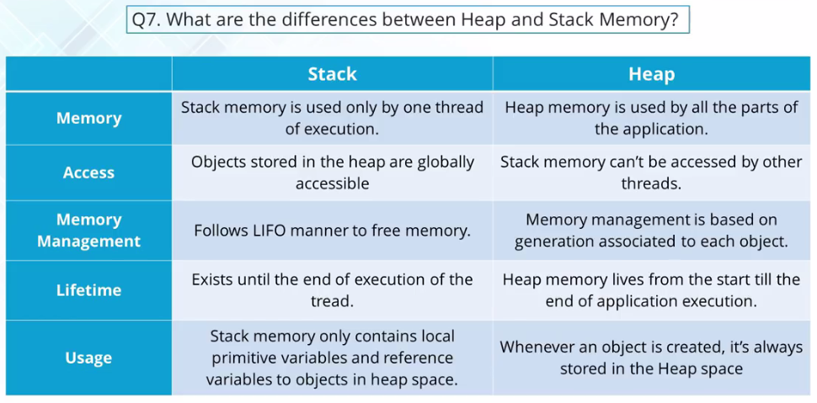

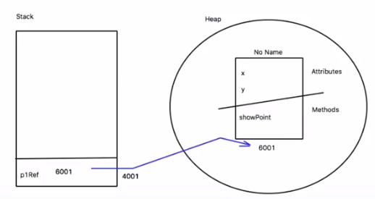

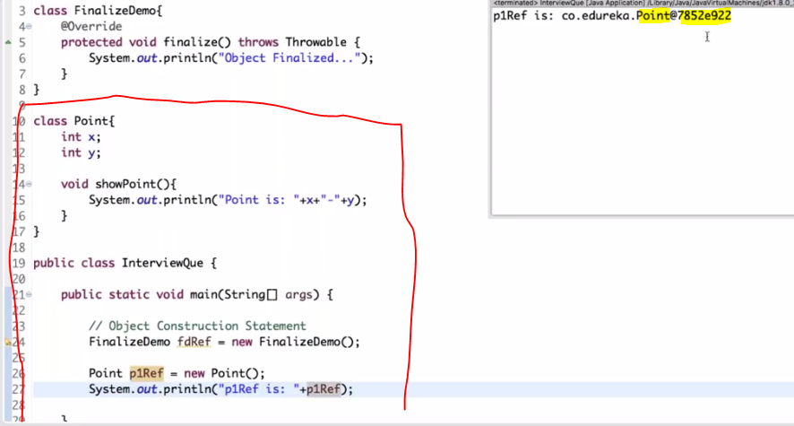

## 10 equals(),== Operator

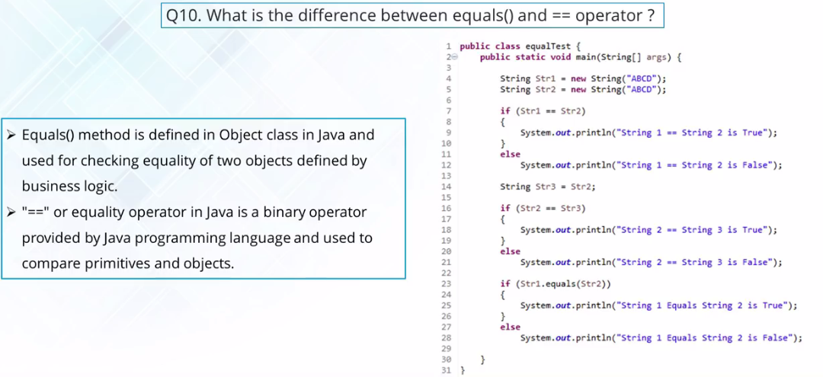

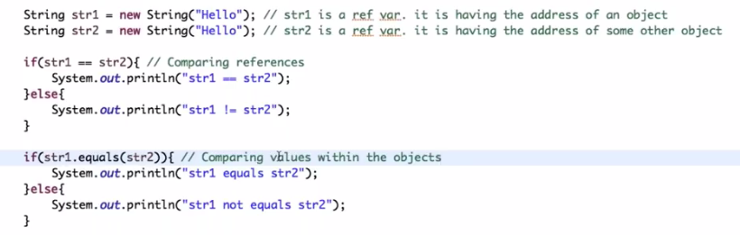

# OOPs: [C]

## 1 Data Hiding:

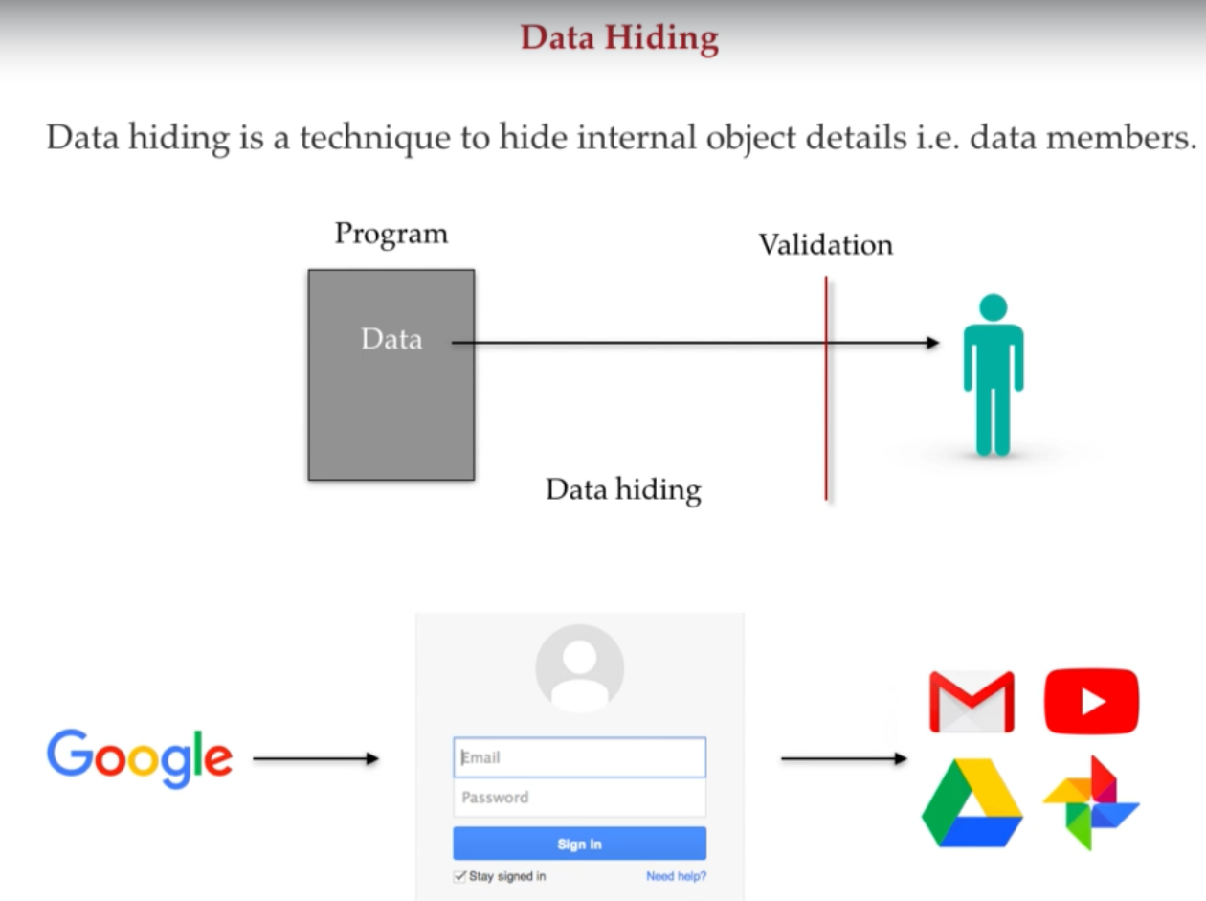

**Data Hiding** is a technique, specifically used in object oriented programming to hide the internal objects details i.e. data members or the data components, that means any outsider or un-authenticated user should not access our internal data directly. Data which is specific to application of programs or to any authenticated user should not be access by without any user. Only completing after all the validation process one can access the data.

**For example:** To access google account, we need to provide proper username & password, only after passing or completing this validation process, we can access our account, even we are authentic user then also we have to pass the validation process.

*Security is the biggest advantages of* **data hiding***.*

## 2 Abstraction:

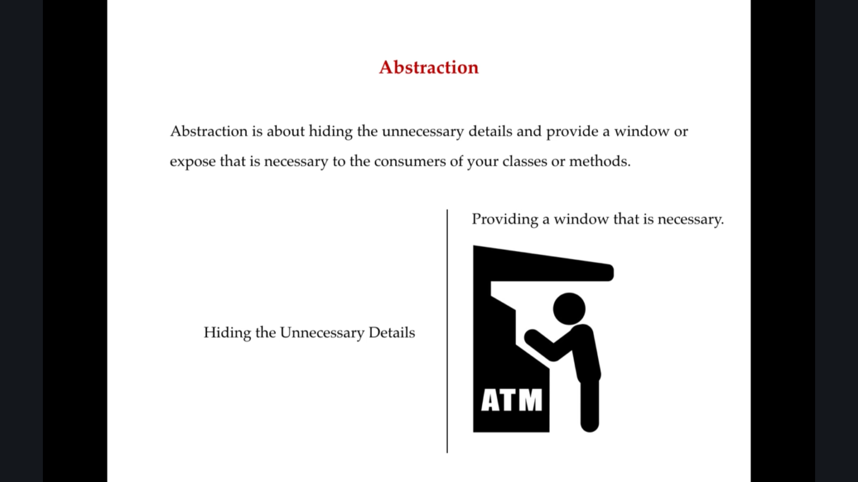

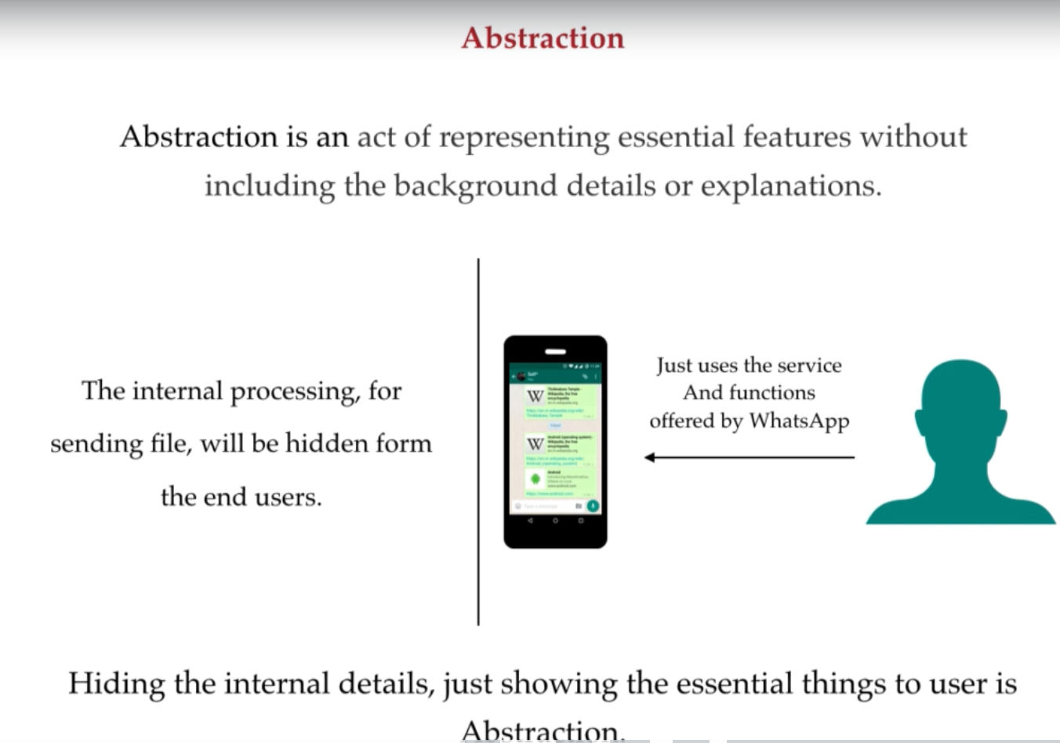

**Abstraction** means hiding the internal implementation and just showcasing the offer services.

**For example** we use various mobile applications in our daily life, we know what functionality they offer, like using WhatsApp we can send any file to any of our contact, but in this scenario we just are aware of service offer by WhatsApp like we can send the file of any of our contacts or group of contacts, people are not actually aware about what it’s internal implementations for sending the file.

Advantages of Abstraction are Security, Enhancement, Maintainability and Modularity

Ex:

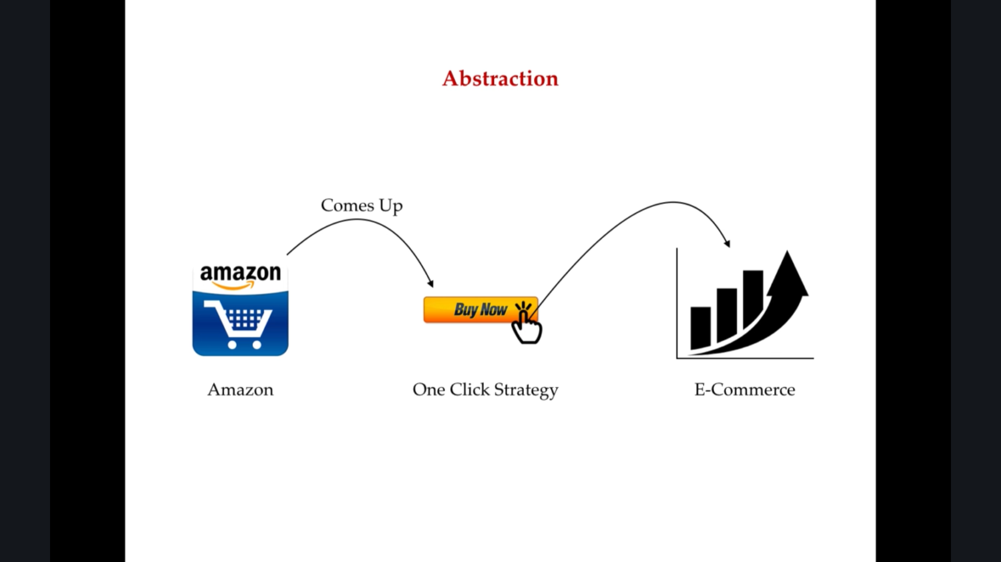

## 3 Data Hiding vs Abstraction:

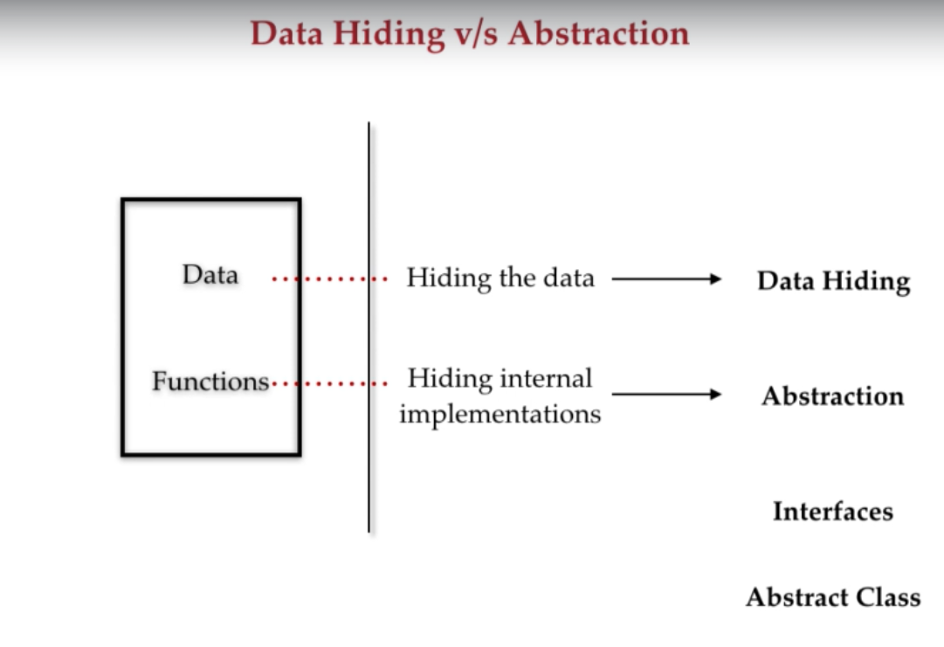

**Data Hiding:** means Hiding the data, in java we are using **private** keyword to achieve data hiding.

**Abstraction:** means Hiding the internal implementations just showing the functionality, in java by using **interface** & **abstract** classes we are achieving abstraction.

## 4 Encapsulation:

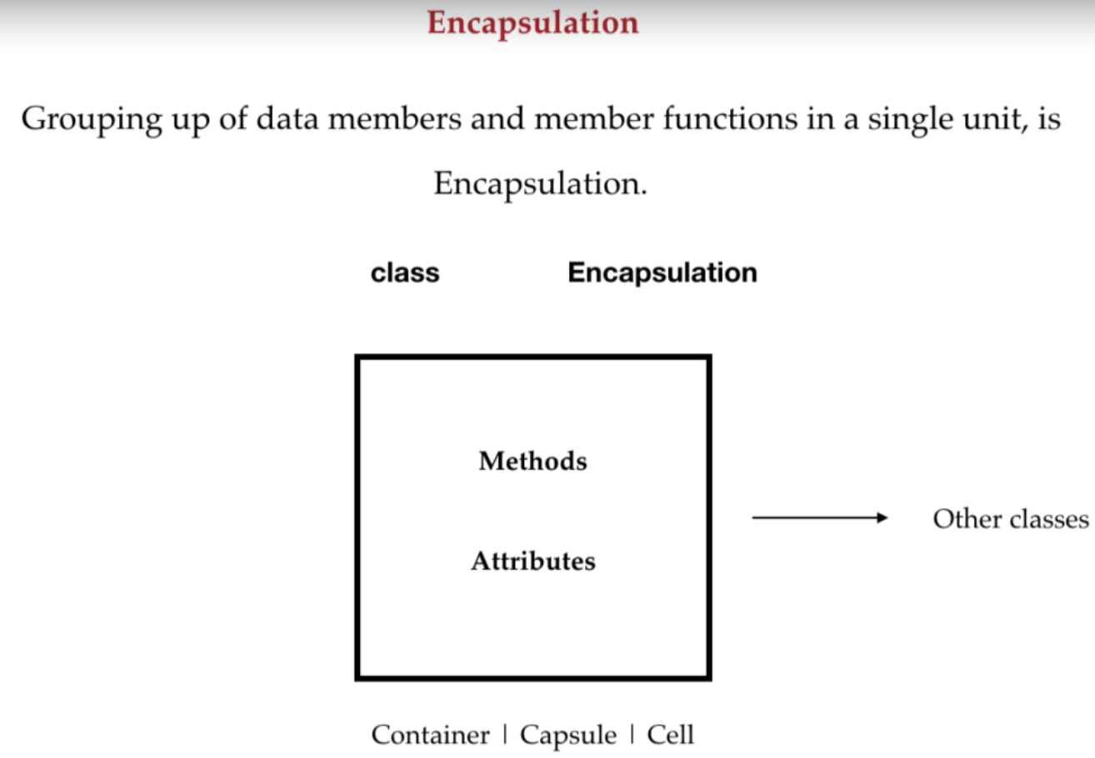

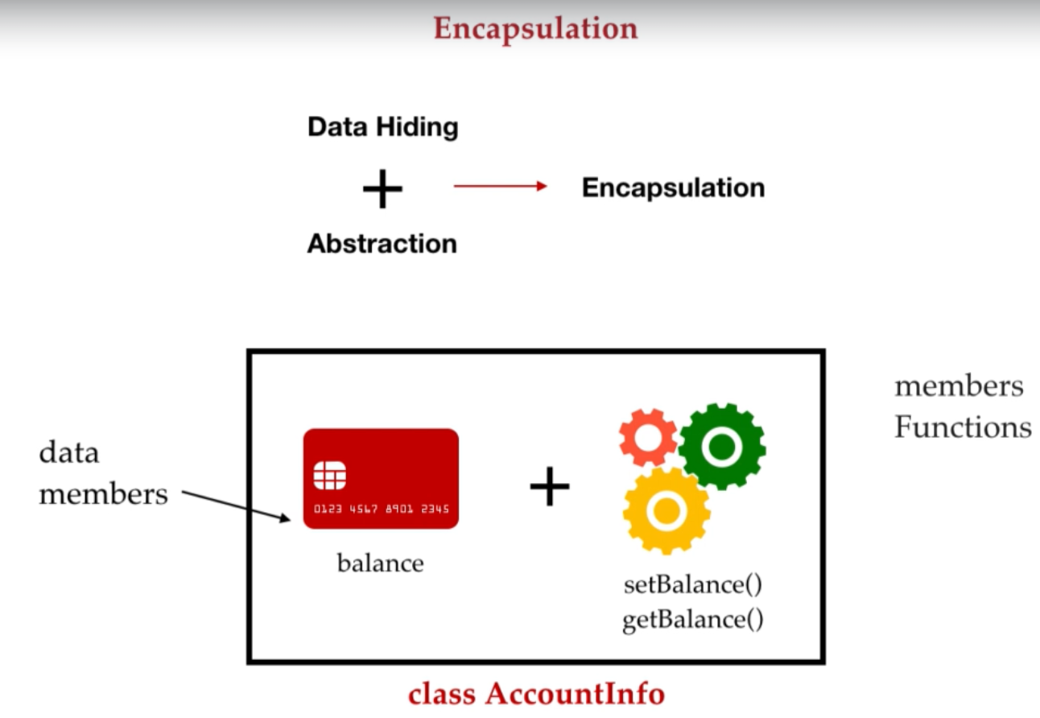

**Encapsulation:** Grouping data members and member functions together in a single unit, is called Encapsulation.

**Data Hiding + Abstraction = Encapsulation**

Advantages of Encapsulation are maintainability, flexibility, reusability, and user would not be knowing what is going on behind the scene.

Real world Example: Capsule

Refer the example: (***D:\core_java\programming_basics\java_in_depth_concept_v1.0\src\com\google\java\oops\encapsulation\EncapsulationDemo.java***)

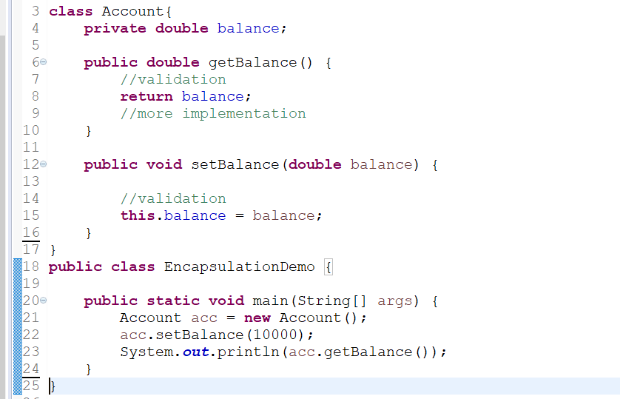

**Tightly Encapsulated class:** A class in which every data member is **private** that class is called tightly encapsulated class.

## 5 Inheritance:

**Inheritance in Java** is a mechanism in which one object acquires all the properties and behaviors of a parent object. It is an important part of [OOPs](https://www.javatpoint.com/java-oops-concepts) (Object Oriented programming system).

The idea behind inheritance in Java is that you can create new [classes](https://www.javatpoint.com/object-and-class-in-java) that are built upon existing classes. When you inherit from an existing class, you can reuse methods and fields of the parent class. Moreover, you can add new methods and fields in your current class also.

Inheritance represents the **IS-A relationship** which is also known as a parent-child relationship.

### Why use inheritance in java

* For [Method Overriding](https://www.javatpoint.com/method-overriding-in-java) (so [runtime polymorphism](https://www.javatpoint.com/runtime-polymorphism-in-java) can be achieved).
* For Code Reusability.

### Terms used in Inheritance

* **Class:** A class is a group of objects which have common properties. It is a template or blueprint from which objects are created.
* **Sub Class/Child Class:** Subclass is a class which inherits the other class. It is also called a derived class, extended class, or child class.
* **Super Class/Parent Class:** Superclass is the class from where a subclass inherits the features. It is also called a base class or a parent class.
* **Reusability:** As the name specifies, reusability is a mechanism which facilitates you to reuse the fields and methods of the existing class when you create a new class. You can use the same fields and methods already defined in the previous class.

### The syntax of Java Inheritance

**class** Subclass-name **extends** Superclass-name

{

   //methods and fields

}

The **extends keyword** indicates that you are making a new class that derives from an existing class. The meaning of "extends" is to increase the functionality.

In the terminology of Java, a class which is inherited is called a parent or superclass, and the new class is called child or subclass.

**Example of Inheritance:**

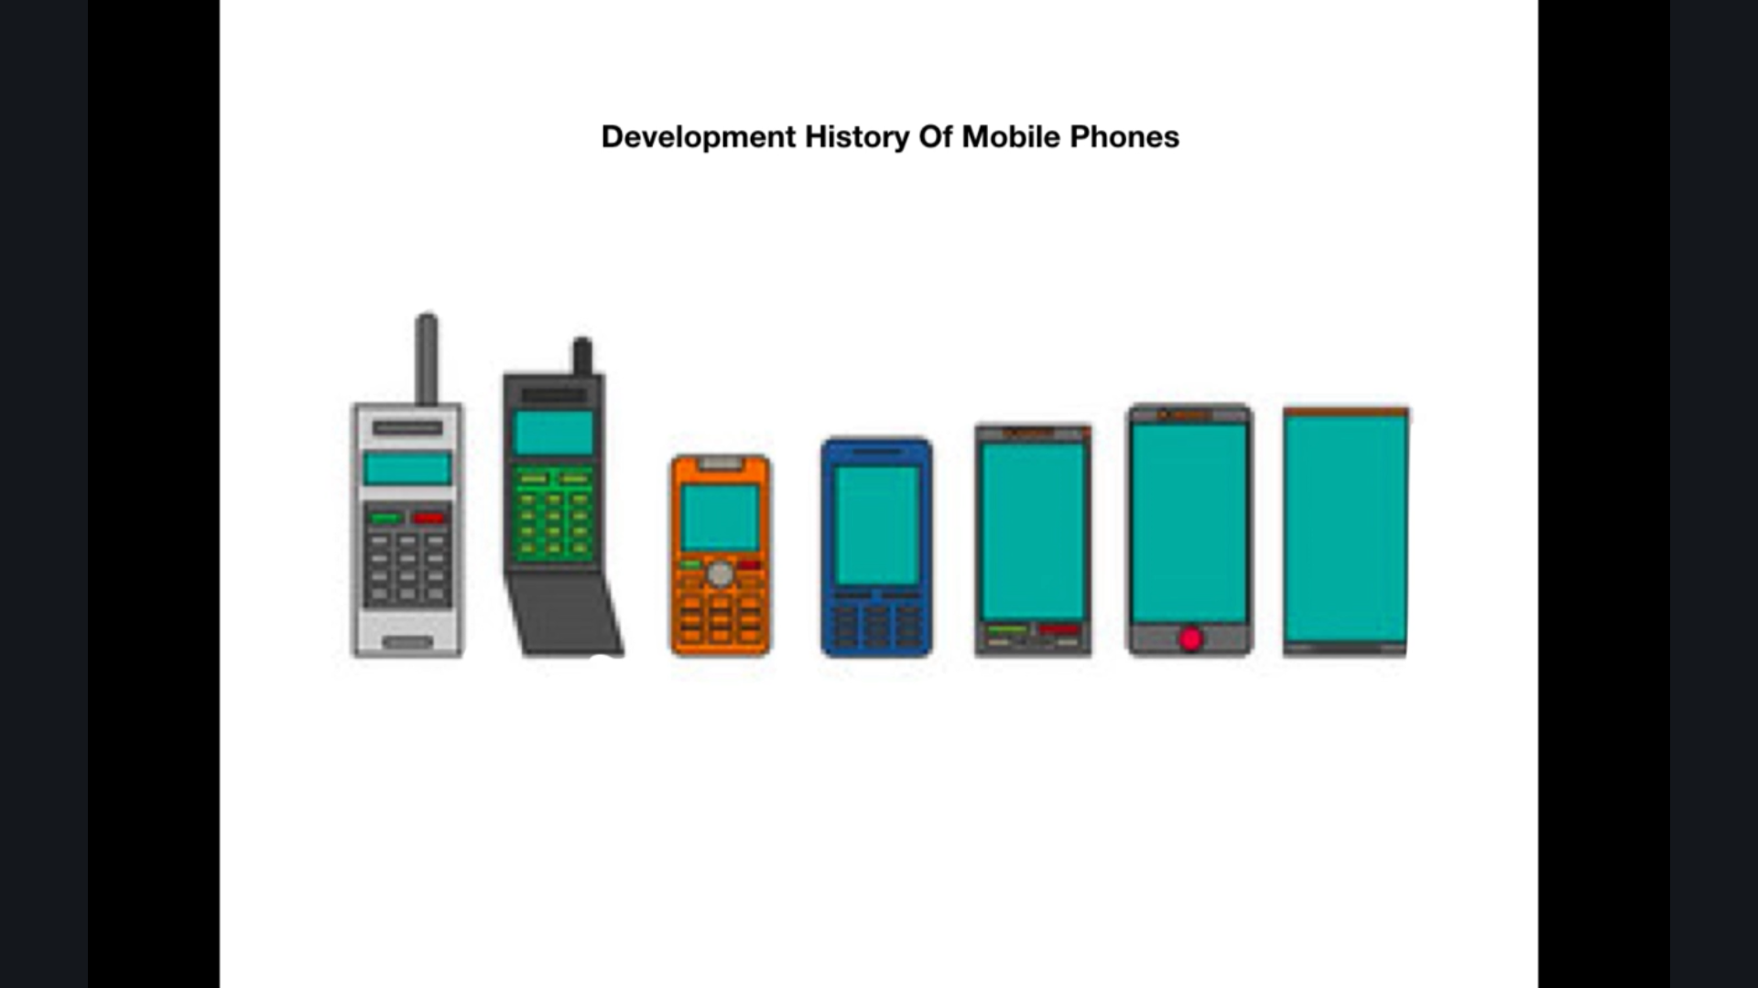

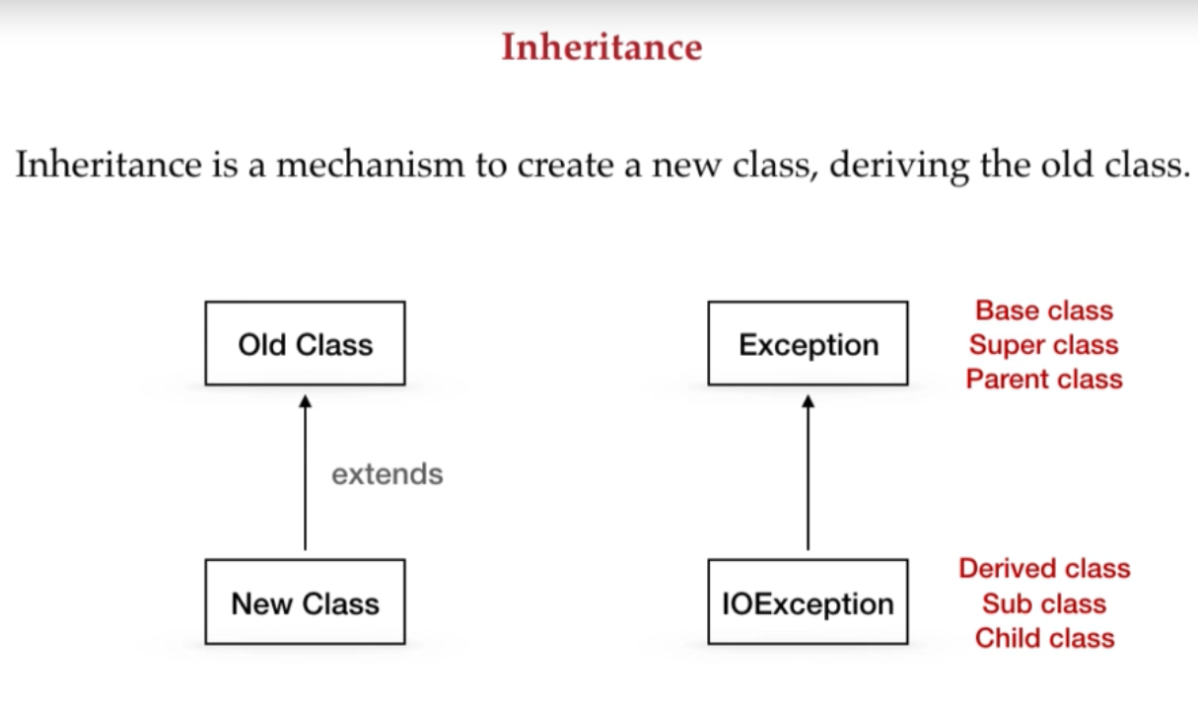

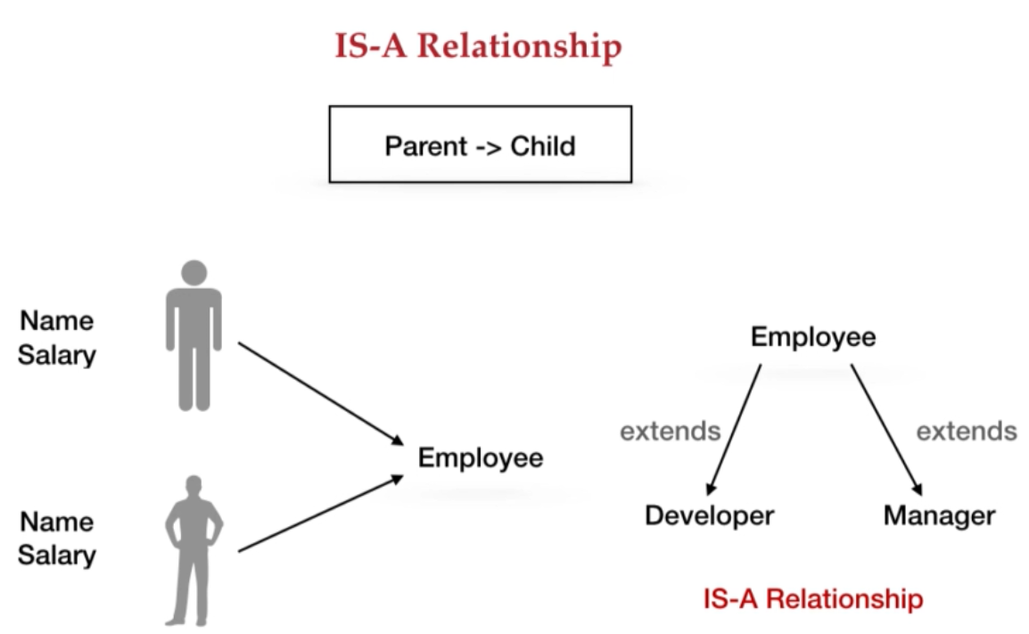

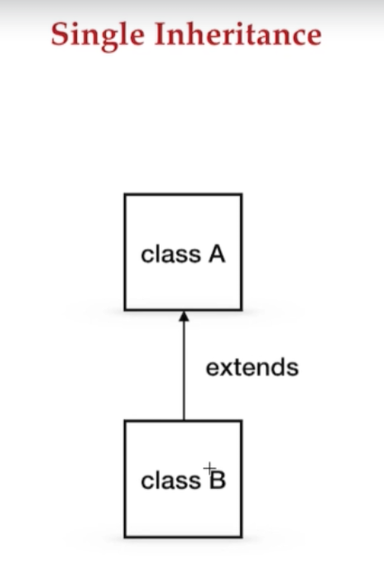

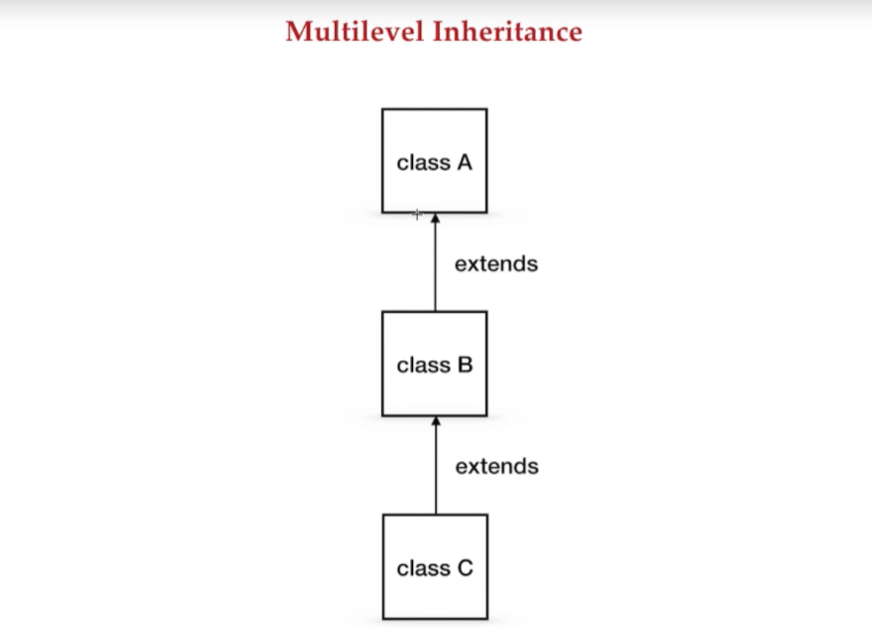

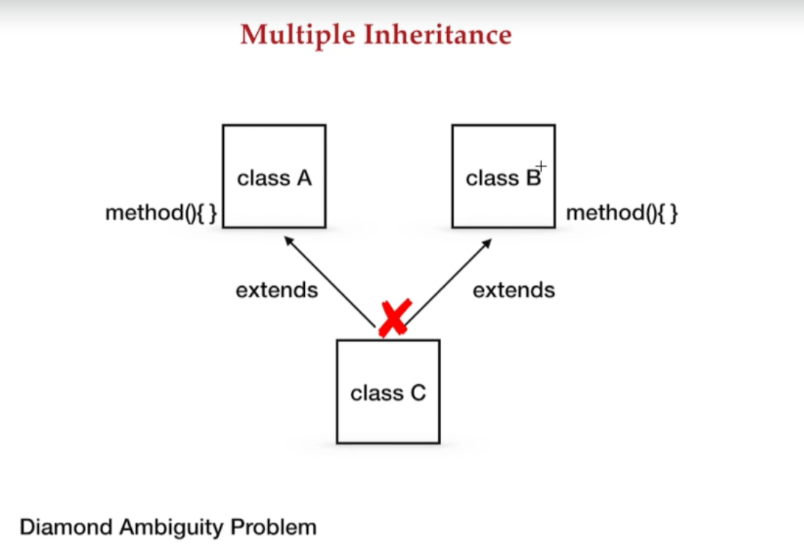

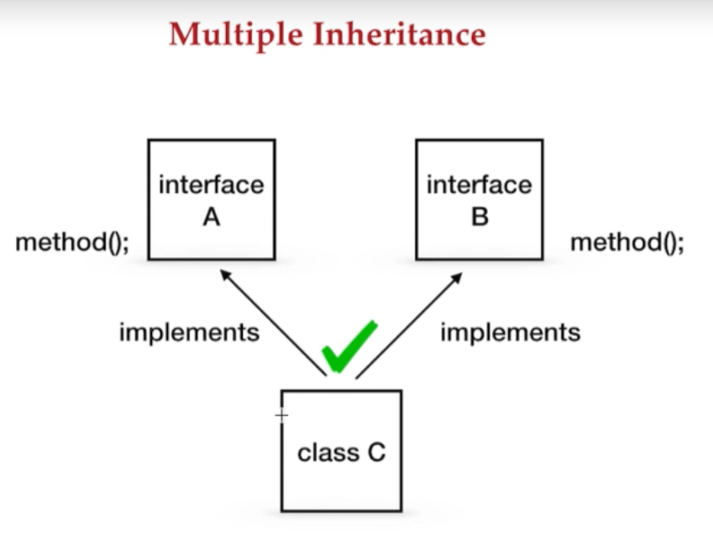

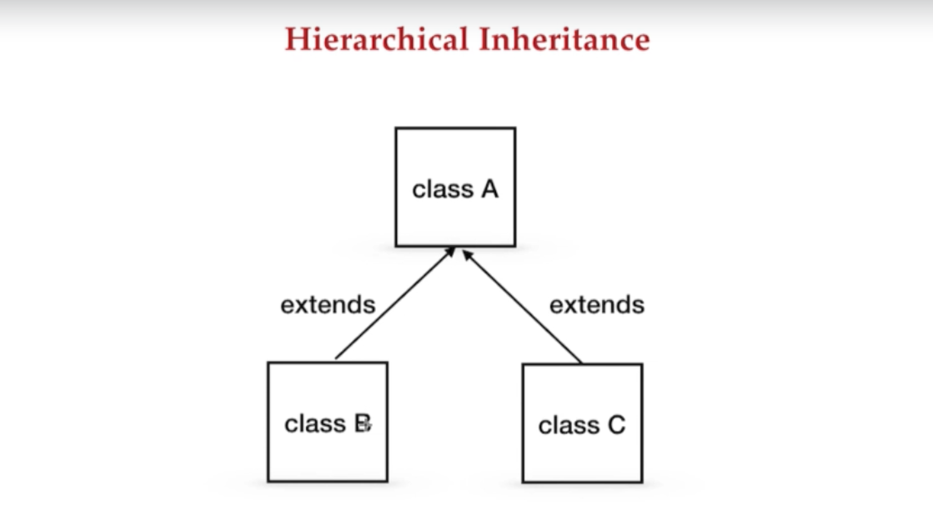

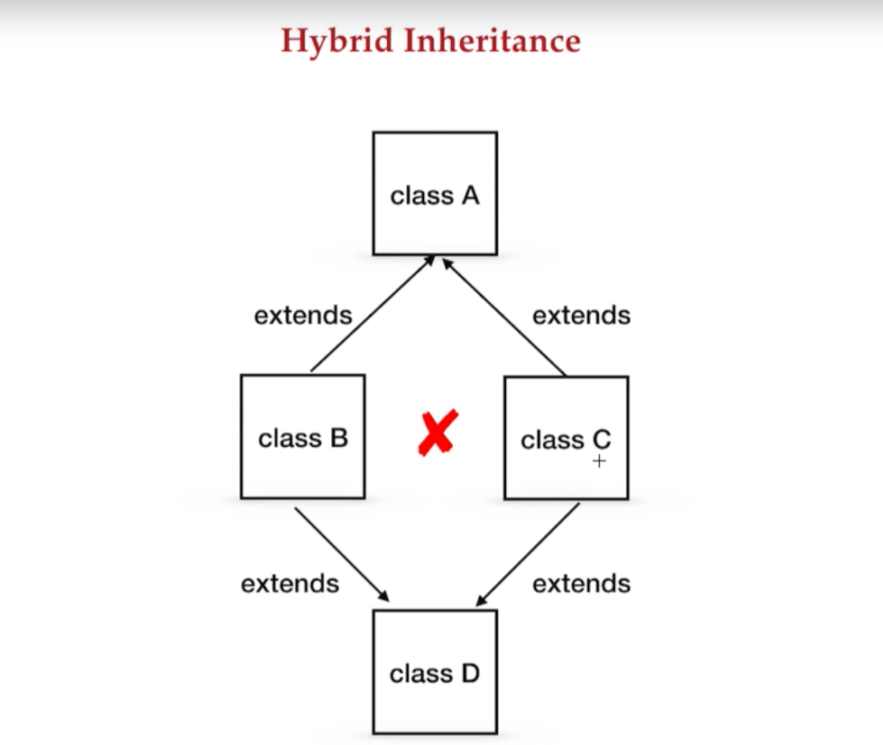

## 6 Polymorphism:

**Polymorphism in Java** is a concept by which we can perform a *single action in different ways*. Polymorphism is derived from 2 Greek words: poly and morphs. The word "poly" means many and "morphs" means forms. So polymorphism means many forms.

There are two types of polymorphism in Java: compile-time polymorphism and runtime polymorphism. We can perform polymorphism in java by method overloading and method overriding.

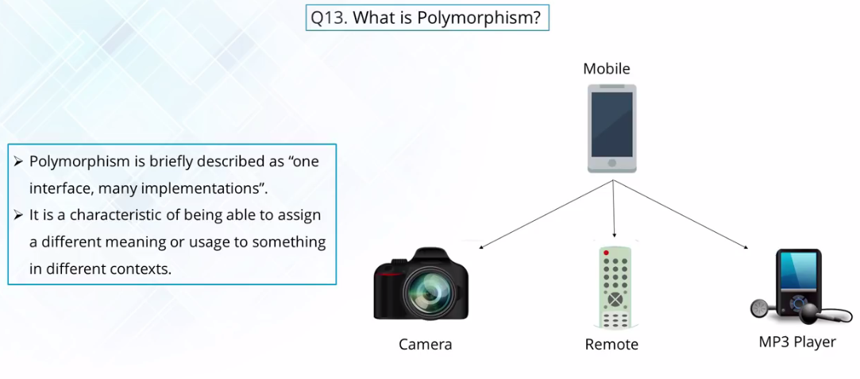

## 7 Overloading, Overriding:

### 7.2 Diff b/w Overloading & Overriding:



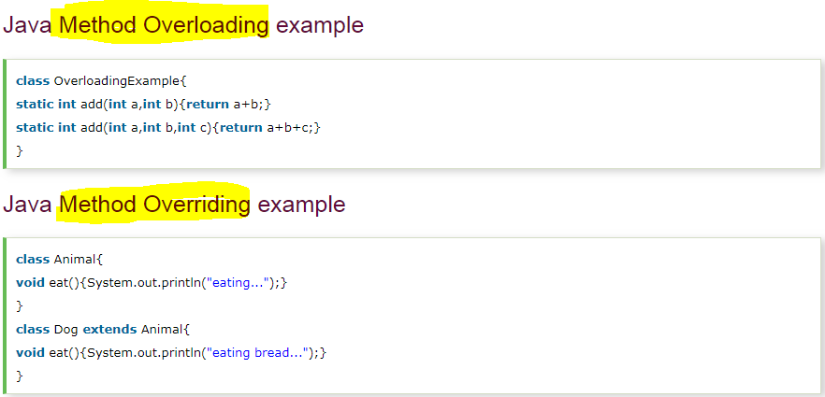

### Method Overloading:

Overloading allows different methods to have the same name, but different signatures where the signature can differ by the number of input parameters or type of input parameters or both. Overloading is related to compile-time (or static) polymorphism.

**Advantage of method overloading?**

We don’t have to create and remember different names of functions doing the same thing. For example, in our code, if overloading is not supported by Java, we would have to create method names like sum1, sum2,…. Or sum2Int, sum3Int, … etc.

### 7.3 When to use method overloading?

In Actual Projects, consider an application for them we have written some API that brings the data to the user on the basis of some inputs, So suppose we have a method which is

**getDetails(int id, String name)**

So this is our method, now suppose requirements changes for the newer version of code this code is not required, enhanced version of this code is required, for that programmers needs to change the logic for existing methods, but if this(getDetails(int id, String name)) method is used by other services then we cannot changed it, right because may be some other services may be using it. So we can not remove this method for this reason, programmer can overload this method.

So if requirement is the method

**getDetails(int id, String name, String password)**

So this is how we can overload the methods and problem will get resolve.

### Method Overriding:

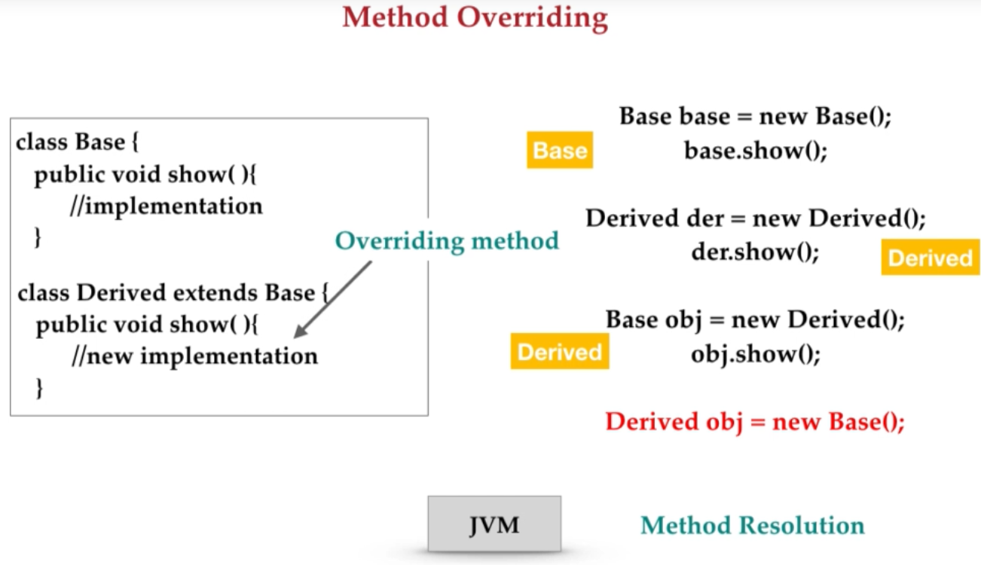

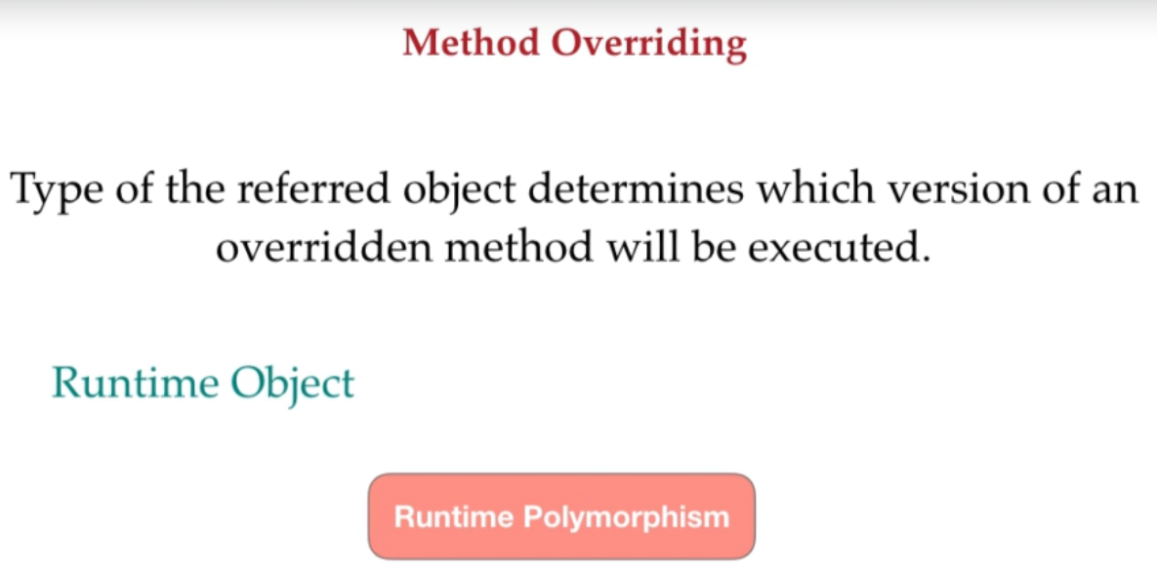

The best example of method overriding is toString() method of Object class it returns the string representation of the object and we can override it and provide our own implementation to get the desired output.

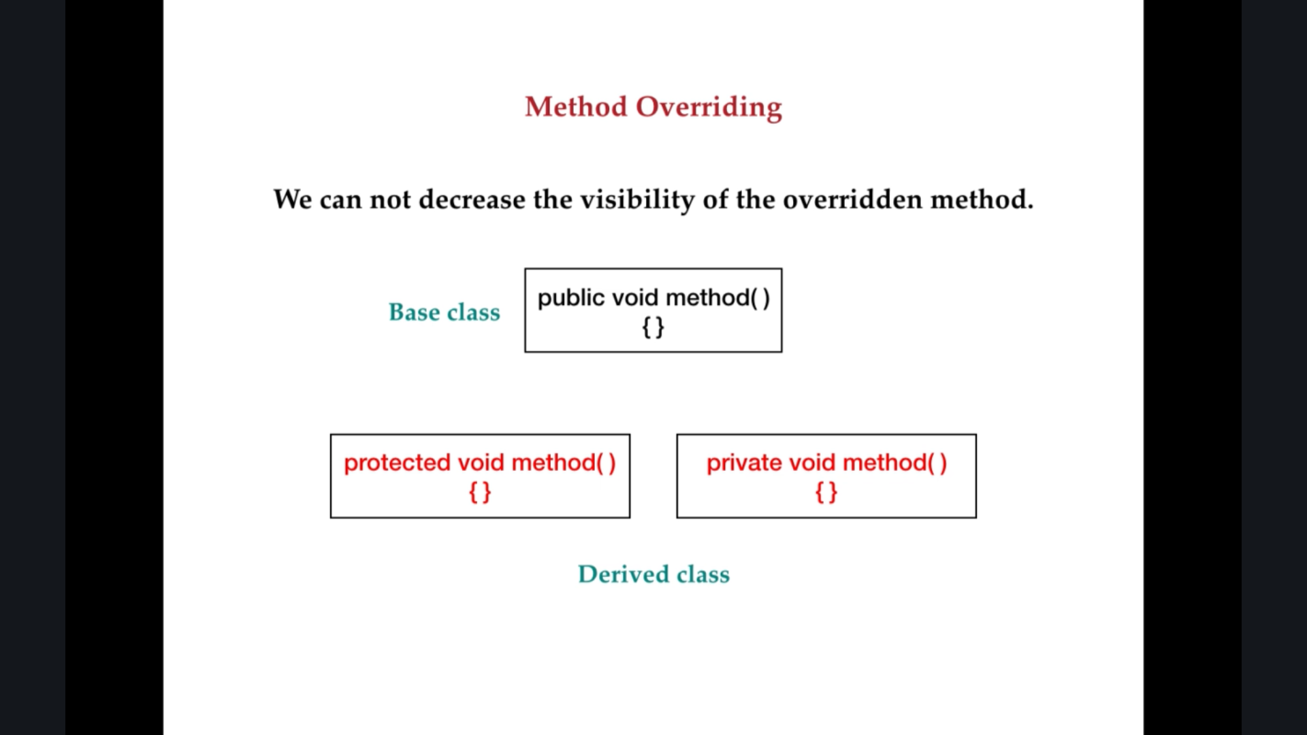



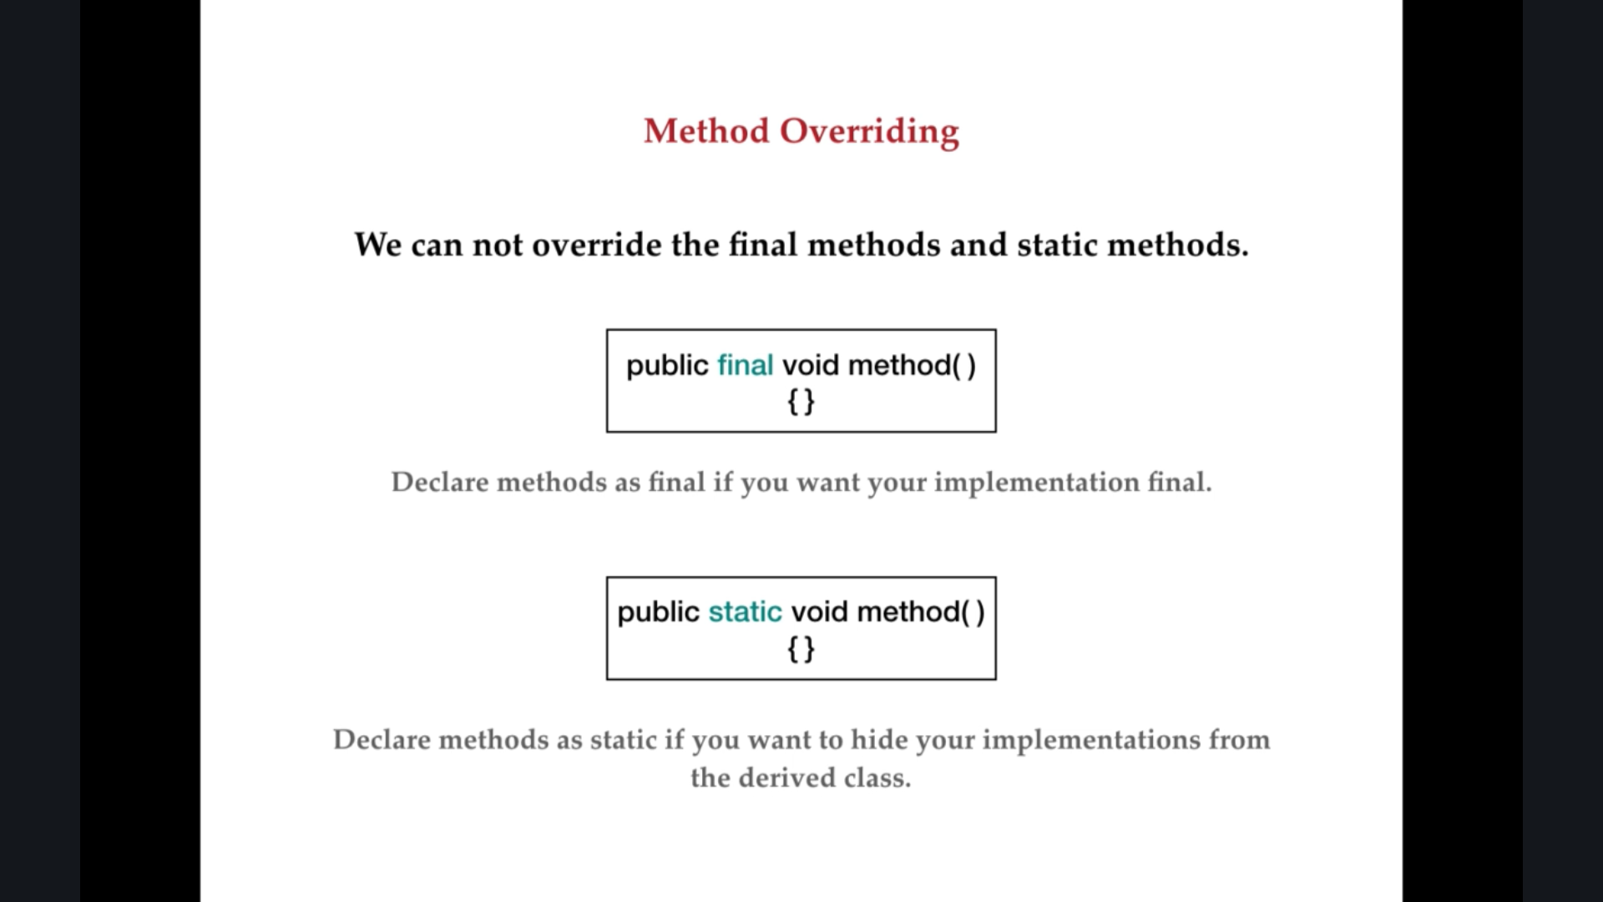

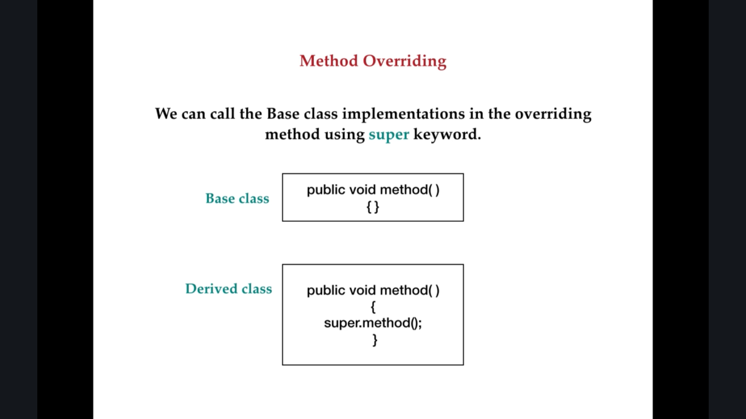

### 7.4 When to use method overriding?

Consider a scenario where Bank is a class that provides a method to get the rate of interest. However, the rate of interest may differ according to banks. For example, SBI, ICICI, and AXIS banks are providing 8.4%, 7.3%, and 9.7% rate of interest.



### 7.5 Runtime Polymorphism example code

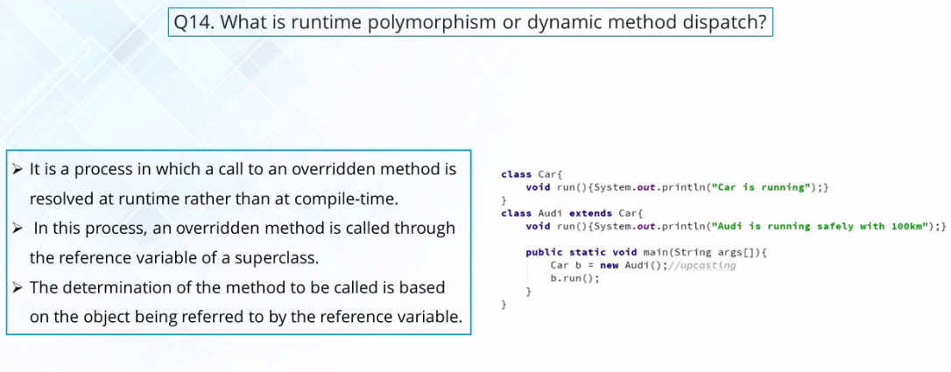

### 7.6 Why we say Compile time polymorphism and Run time polymorphism?

In Runtime polymorphism a call to an overridden method is resolved at runtime.

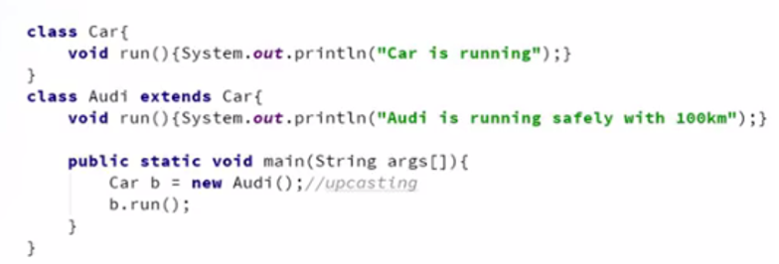

In Compile time polymorphism a call to an overloaded method is resolved at compile time.

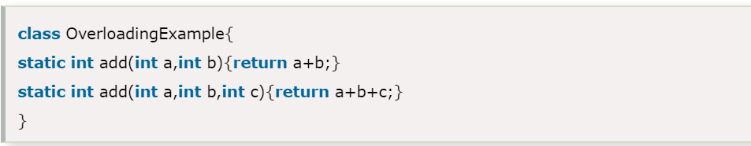

## 7 Why we need interface at all?

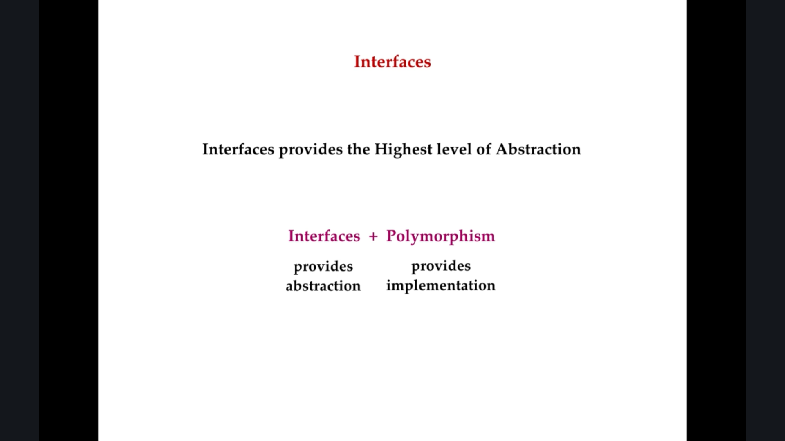

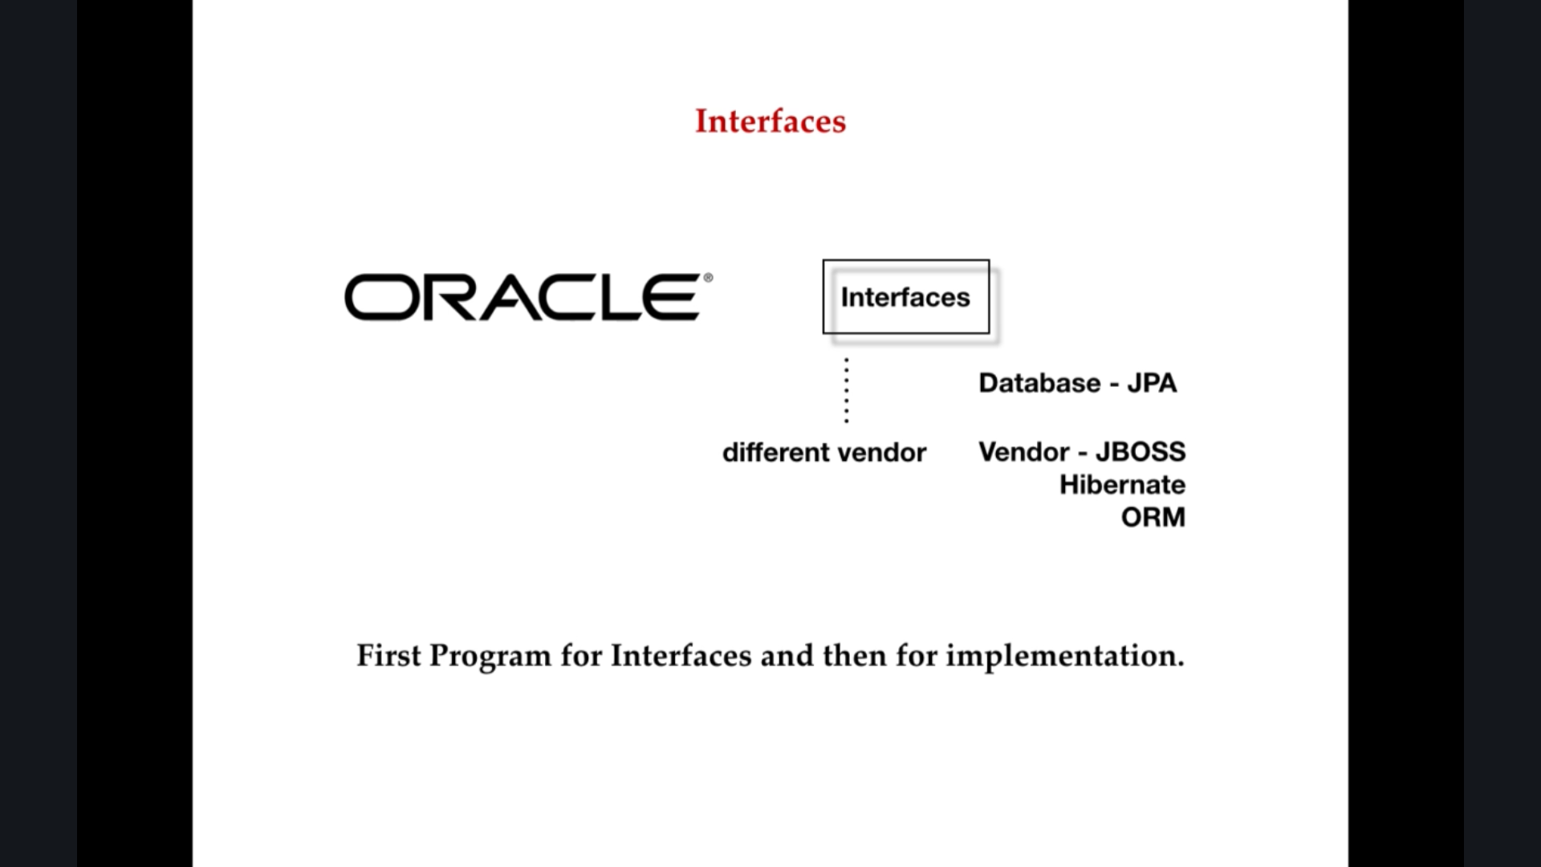

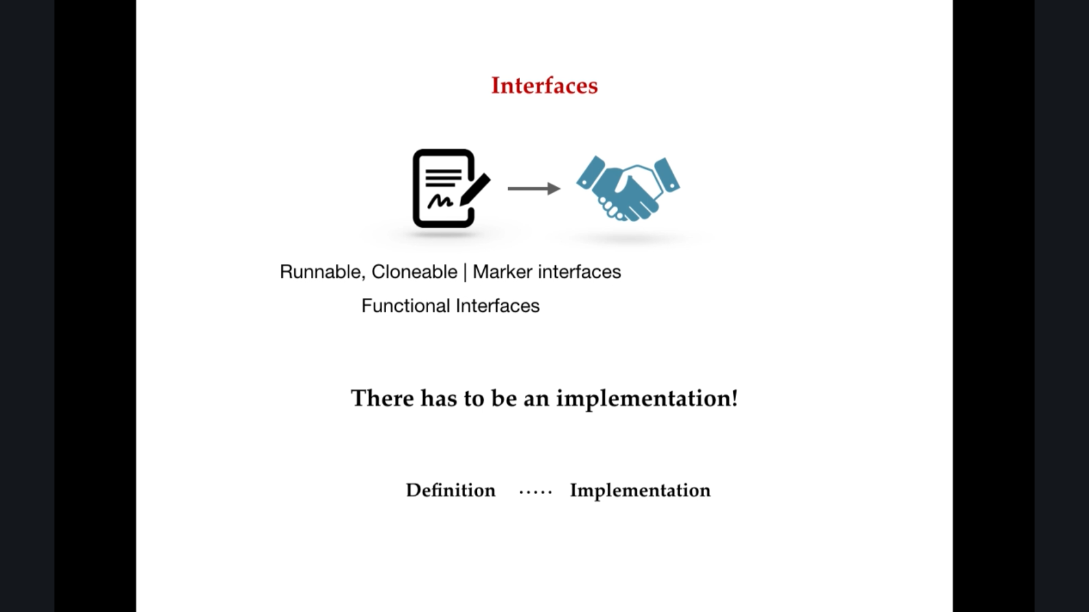

## 8 Static vs Non-Static:

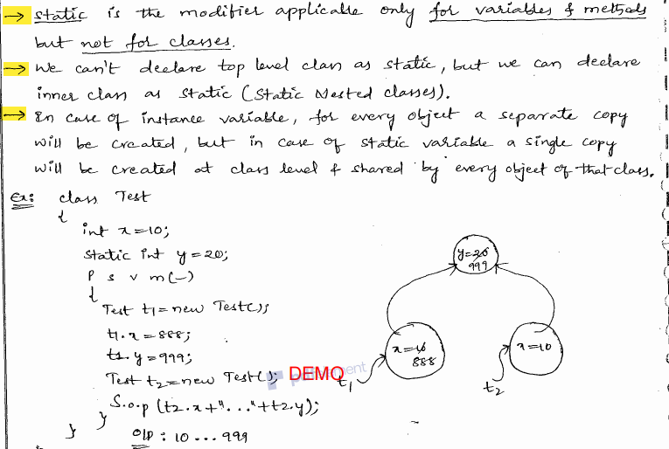

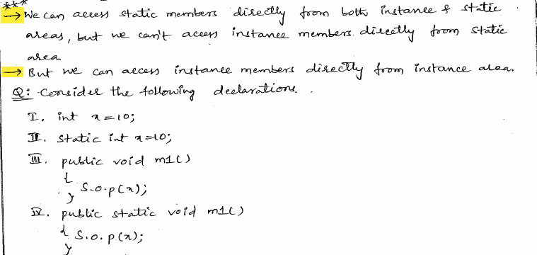

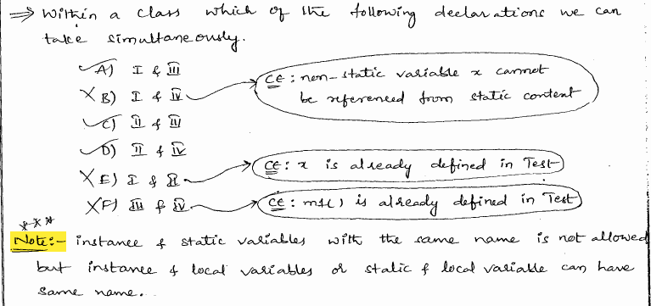

## 9 When to use Abstract class & When to use Interface

### 9_1 When to use Abstract class & When to use Interface

First let me define **what is the Abstract class**?

Abstract class is a class, which contains at least one abstract method, here **abstract method** means, the method that does not have the any implementation, just have method signature, that means without body, the method has without body, only method signature is available, such type of methods are abstract method.

If any class contains abstract method then that class is called as an abstract class. So, how to define abstract class means, by using **abstract** keyword. We need to use a keyword abstract.

Then, **What is the use of Abstract class?**

By using the abstract class we can achieve abstraction, which is one of the OOPs concept. Here abstraction means shows functionality by hiding the implementation details is called an abstraction.

Then, **When to use an abstract class?**

If you have any requirement where few set of functionality is common across all the sub-classes and few functionality is different from sub-class then the common functionality we can define in the abstract class.

But an abstract class cannot instantiated. It can be only be used as a super class for other classes that extends the abstract class. That means if you know partial implementation but not completely, abstract class is good choice, that means you don’t know 100% requirement from the clients you know only partial implementation at that time you need to choose abstract class.

In addition to abstract method we can declare concreate method also in the abstract class, and for abstract method there is no restriction to declare any modifier like private, protected, final etc.

Then, **What is interface?**

Interface is a 100% abstract method. That means it doesn’t have any implementation. It contains only method declaration. What ever method declare in the interface should be implemented by classes that implements the interface. Remember that a class can implement more than one interface, but can extends only one class. Interfaces also can’t be create objects like abstract class.

Then, **When to use interface?**

In java, multiple inheritance problem is solved a powerful construct called interfaces. Interface contains only abstract methods, that means interface contains only abstract method there is no concreate method. Interface just specify method declaration but no body of the method.

If you use interface you need to implement all the methods in the class that extends the interface. If you like to support for future expansion when using interfaces, you will need to extends the interface and create new one.

You can use interface if you want contract on some functionality. Interface is the good choice when you think that the API will not change for a while. Interfaces are also good choice if you want to something similar to multiple inheritance, since you can implement multiple inheritance using interface.

**Main Key notes:**

When you have a common implementation, abstract classes shine. Using abstract classes you can enforce an implementation hierarchy and avoid duplicate code.

An **abstract class** allows to add new methods without breaking compatibility. The derived class can just provide working implementation of a subset of the methods defined in the abstract class.

While if you add new methods to an **interface**, you'd need to update all the classes that implements the interface

### 9_2 Diff b/w Interface and Abstract class:



OR

### When to use Abstract methods & Abstract class?

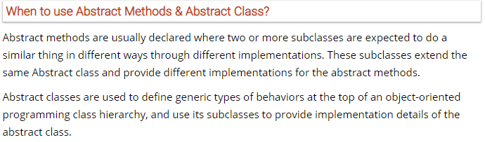

### 9_3 When to use Abstract class and when to use interface?

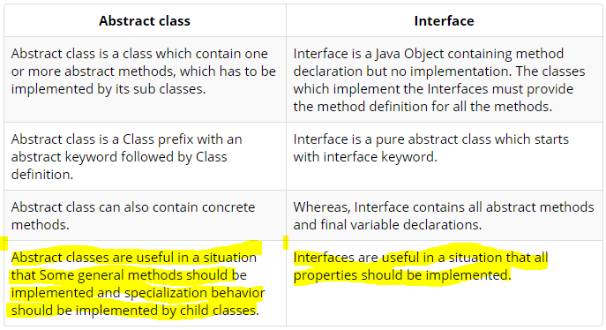

## 10 What is 'instanceof'?

The **java instanceof operator** is used to test whether the object is an instance of the specified type (class or subclass or interface).

The **instanceof** in java is also known as type *comparison operator* because it compares the instance with type. It returns either true or false. If we apply the instanceof operator with any variable that has null value, it returns false.

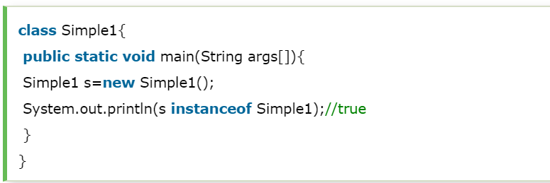

Advanced Example:

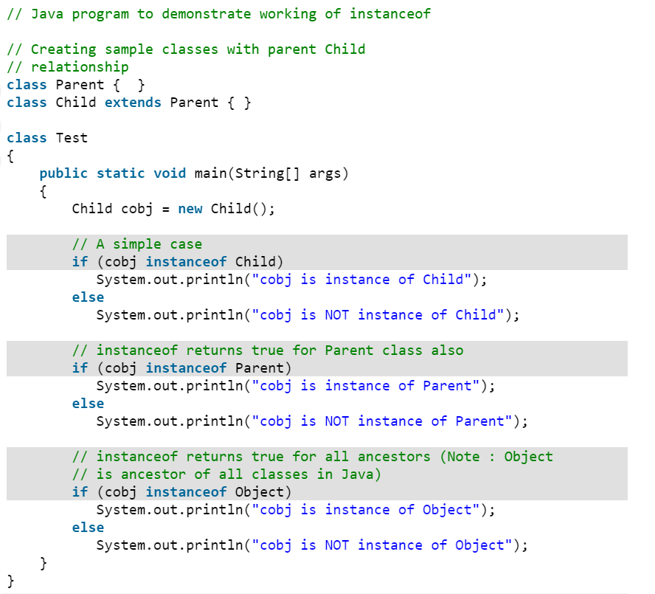 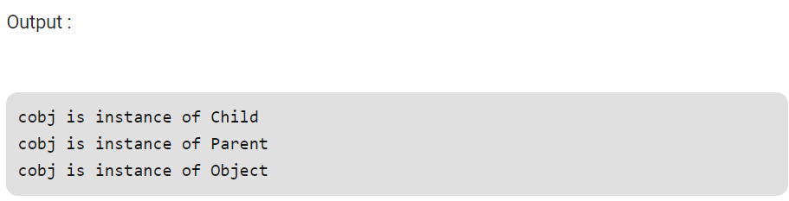

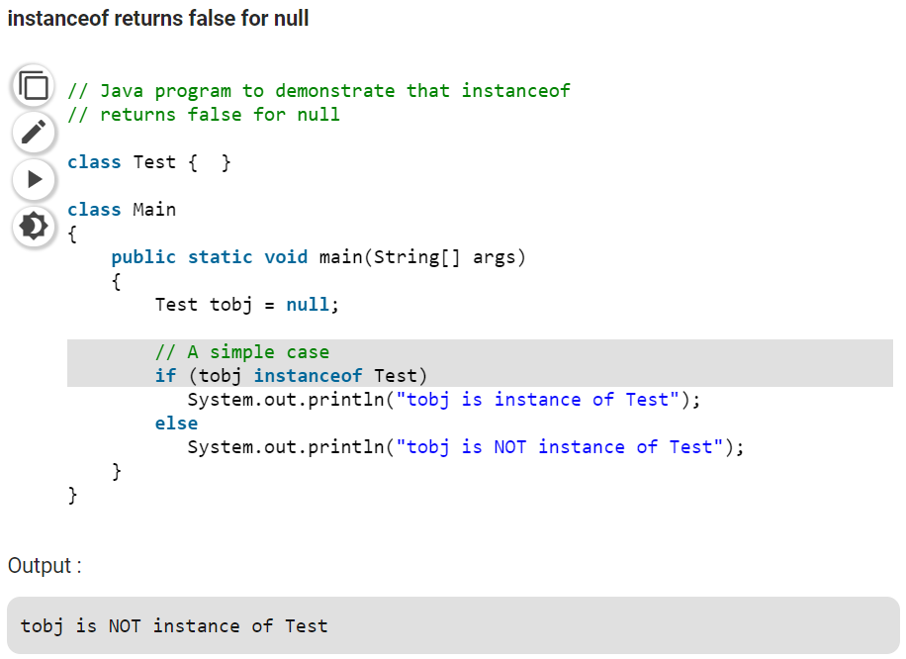

## 11 Difference between compile time error and run time error?

**Compile-Time Errors:** Errors that occur when you **violate the rules** of writing syntax are known as Compile-Time errors. This compiler error indicates something that must be fixed before the code can be compiled. All these errors are detected by the compiler and thus are known as compile-time errors.  
Most frequent Compile-Time errors are:

* Missing Parenthesis (**}**)
* Printing the value of variable without declaring it
* Missing semicolon (terminator)

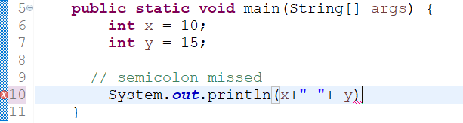

**Run-Time Errors**: Errors which occur during program execution(run-time) after successful compilation are called run-time errors. One of the most common run-time error is division by zero also known as Division error. These types of error are hard to find as the compiler doesn’t point to the line at which the error occurs.

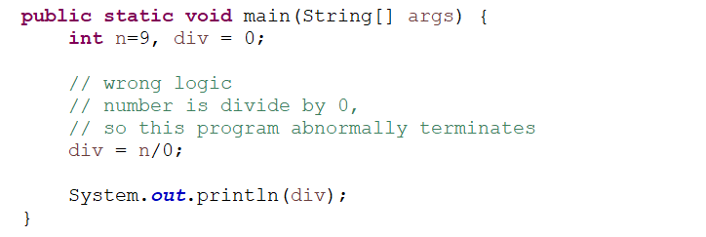

This is an example of run-time error i.e errors occurring while running the program.

Some more example on RunTime Error.

* trying to invoke a method on an uninitialized variable (**NullPointerException**)
* ran out memory (memory leaks...) (**OutOfMemoryError**)
* trying to open a file that doesn't exist (**FileNotFoundException**)
* trying to pass arguments to a method which are not within the accepted bounds (**IllegalArgumentException**)
* trying to invoke wait() or notify() on an object without owning the object's monitor (**IllegalMonitorStateException**)

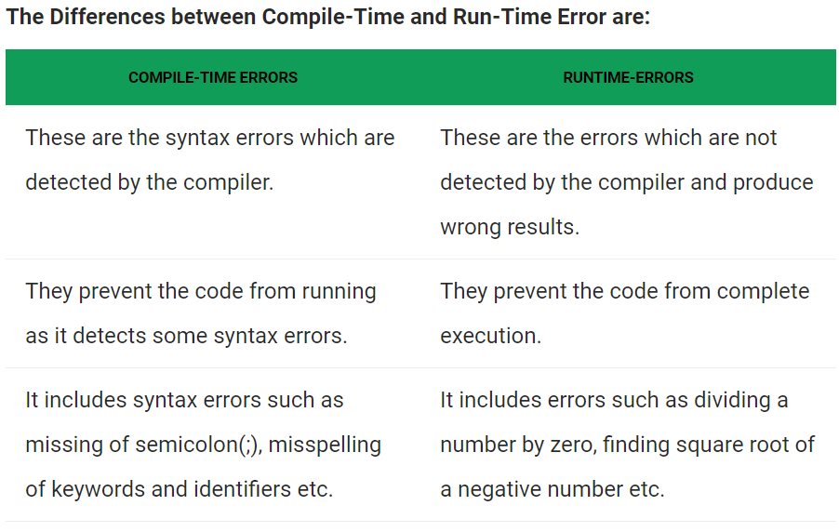

# Collection:[C]

## 0 How collection came into the picture? Problem with Array?

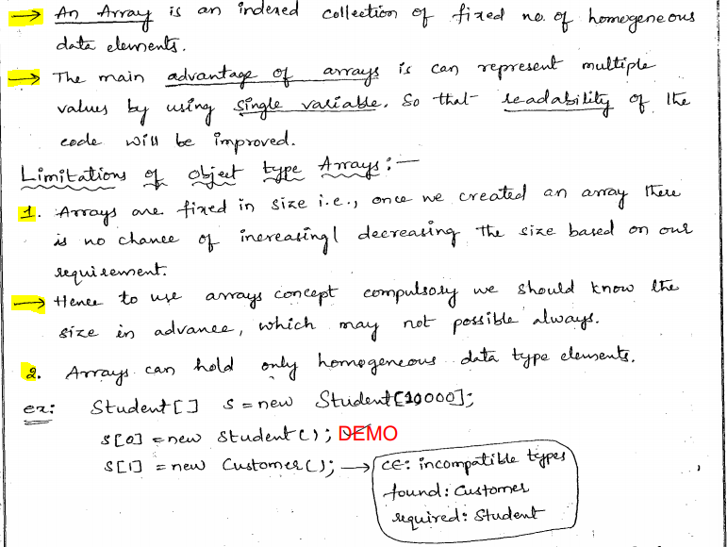

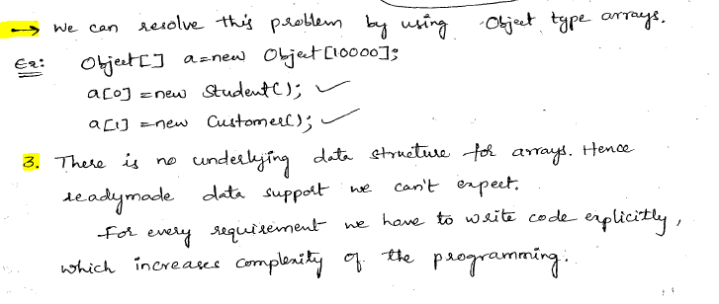

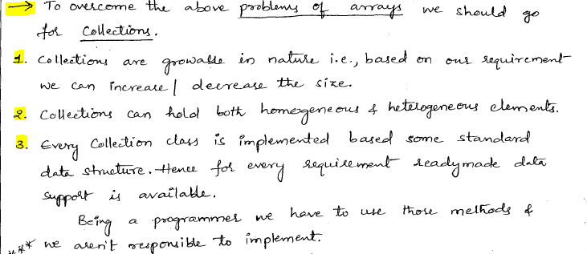

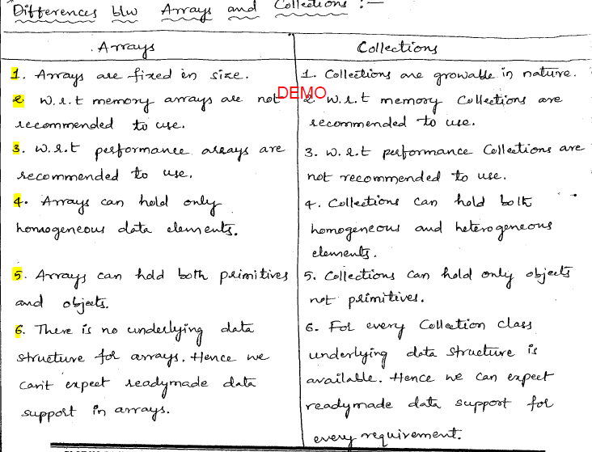

## 1 HashMap internally working?

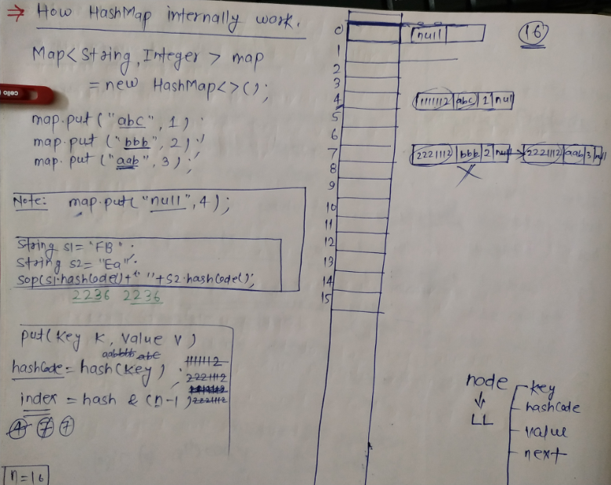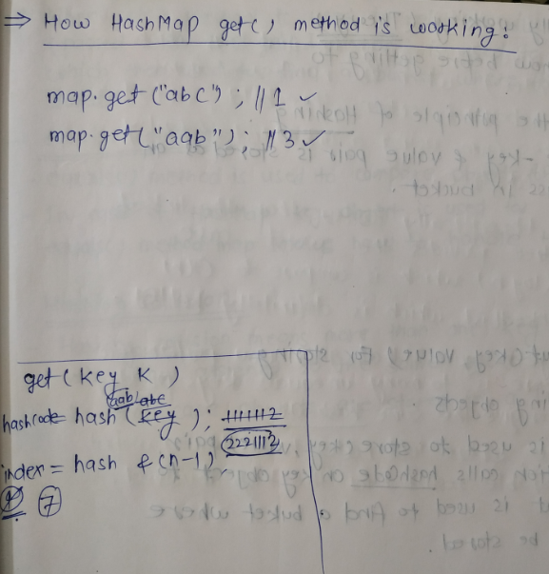

## 2.1 How to iterate?[Cursor,iterator,listIterator]

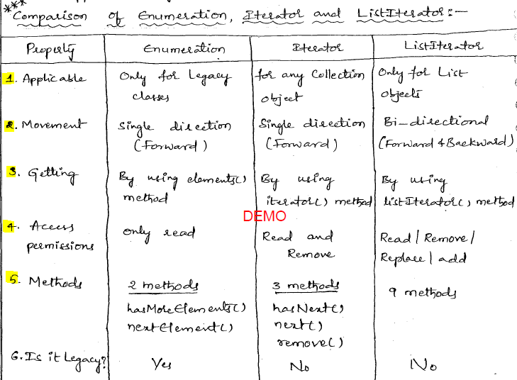

## 2.2 Why should we use iterator?

* If you need to modify your collection during the iteration, you should set using the iterator.
* If you want to keep your code generic and well-designed or you are working in a multithreaded application you also better work with iterator.

## 2.3 Diff b/w fail-fast and fail-safe iterator?

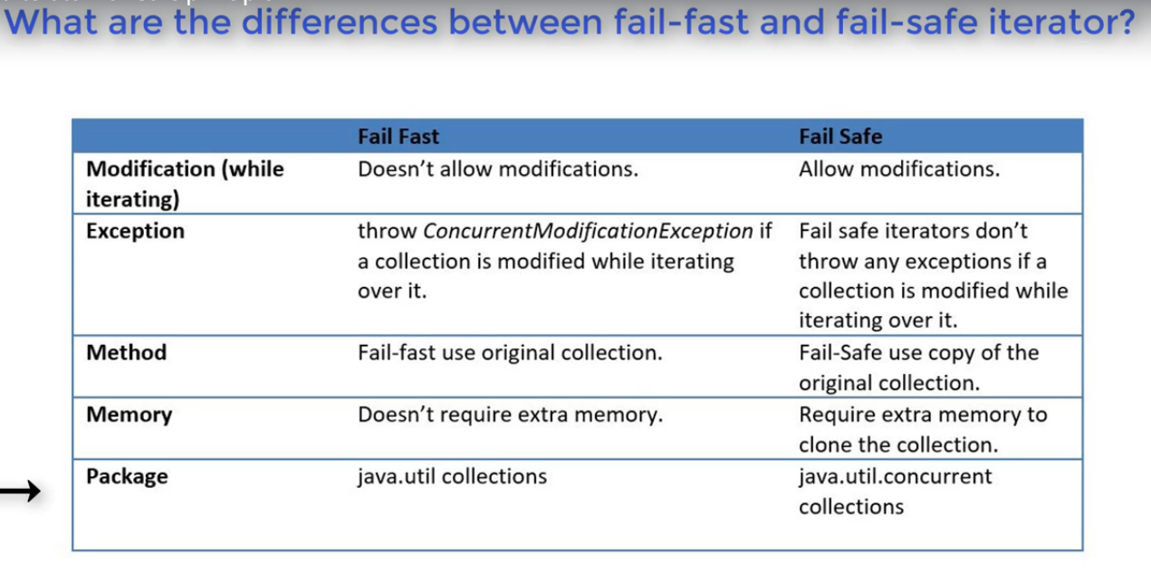

## 3.1 Diff b/w Comparable and Comparator?

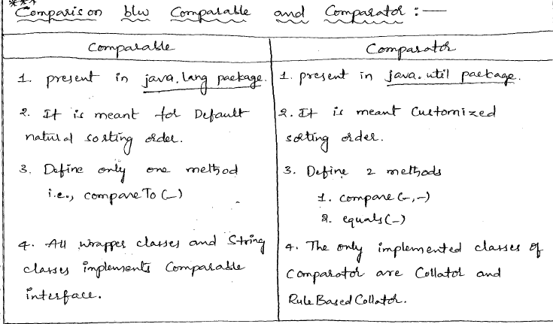

## 3.2 When to use Comparable & When to use Comparator?

[**Comparable**](https://docs.oracle.com/javase/7/docs/api/java/lang/Comparable.html) - java.lang.Comparable: int compareTo(Object o1)

A comparable object is capable of comparing itself with another object. The class itself must implements the java.lang.Comparable interface in order to be able to compare its instances.

* Capable of comparing current object with the provided object.
* By using this we can implement **only one sort sequence** based on the instances properties. EX: Person.id
* Some of the Predefined Classes like String, Wrapper classes, Date, Calendar has implemented Comparable interface.

[**Comparator**](https://docs.oracle.com/javase/7/docs/api/java/util/Comparator.html) - java.util.Comparator: int compare(Object o1, Object o2)

A comparator object is capable of comparing two different objects. The class is not comparing its instances, but some other class’s instances. This comparator class must implement the java.util.Comparator interface.

* Capable of comparing any two Objects of Same Type.
* By using this we can implement **many sort sequence** and name each, based on the instances properties. EX: Person.id, Person.name, Person.age
* We can implement Comparator interface to our Pre-defined classes for Customized sorting.

**Example:**

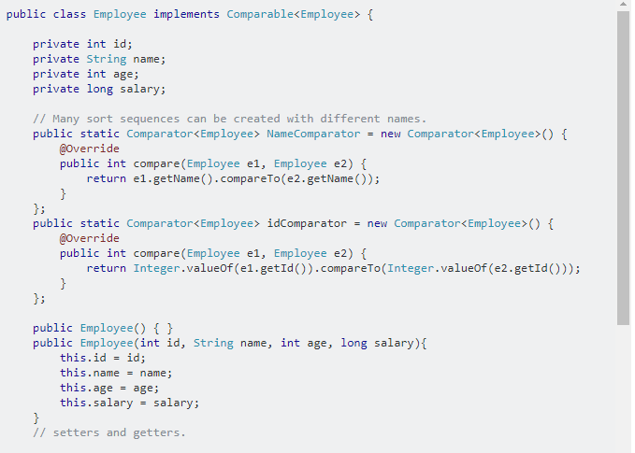

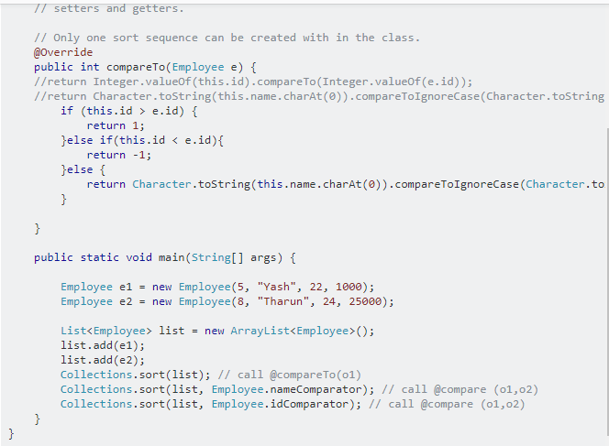

After slide the image:

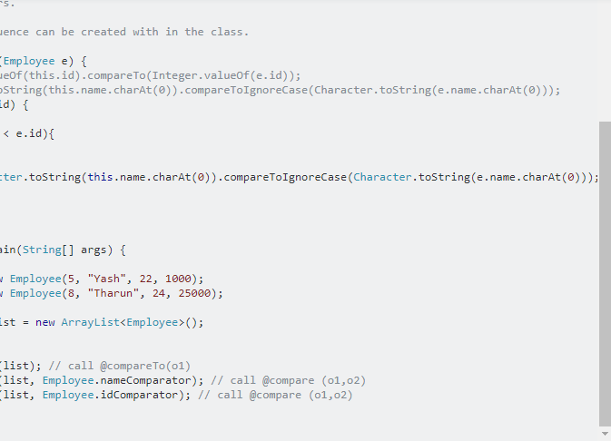

## 4 Employee [eid,name] sort using Comparable and Comparator. One Scenario Based question.

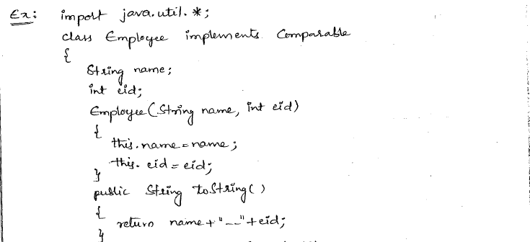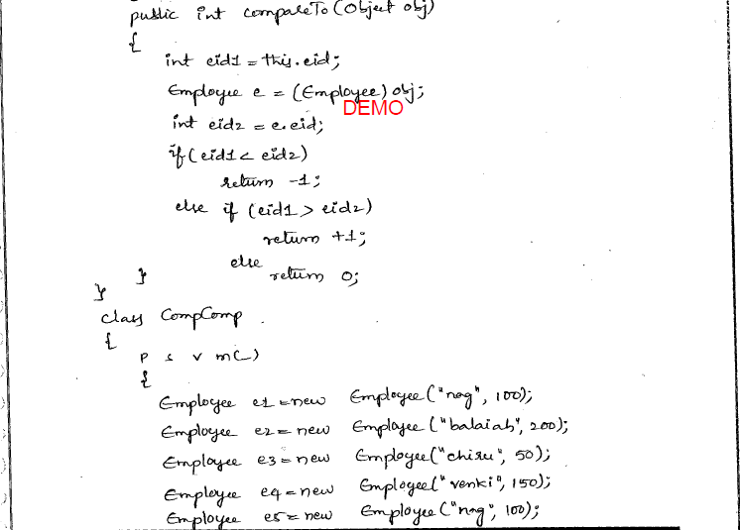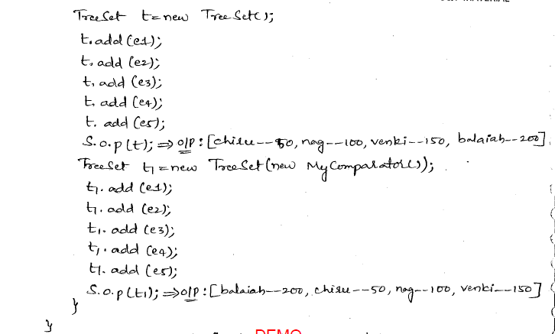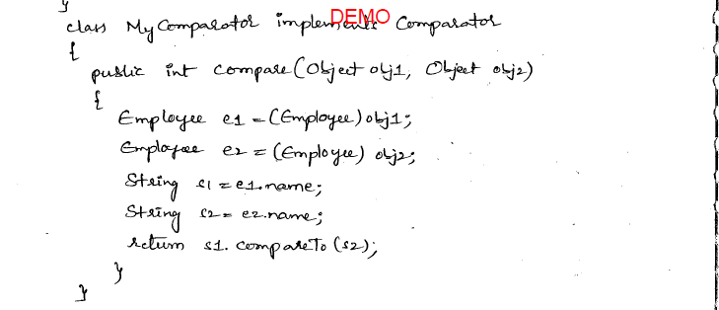

## 5.1 Diff b/w ArrayList and LinkedList?

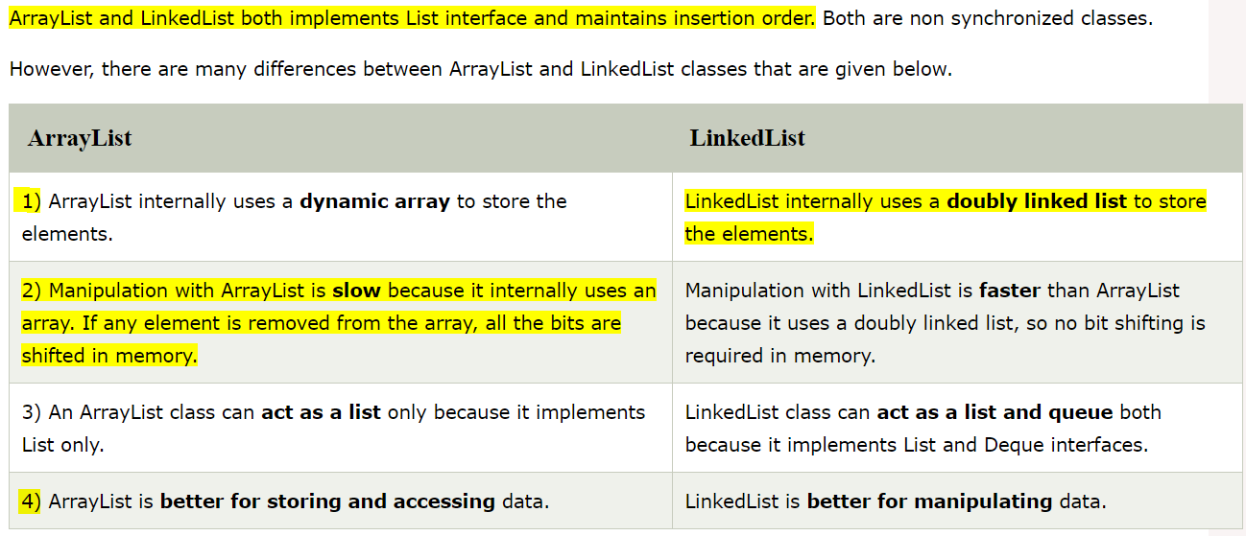

## 5.2 When to use ArrayList and When to use LinkedList?

Use **ArrayList** , If you have lots of reads, especially with specific index, and not so many modifications.(add/remove)

Use **LinkedList**, If you have lots of modifications, and not so many reads.

## 6.1 Diff b/w ArrayList and Vector?

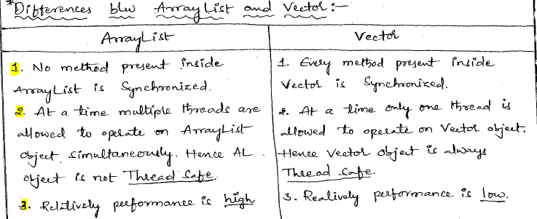

## 6.2 When to use ArrayList and When to use Vector?

If your List collection is accessed and modify by multiple threads simultaneously use the **Vector** class, which will be slower but thread-safe. Otherwise in all other cases you should use **ArrayList** class, which is not thread-safe but faster

## 7 Diff b/w HashMap vs HashSet?

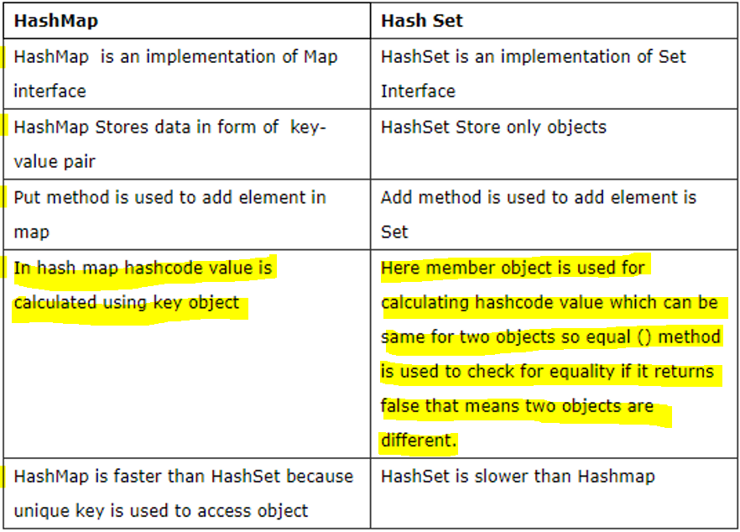

## 8 Diff b/w HashSet and LinkedHashSet?

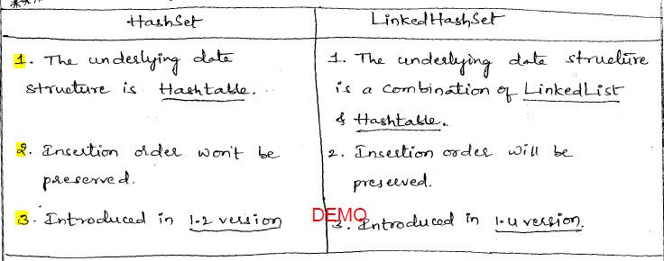

## 8.2 When should we use List and when to use Set?

* If we need to maintain insertion order and we can have duplicates too then we use **List**.
* If we want Collection of unique objects then we should use **Set**.

## 9 Diff b/w HashMap and Hashtable?

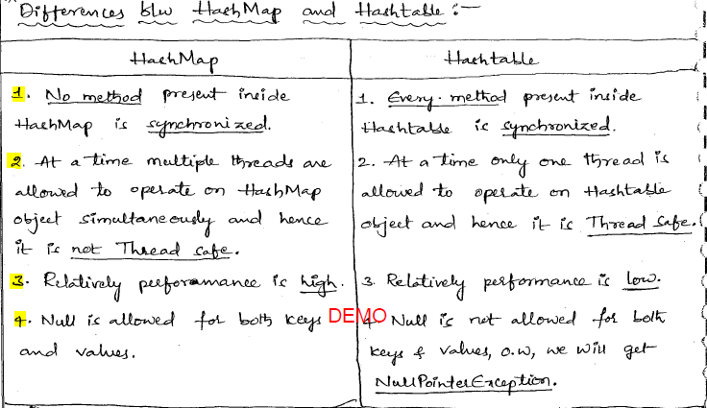

## 10 Diff b/w Hashmap and ConcurrentHashMap?

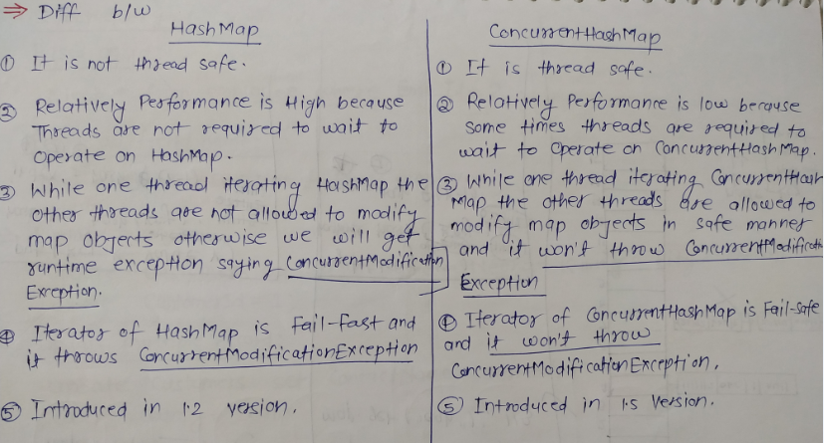

## 13 Diff b/w HashMap and LinkedHashMap?

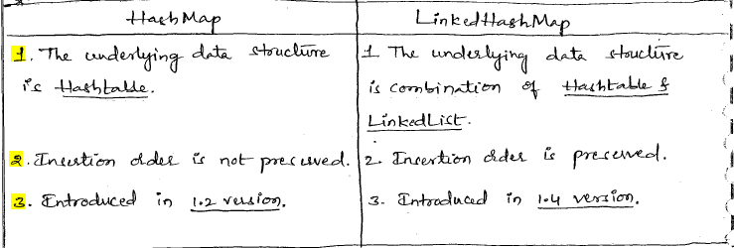

## 11 Collection related class hierarchy?

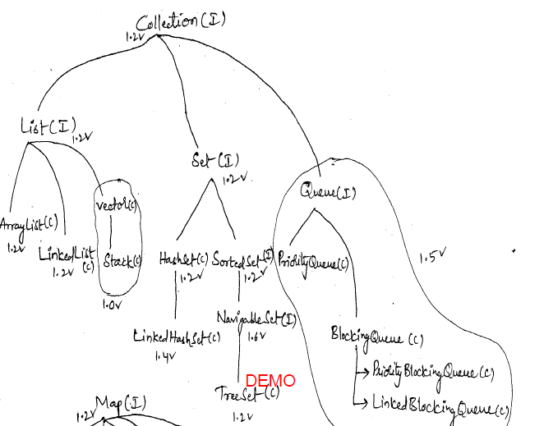

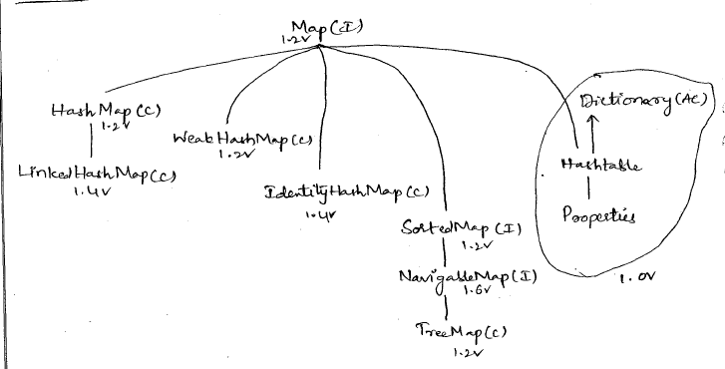

## 12 Comparision b/w HashSet, LinkedHashSet and TreeSet:

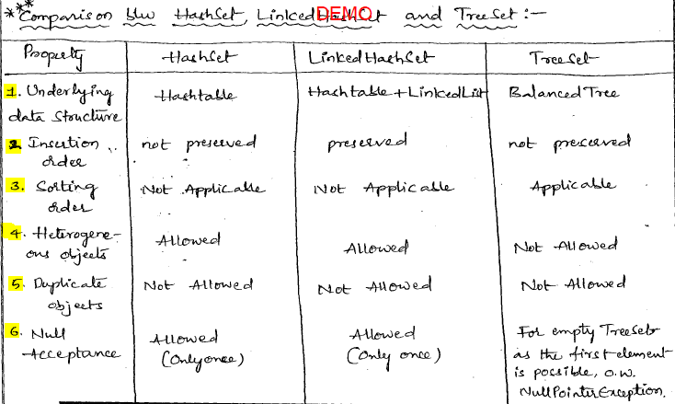

## ArrayList vs. LinkedList -- Which one is better?

* ArrayList implements the RandomAccess interface, and LinkedList does not. Note that Collections.binarySearch does take advantage of the RandomAccess property, to optimize searches. A LinkedList does not support efficient random access
* An ArrayList is much faster than a LinkedList for random access, that is, when accessing arbitrary list elements using the get method. The get method is implemented for LinkedLists, but it requires a sequential scan from the front or back of the list. This scan is very slow. (see [What is the advantage of using an Iterator compared to the get(index) method?](http://www.xyzws.com/faq.do?cat=faq&article=19))
* An ArrayList is much faster than LinkedList doing a binary search on the large list of sorted element.
* A LinkedList are more efficient speed wise than ArrayList when inserting and removing at random places in the list multiple times. If you're just adding to the end of the list, an ArrayList is what you want.
* A LinkedList is faster than an ArrayList when elements are only added to the beginning of the list.
* A LinkedList has a simple growth pattern of just adding and removing nodes when it needs to, but the ArrayList has a growth algorithm of (n*3)/2+1, meaning that each time the buffer is too small it will create a new one of size (n*3)/2+1 where n is the number of elements of the current buffer and there will be a significant amount of space wasted at the end.
* The reversing a LinkedList using Collections.reverse. The internal algorithm does this, and gets reasonable performance, by using forward and backward iterators.

## Why always override hashcode ( ) if overriding equals ( )?

In Java, every object has access to the *equals ()* method because it is inherited from the *Object* class. However, this default implementation just simply compares the memory addresses of the objects. You can override the default implementation of the *equals ()* method defined in *java.lang.Object*. If you override the *equals ()*, you MUST also override *hashCode ()*. Otherwise a violation of the general contract for Object.hashCode will occur, which can have unexpected repercussions when your class is in conjunction with all hash-based collections.  
Here is the contract, copied from the *java.lang.Object* specialization:

public int hashCode ()

Returns a hash code value for the object. This method is supported for the benefit of hashtables such as those provided by *java.util.Hashtable*.

The general contract of hashCode is:

∙         Whenever it is invoked on the same object more than once during an execution of a Java application, the *hashCode* method must consistently return the same integer, provided no information used in *equals* comparisons on the object is modified. This integer need not remain consistent from one execution of an application to another execution of the same application.

∙         **If two objects are equal according to the *equals (Object)* method, then calling the *hashCode* method on each of the two objects must produce the same integer result.**

∙         It is *not* required that if two objects are unequal according to the *equals (java.lang.Object)*method, then calling the *hashCode* method on each of the two objects must produce distinct integer results. However, the programmer should be aware that producing distinct integer results for unequal objects might improve the performance of hashtables.

As much as is reasonably practical, the *hashCode* method defined by class *Object* does return distinct integers for distinct objects. (This is typically implemented by converting the internal address of the object into an integer, but this implementation technique is not required by the JavaTM programming language.)

The default implementation of *equals ()* method checks to see if the two objects have the same identity. Similarly, the default implementation of the hashCode() method returns an integer based on the object's identity and is not based on the values of instance (and class) variables of the object. No matter how many times the values of its instance variables (data fields) change, the hash code calculated by the default hashCode implementation does not change during the life of the object.  
Consider the following code, we have overridden *equals()* method to check if two objects are equal based on the values of their instance variables. Two objects may be stored at different memory addresses but may still be equal base on their instance variable.

public class CustomerID {

 private long crmID;

  private int nameSpace;

  public CustomerID(long crmID, int nameSpace) {

    super();

    this.crmID = crmID;

    this.nameSpace = nameSpace;

  }

  public boolean equals(Object obj) {

    //null instanceof Object will always return false

    if (!(obj instanceof CustomerID))

      return false;

    if (obj == this)

      return true;

    return  this.crmID == ((CustomerID) obj).crmID &&

            this.nameSpace == ((CustomerID) obj).nameSpace;

  }

  public static void main(String[] args) {

    Map m = new HashMap();

    m.put(new CustomerID(2345891234L,0),"Jeff Smith");

    System.out.println(m.get(new CustomerID(2345891234L,0)));

  }

}

Compile and run the above code, the output result is

null

What is wrong? The two instances of CustomerID are logically equal according to the class's *equals* method. Because the *hashCode()* method is not overridden, these two instances' identities are not in common to the default *hashCode*implementation. Therefore, the *Object.hashCode* returns two seemingly random numbers instead of two equal numbers. Such behavior violates "Equal objects must have equal hash codes" rule defined in the hashCode contract.  
Let's provide a simple *hashCode()* method to fix this problem:

public class CustomerID {

  private long crmID;

  private int nameSpace;

  public CustomerID(long crmID, int nameSpace) {

    super();

    this.crmID = crmID;

    this.nameSpace = nameSpace;

  }

  public boolean equals(Object obj) {

    //null instanceof Object will always return false

    if (!(obj instanceof CustomerID))

      return false;

    if (obj == this)

      return true;

    return  this.crmID == ((CustomerID) obj).crmID &&

            this.nameSpace == ((CustomerID) obj).nameSpace;

  }

  public int hashCode() {

    int result = 0;

    result = (int)(crmID/12) + nameSpace;

    return result;

  }

  public static void main(String[] args) {

    Map m = new HashMap();

    m.put(new CustomerID(2345891234L,0),"Jeff Smith");

    System.out.println(m.get(new CustomerID(2345891234L,0)));

  }

}

Compile and run the above code, the output result is

Jeff Smith

The hashcode distribution for instances of a class should be random. This is exactly what is meant by the third provision of the *hashCode* contract. Write a correct *hashCode* method is easy, but to write an effective *hashCode* method is extremely difficult.  
For example, From [How to Avoid Traps and Correctly Override Methods From java.lang.Object](http://www.javaworld.com/javaworld/jw-01-1999/jw-01-object.html): If you are unsure how to implement hashCode (), just always return 0 in your implementations. So all of your custom objects will return the same hash code. Yes, it turns hashtable of your objects into one (possibly) long linked-list, but you have implemented hashCode() correctly!

public int hashCode(){

  return 0;

}

**It's legal because it ensures that equal objects have the same hash code, but it also indicates that every object has the same hash code. So every object will be hashed into the same bucket, and hash tables degenerate to linked lists. The performance is getting worse when it needs to process a large number of objects. How to implement a good hash function is a big topic and we will not cover here.**

## What is the difference (or relation) between the Comparator and the Comparable interfaces?

Classes that implement these two interfaces play different roles in the sorting process. A class that implements the *Comparable* interface, i.e., a Comparable type, is the type that is sorted, while a class that implements the *Comparator*interface, i.e., a Comparator, is used to compare other types.  
A *Comparable* object can compare itself to another Object using its *compareTo(Object other)* method. The object itself defines how the comparison is done.  
Interface Comparable has a method:  
public int compareTo(T o)  
A *Comparator* object is used to compare two objects of the same type using the compare(Object other1, Object other2) method. When using a Comparator, the objects being compared don't need to define the rule of comparison.  
Interface Comparator has a method:  
public int compare(T o1, T o2)  
The primary use of a Comparator is to pass it to something that does sorting, either one of the explicit sort methods, or to a data structure than implicitly sorts (e.g., TreeSet or TreeMap).

...

Comparator fileComp = new FileComparator();

//... Create a File object for the current directory.

File dir = new File(".");

File[] children = dir.listFiles();

// Sort using a comparator.

Arrays.sort(children, fileComp);

...

You use *Comparable* if you want to implement the comparison method into the value object class itself. If you want to keep the comparison method separate from the value object class, you should use *Comparator* and create a separate class that implements that interface.  
Here are some rules of thumb:

* If the comparison rules are simple and all the objects in the collection are of a single type, as well as you can change the code of object class. In such case, it's often easier to make them *Comparable* and let the container do the comparing.
* If the comparison rules are complex and/or objects in the collection are a wide variety of object types, it makes more sense to build an external *Comparator* interface.
* Sometime, implementing *Comparator* is the only option because you can't change the code of the object. But you still want to sort these objects in a *Collection*. You can create a *Comparator* that will take two objects and compare based on your own criteria, then pass that into the Sorted Collection, or using the *Collections.sort()* method to sort based on your way of sorting.
* Sometimes it's desirable to have the comparison method separate from the value object class itself. For example, if there are different possible way of sorting, you could write different classes that implement *Comparator* interface and choose the one you need at a specific point in the program.

A Comparator is a "third-party" tool used by a container to order its contents. The container will pass two objects to the supplied Comparator each time it needs to compare them. The Comparator is responsible for returning an indication of the ordering of the two objects but has no relationship with the objects other than that. The comparator object does not need to be an instance of any class related to the objects being compared, it just needs to know how to compare them.  
A Comparable object, on the other hand, knows how to compare itself with another supplied object. If no Comparator is specified then the container must compare its contents by asking each one how it relates to another.

## Why String is popular hashmap key in java?

# Exception:[C]

## 1 How to create Custom Exception?





## Diff b/w Checked vs Unchecked Exception?

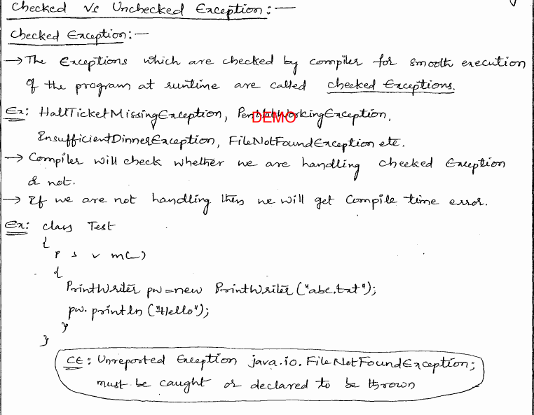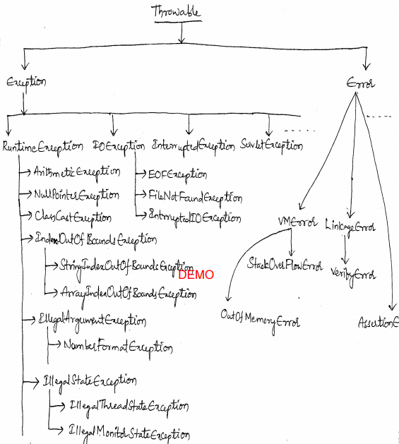

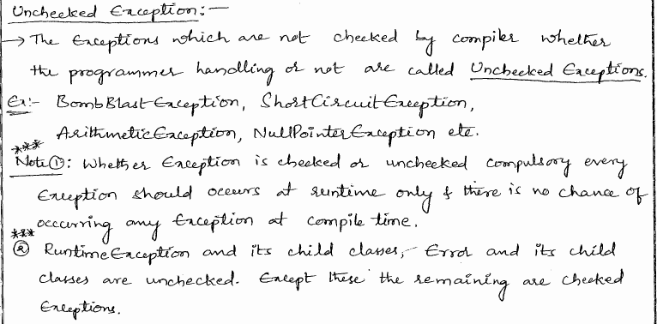

## 2 Diff b/w throw and throws







## 3 Multi-Catch Block?

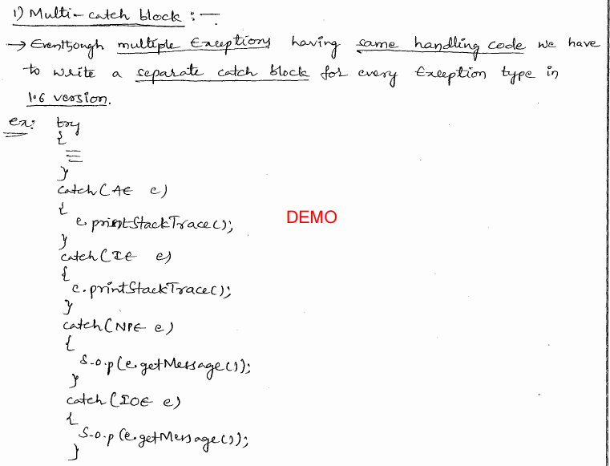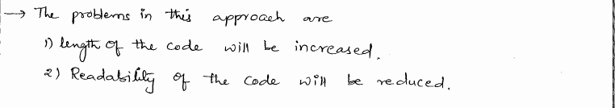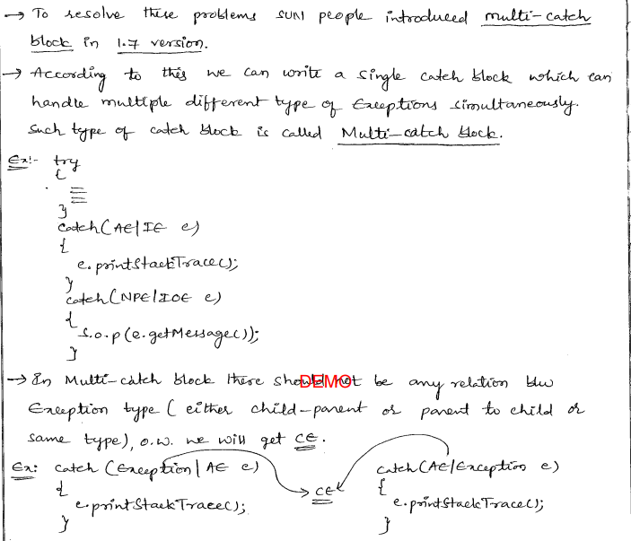

## 4 Try with resource?

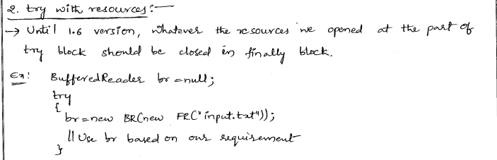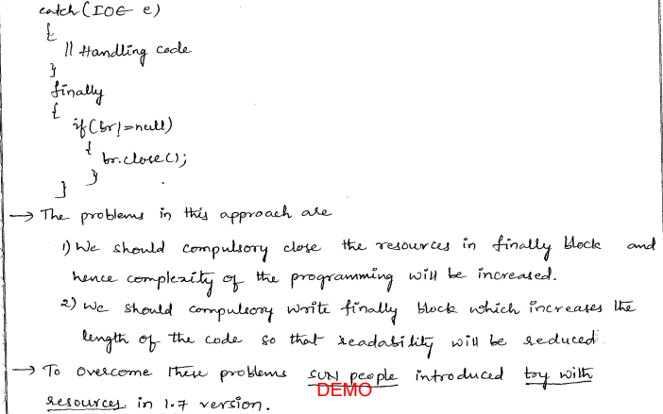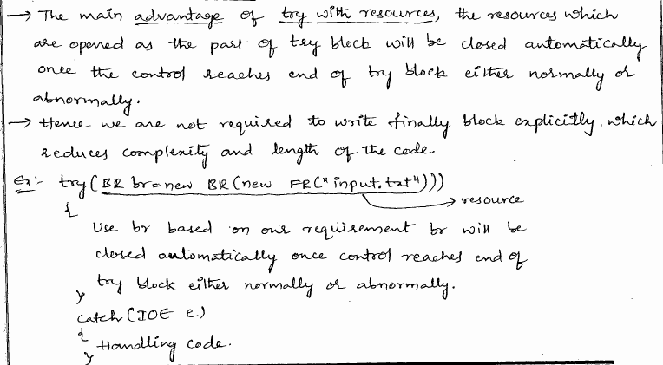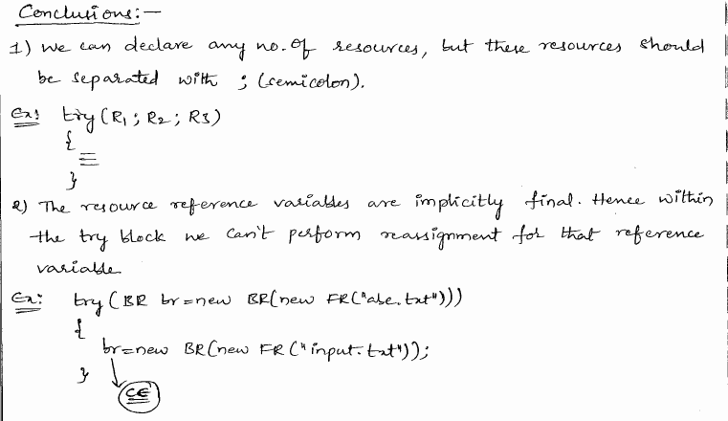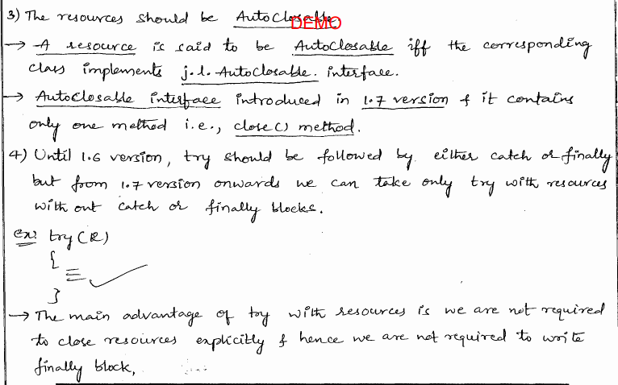

## 5 Diff b/w Exception and Error.

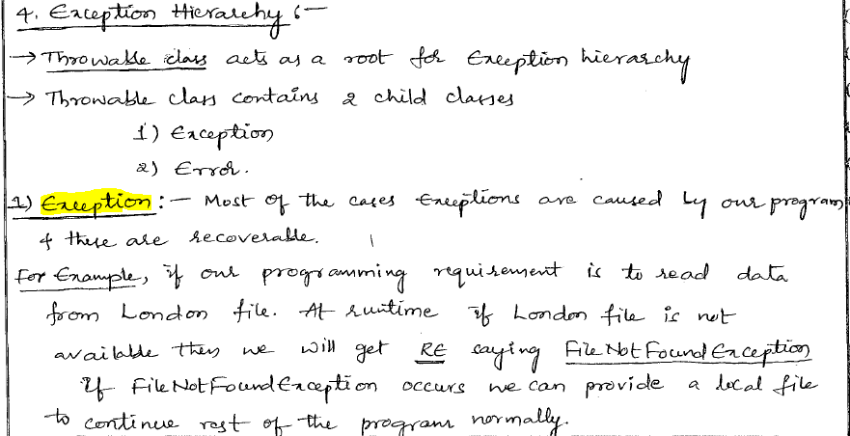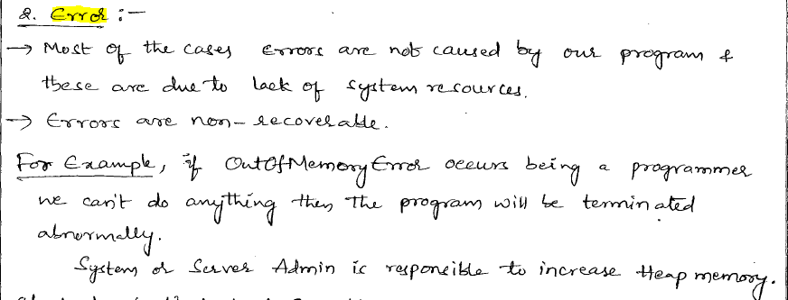

## 6 Exception Handling Keywords Summary?

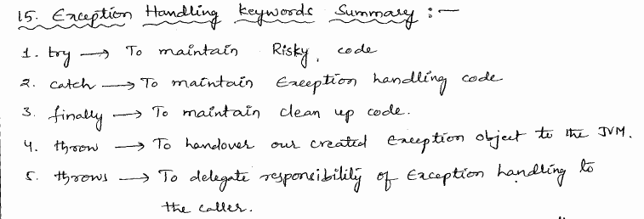

## 7 Top 10 Exceptions?

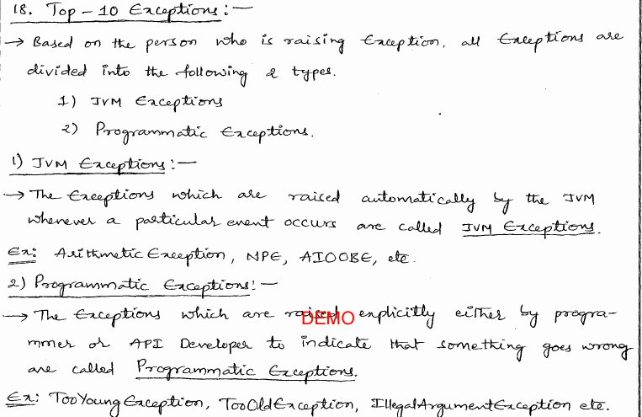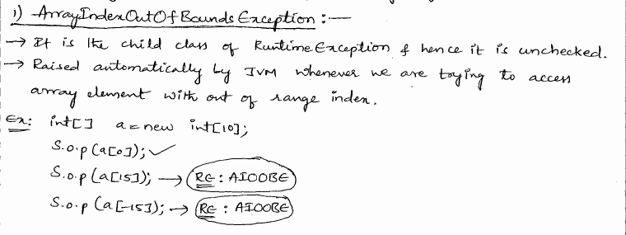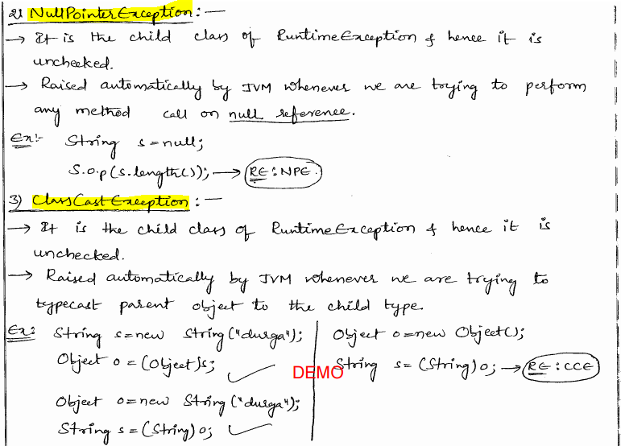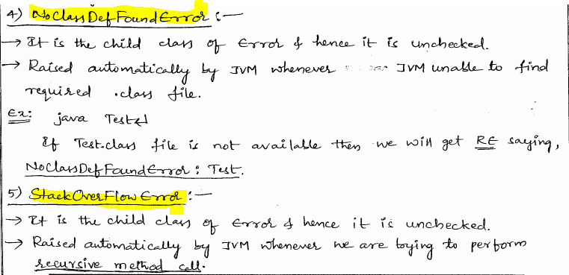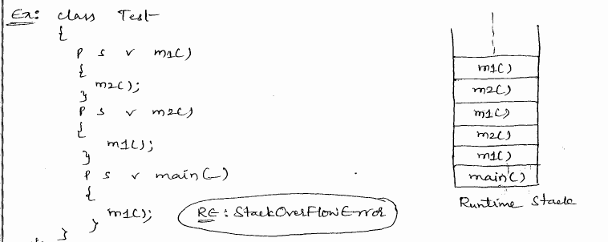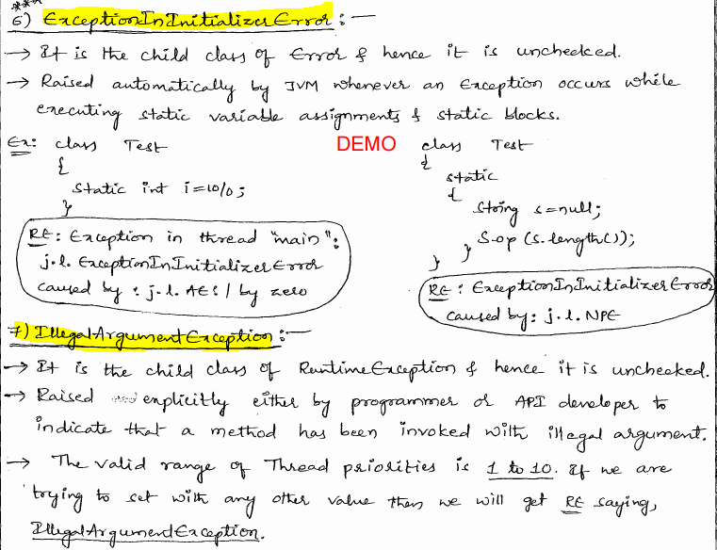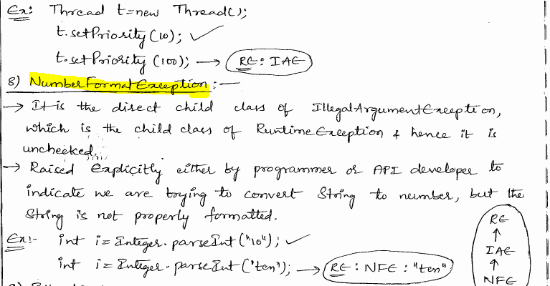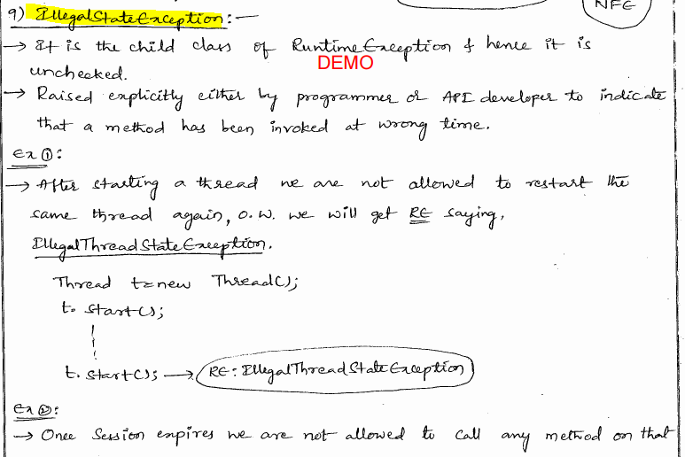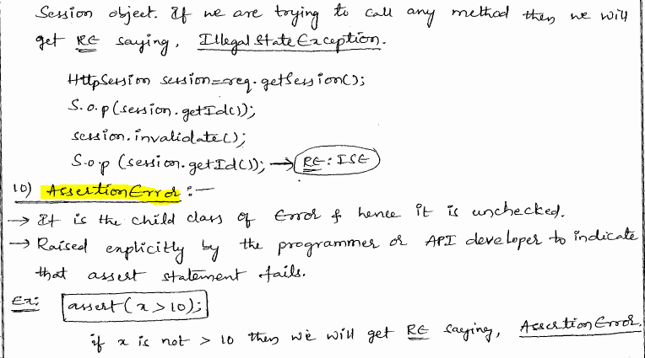

## 8 Exception/Error and Raised by?

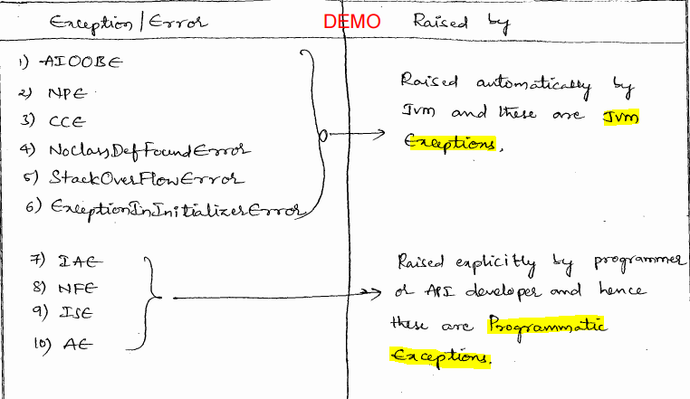

## How Can I Catch All Possible Exceptions in Java?

All exceptions come from the "mother class" called java.lang.Throwable and one of two subclasses called java.lang.Error and java.lang.Exception. A block of code that is executed when an exception occurs is called an Exception handler. By catching java.lang.Throwable, it is possible to handle all unexpected conditions.

...

try {

}

catch(Throwable e) {

...

}

...

There are some special exceptions that used by the JVM, those are the sub-classes of java.lang.Error. We are not suppose the catch them in our real code and we usually catch java.lang.Exception for all application and runtime exceptions.

...

try {

}

catch(Exception e) {

...

}

...

## How differently does Java handle checked and unchecked exceptions?

* If a method may throw checked exceptions, the calling code must handle the exception by either catching it or by declaring in the signature of the method (as throws). Unchecked exceptions do not have to be handled by the calling code.
* If a method might throw a checked exception, it must be declared in the signature of the method. Unchecked exceptions do not have to be listed in the method signature.

## What can you catch when try block does not throw exception?

Let's take a look at the following code:

class Program {

  public static void main(String[] args) {

    try {

      method();

    }

    catch (FileNotFoundException e) {

          ;

    }

  }

  static void method() {

  }

}

The above code will generate a compile-time error: "Unreachable catch block ....".  
But the following code does not generate a compile time error:

class Program {

  public static void main(String[] args) {

    try {

      method();

    }

    catch (Exception e) {

          ;

    }

  }

  static void method() {

  }

}

The Java compiler does not require you to catch an unchecked exception. If you do catch an unchecked exception even the code does not throwing it, the compiler will not generate a compile-time error. The unchecked exceptions have the benefit of not forcing the client code to explicitly deal with them.  
The *RuntimeException* and its subclasses are unchecked exceptions. *Error* and its subclasses are also unchecked exceptions. The *RuntimeException* is the subclass of *Exception*, Therefore, catching the *Exception* exception without throwing any exceptions in try block will not generate comiple-time error.  
Summary for try-catch without throw exception:

* Catching *Throwable*, *Error (including its subclasses)*, *Exception*, and *RuntimeException (including its subclasses)*always compile.
* Catching directly subclasses of *Throwable* except for *Exception* and *Error* will generate a compile time error.
* Catching subclasses of *Exception* except for *RuntimeException* will generate a compile time error

# String:[C]

## 1 Diff b/w String,StringBuffer and StringBuilder?



## 2 Can you write Immutable class in java?



## 3 Diff b/w == operator and .equals(-) method?

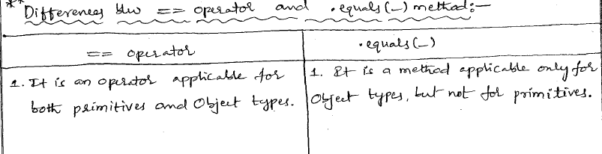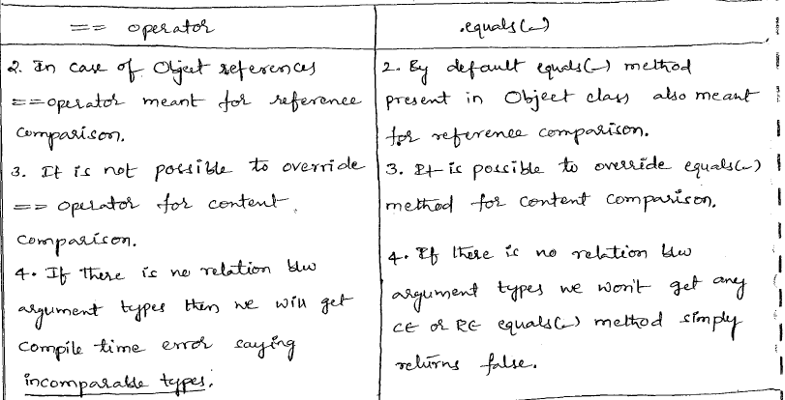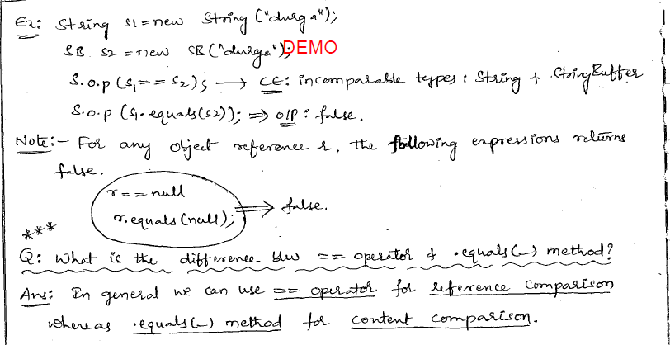

## 4 Diff b/w String and StringBuffer?

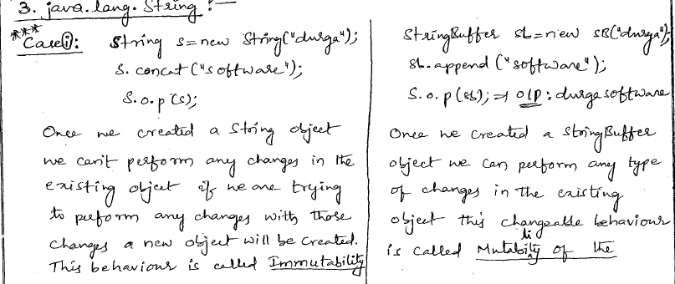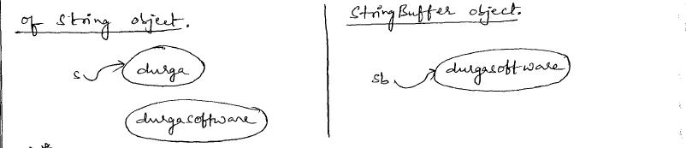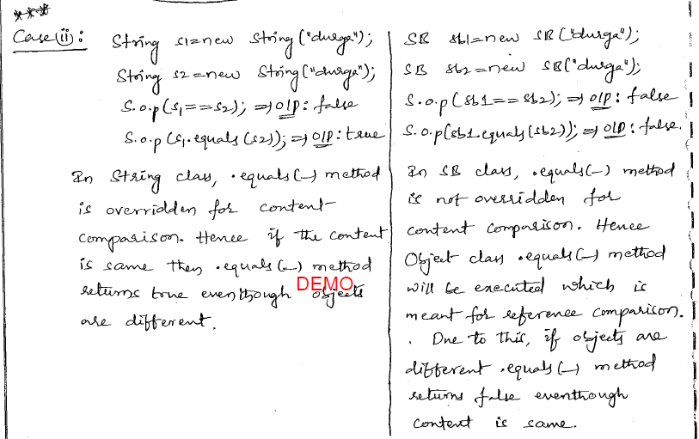

## 5 Why String objects are immutable? where as StringBuffer objects are mutable?

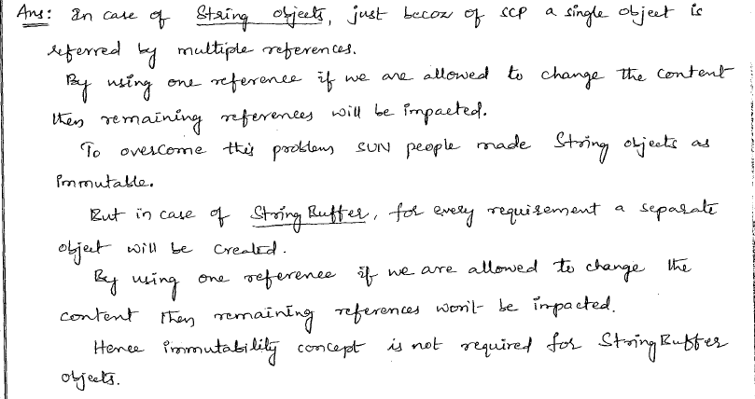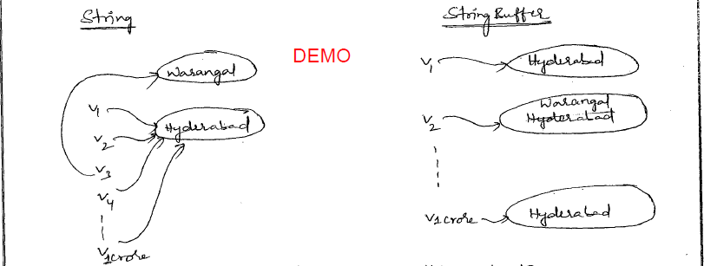

## 6 final means non-changeable where as immutable means non-changeable then what is the difference b/w final & immutable?

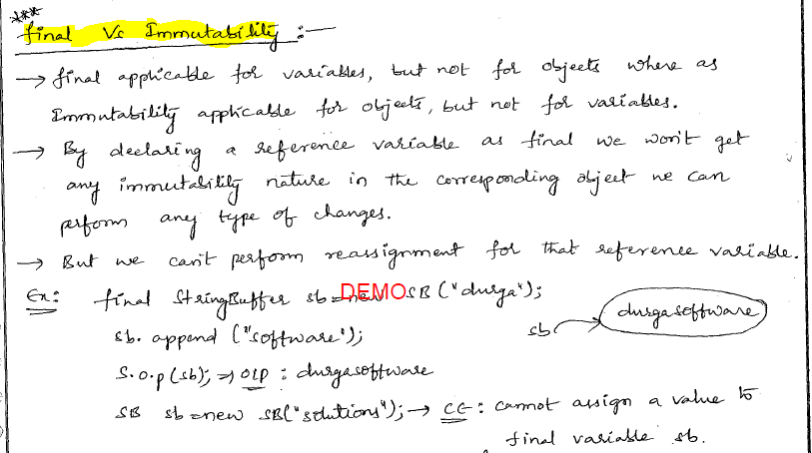

## 7 Diff b/w StringBuffer and StringBuilder?

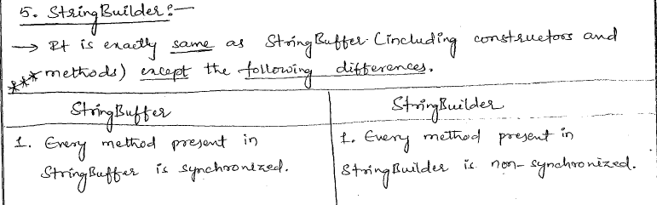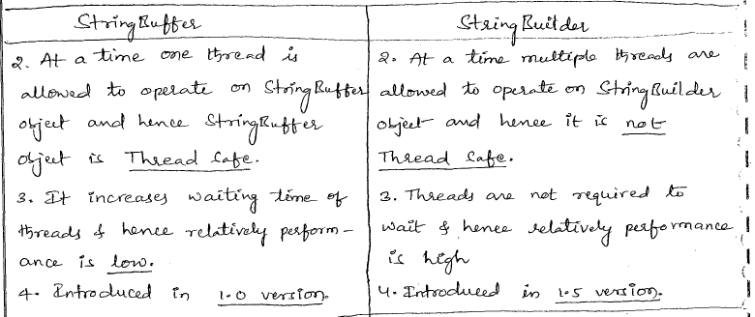

## 8 Dancing b/w Wrapper object, primitive and String?

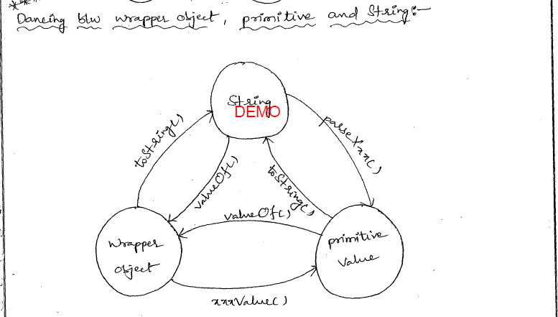

## How does the result differ between the String and number operands of the '+' operator?

Let's take a look at the following example,

class Program {

  public static void main(String[] args) {

    System.out.println(1 + 2 + " fiddlers");

    System.out.println("fiddlers " + 1 + 2);

  }

}

The output is:

3 fiddlers

fiddlers 12

The + operator is syntactically left-associative, the expression a + b + c is always regarded as (a + b) + c. The type analysis to represent string concatenation or addition is based on the evaluation order.  
In the 1 + 2 + " fiddlers", the first two are int, so the result is 3. Then since the next operand is a String object, 3 is converted to String and "fiddlers" is concatenated to 3, so the result is "3 fidders".  
In the "fiddlers " + 1 + 2, since the first operand is a String, the rest of the operands are converted to String then concatenated to it, so the result is "fiddlers 12".

## What are mutable objects and immutable objects?

An Immutable object is a kind of object whose state cannot be modified after it is created. This is as opposed to a mutable object, which can be modified after it is created.  
In Java, objects are referred by references. If an object is known to be immutable, the object reference can be shared. For example, *Boolean*, *Byte*, *Character*, *Double*, *Float*, *Integer*, *Long*, *Short*, and *String* are immutable classes in Java, but the class *StringBuffer* is a mutable object in addition to the immutable *String*.

class Program {

  public static void main(String[] args) {

    String str = "HELLO";

    System.out.println(str);

    str.toLower();

    System.out.println(str);

  }

}

The output result is

HELLO

HELLO

From the above example, the toLower() method does not impact on the original content in *str*. What happens is that a new String object "hello" is constructed. The toLower() method returns the new constructed String object's reference. Let's modify the above code:

class Program {

  public static void main(String[] args) {

    String str = "HELLO";

    System.out.println(str);

    String str1 = str.toLower();

    System.out.println(str1);

  }

}

The output result is

HELLO

hello

The *str1* references a new String object that contains "hello". The String object's method never affects the data the String object contains, excluding the constructor.  
In Effective Java, Joshua Bloch makes this recommendation: "Classes should be immutable unless there's a very good reason to make them mutable....If a class cannot be made immutable, you should still limit its mutability as much as possible."  
What are the guidelines to implement immutable object? Please visit [Immutable Object](http://wiki.java.net/bin/view/Javapedia/ImmutableObject).

### Immutable Object

Objects have identity (location in memory), state (data), and behavior (methods). Once constructed, an Immutable Object cannot change state.   
Immutable objects greatly simplify your program, since they 

* are simple to construct, test, and use
* are automatically thread-safe and have no synchronization issues
* do not need a copy constructor
* do not need an implementation of clone
* do not need to be copied defensively when used as a field
* make good Map keys and Set elements (these objects must not change state while in the collection)
* [Immutable Objects](http://wiki.java.net/bin/view/Javapedia/ImmutableObject) are often also [ValueObjects](http://wiki.java.net/bin/view/Javapedia/ValueObject), e.g. when used as Map keys

Make a class immutable by following these guidelines : 

* always put all data in the constructor, instead of using a no-argument constructor combined with subsequent calls to setXXX methods
* do not provide any methods which can change the state of the object in any way - not just setXXX methods, but any method which can change state
* ensure no methods can be overridden - make the class final, or use static factories and keep constructors private
* make fields final
* if a mutable object field's state is "owned" by the native class, such that no other class is to be allowed to change the state of the field, then when the field "crosses the interface" (as in a get method, when the field is returned to the user, or in the constructor itself), then a defensive copy must be made, in order to maintain encapsulation.
* if a mutable object field's state is not "owned" by the native class, then defensive copies of the object field are not necessary

Example

import java.util.Date;

/**

* Planet is an immutable class, since there is no way to change

* its state after construction.

*/

public final class Planet {

  /**

  * Primitive data is always immutable.

  */

  private final double mass;

  /**

  * An immutable object field. (String objects never change state.)

  */

  private final String name;

  /**

  * A mutable object field. In this case, the state of this mutable field

  * is to be changed only by this class. (In other cases, it makes perfect

  * sense to allow the state of a field to be changed outside the native

  * class; this is the case when a field acts as a "pointer" to an object

  * created elsewhere.)

  */

  private final Date dateOfDiscovery;

  /** Sole constructor */

  public Planet (double mass, String name, Date dateOfDiscovery) {

     this.mass = mass;

     this.name = name;

     //make a private copy of dateOfDiscovery

     //this is the only way to keep the dateOfDiscovery

     //field private, and shields this class from any changes

     //to the original dateOfDiscovery object

     this.dateOfDiscovery = new Date(dateOfDiscovery.getTime());

  }

  //gets but no sets, and no methods which change state

  public double getMass() {

    return mass;

  }

  public String getName() {

    return name;

  }

  /**

  * Returns a defensive copy of the field.

  * The caller of this method can do anything they want with the

  * returned Date object, without affecting the internals of this

  * class in any way.

  */

  public Date getDateOfDiscovery() {

    return new Date(dateOfDiscovery.getTime());

  }

}

## StringBuffer,StringBuilder



What is the difference between StringBuffer and StringBuilder?

String is ***immutable*** version, where as StringBuffer and StringBuilder they are the ***mutable*** versions.

Let me define what is immutable and mutable?

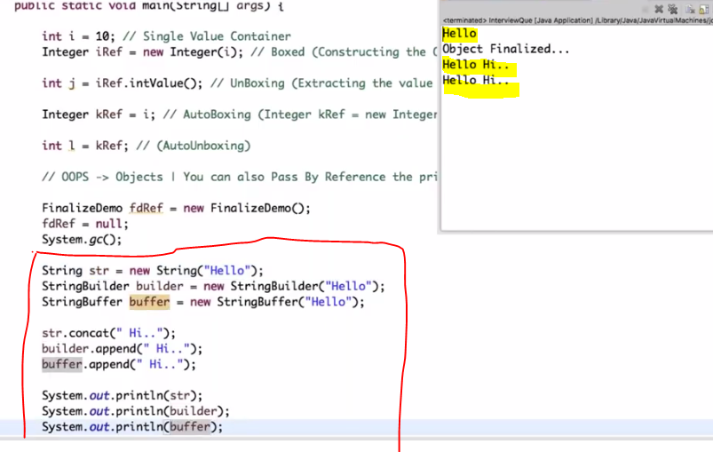if you notice that you seen one major difference over here you get

Hello, so nothing happens when you concat data into **str** . right? But in case of **builder** and **buffer** the data is concatenated. This is why because Strings are *immutable*, whereas buffer and builder are *mutable*.

* StringBuffer operations are thread-safe, so it means that by default when you are going to use buffer it will be synchronized, you need not to worry on top of multiple or concurrent threading now, whereas StringBuilder it is not thread-safe,
* StringBuffer is to be used when multiple threads are going to work on the same string whereas

StringBuilder is supposed to be single threaded environment

* Otherthan that StringBuilder is quite better as compared to StringBuffer over the performance part, because there is no synchronization overhead.

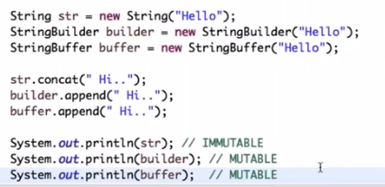

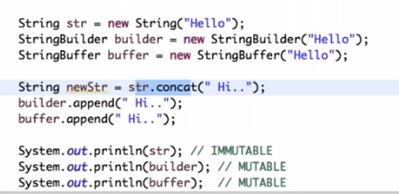

## Other than string what all are immutable classes.

## How to Use StringTokenizer in Java?

The string tokenizer class allows an application to break a string into tokens. A token is returned by taking a substring of the string that was used to create the StringTokenizer object. There are three ways to construct a StringTokenizer.

public class Program {

    public static void main(String[] args) {

        System.out.println("Case 1.");

        StringTokenizer st = new StringTokenizer("this is a test");

        while (st.hasMoreTokens()) {

            System.out.println(st.nextToken());

        }

        System.out.println("Case 2.");

        st = new StringTokenizer("this,is a=test", " ,=");

        while (st.hasMoreTokens()) {

            System.out.println(st.nextToken());

        }

        System.out.println("Case 3.");

        st = new StringTokenizer("this,is a=test", " ,=", true);

        while (st.hasMoreTokens()) {

            System.out.println(st.nextToken());

        }

        System.out.println("Case 4.");

        st = new StringTokenizer("this,is a=test", " ,=", false);

        while (st.hasMoreTokens()) {

            System.out.println(st.nextToken());

        }

    }

}

The output is

Case 1.

this

is

a

test

Case 2.

this

is

a

test

Case 3.

this

,

is

a

=

test

Case 4.

this

is

a

test

StringTokenizer is pretty straight forward. You can separate a String by any delimiters that you choose such as a blank space, or a comma. Once you create a StringTokenizer object with a String, like above example. You can call nextToken() to get the next block of String (token).

# Multithreading:[C]

## 1 Why we use synchronization?

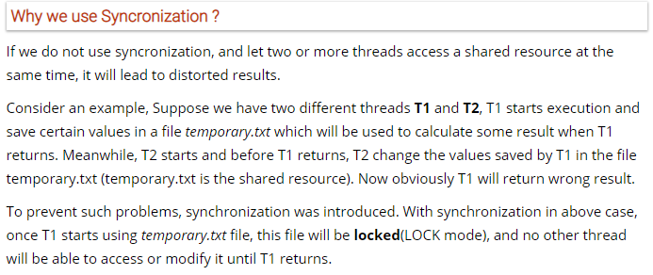

## 1_2 synchronized block?

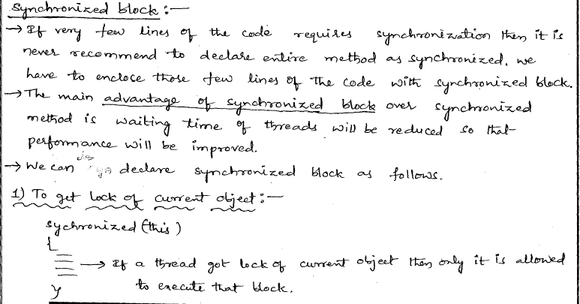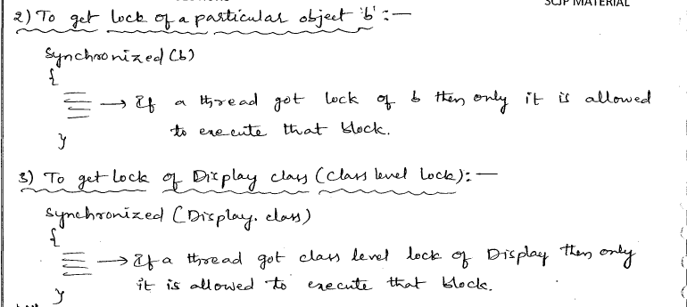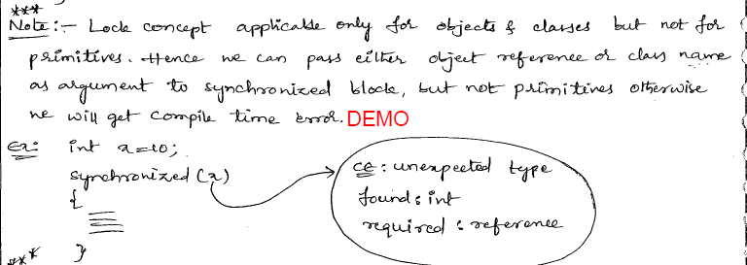

## 1_3 Which is more preferred - synchronized method or synchronized block?

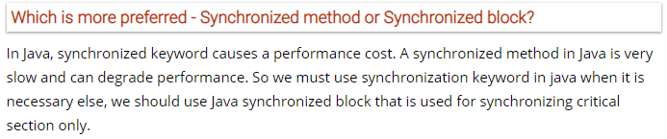

## 2 Diff b/w sleep(),wait()?

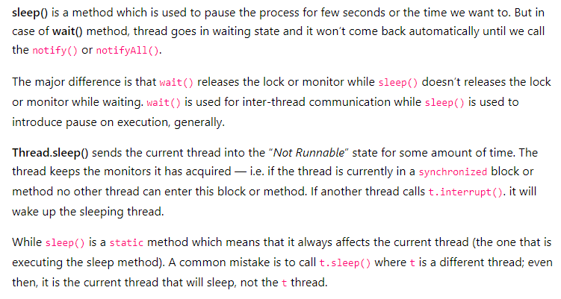

## 2_2 Diff b/w notify() and notifyAll() method?

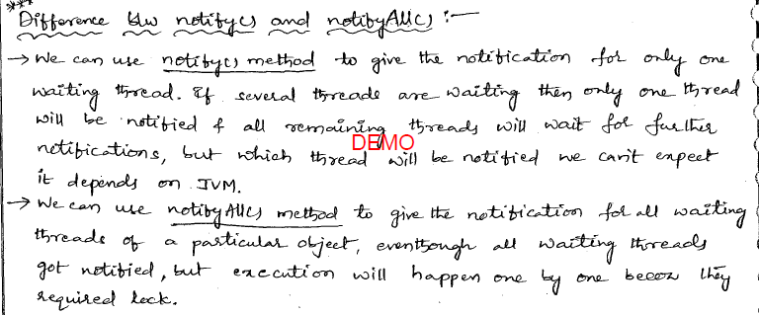

## 3 Callable and Future in Java

The Callable object returns a Future object which provides methods to monitor the progress of a task being executed by a thread. The future object can be used to check the status of a Callable and then retrieve the result from the Callable once the thread is done. It also provides timeout functionality.

#### Syntax

//submit the callable using ThreadExecutor

//and get the result as a Future object

Future<Long> result10 = executor.submit(new FactorialService(10));

//get the result using get method of the Future object

//get method waits till the thread execution and then return the result of the execution.

Long factorial10 = result10.get();

## Special Note: for interview not required==========

Refer 1 to 5 only for this movment.

## Why Synchronization? If to achieve these things without using Synchronization? Lock and InterantLock?

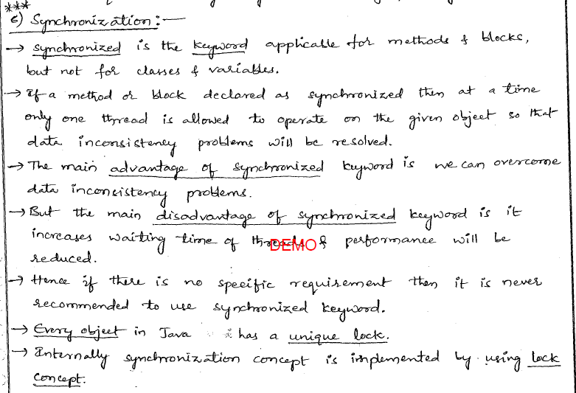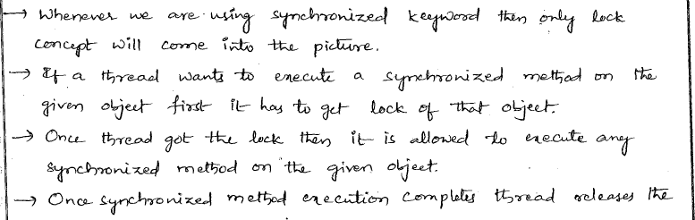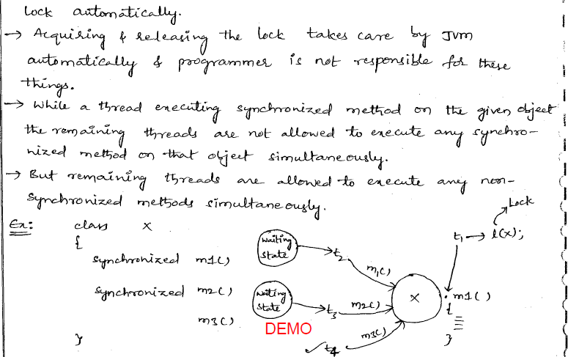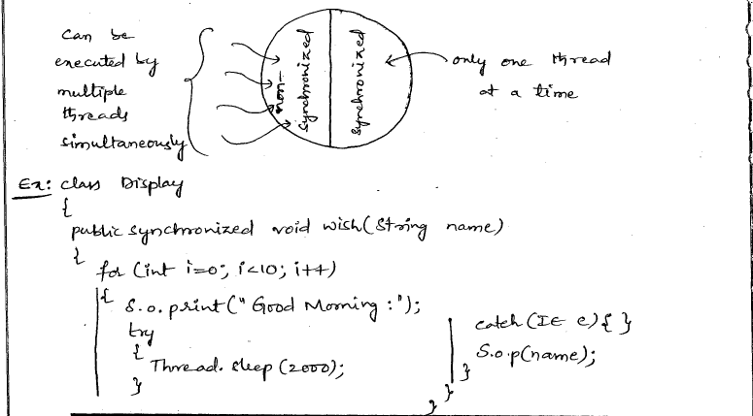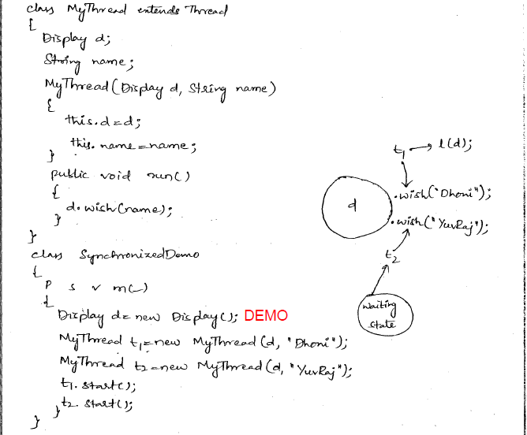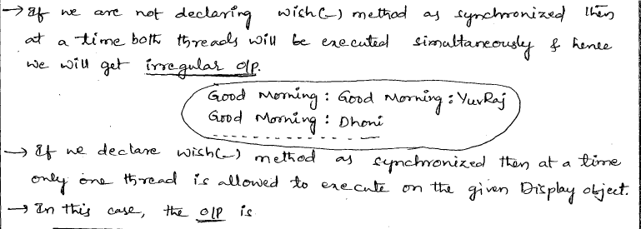

Conclusion point:

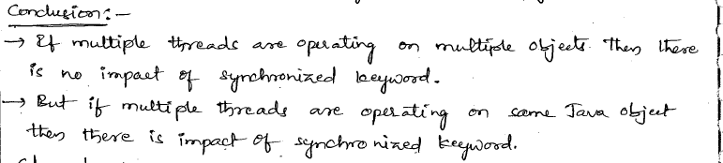

## Lock concept applicable?

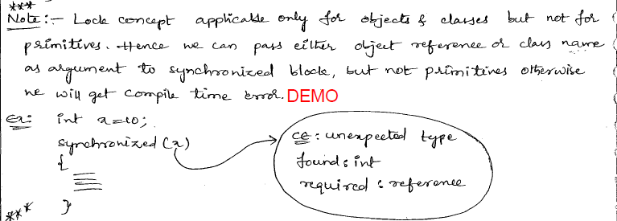

## What is synchronized? and where we can apply?

Synchronization is the process of allowing threads to execute one after another.

Synchronization control the access the multiple threads to a shared resources. Without synchronization of threads, one thread can modify a shared variable while another thread can update the same shared variable, which leads to significant errors.

### What is synchronization and why is it important?

Java supports multiple threads to be executed. This may cause two or more threads to access the same fields or objects. Synchronization is a process which keeps all concurrent threads in execution to be in synch. Synchronization avoids memory consistence errors caused due to inconsistent view of shared memory. When a method is declared as synchronized; the thread holds the monitor for that method's object If another thread is executing the synchronized method, your thread is blocked until that thread releases the monitor.

### Explain the use of synchronization keyword.

When a method in Java needs to be synchronized, the keyword synchronized should be added.

**Example:**

public synchronized void bookMovieTicket() or bookTrainTicket() or bookFlightTicket()

{

//Movie,Train,Flight Ticket booking logic

}

Synchronization does not allow invocation of this Synchronized method for the same object until the first thread is done with the object. Synchronization allows having control over the data in the class.

## Why we need Synchronization in java?

If your code is executing in a multi-threaded environment, you need **syn**chronization for objects**,** which are shared among multiple threads, to avoid any corruption of state or any kind of unexpected behavior. Synchronization in Java will only be needed if shared object is mutable. if your shared object is either read-only or[immutable object](http://javarevisited.blogspot.com/2013/03/how-to-create-immutable-class-object-java-example-tutorial.html), then you don't need synchronization, despite running multiple threads. Same is true with what threads are doing with an object if all the threads are only reading value then you don't require synchronization in Java. JVM guarantees that ***Java synchronized code will only be executed by one thread at a time***.

In Summary, Java synchronized Keyword provides following functionality essential for concurrent programming:

1) The synchronized keyword in Java provides locking, which ensures mutually exclusive access to the shared resource and prevents data race.

2) synchronized keyword also prevent reordering of code statement by the compiler which can cause a subtle concurrent issue if we don't use synchronized or volatile keyword.

3) synchronized keyword involve locking and unlocking. before entering into **synchronized method or block** thread needs to acquire the lock, at this point it reads data from main memory than cache and when it release the lock, it flushes write operation into main memory which eliminates memory inconsistency errors.

## Why we use synchronization?



## Diff b/w synchronized keyword and synchronized block?

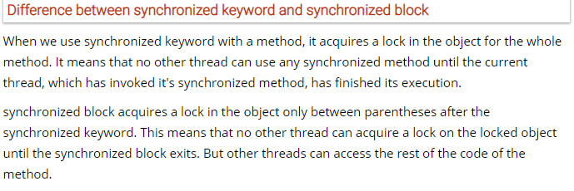

## How many ways we can create Thread? In which situation which one you preferred?

There are two ways

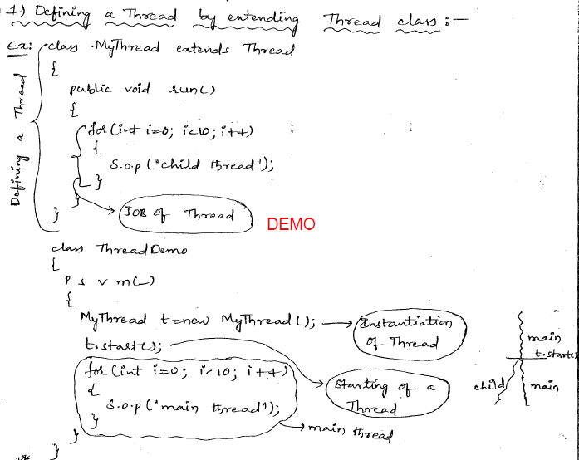



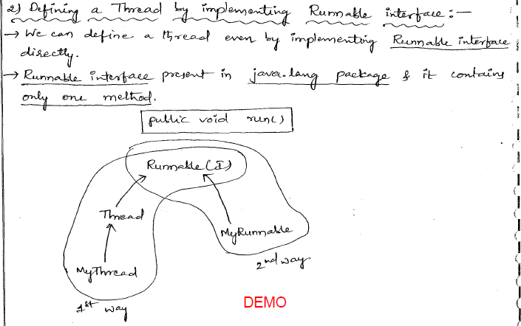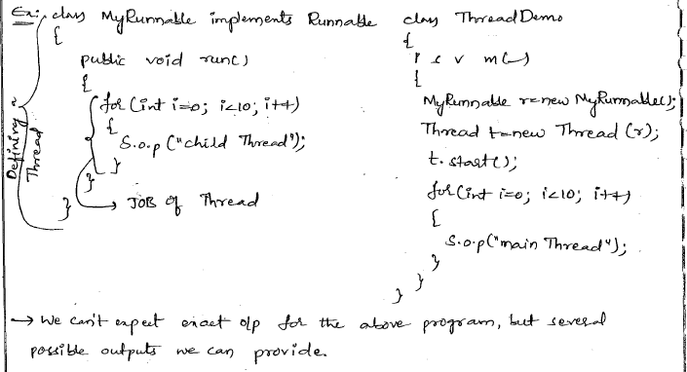

## Recommended way to define Thread?

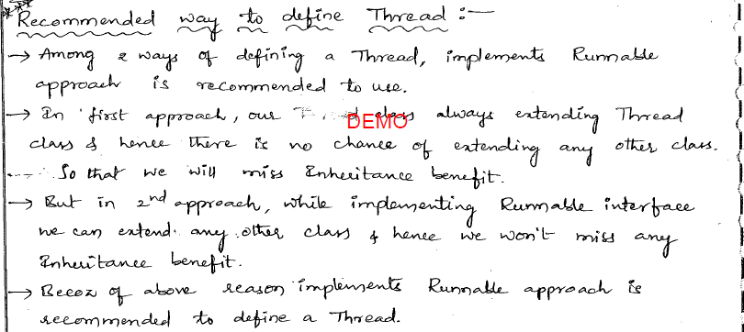

## Diff b/w start() and run()?

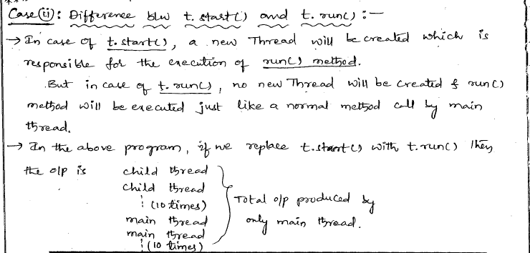

## Diff b/w yield(),sleep(),join()?

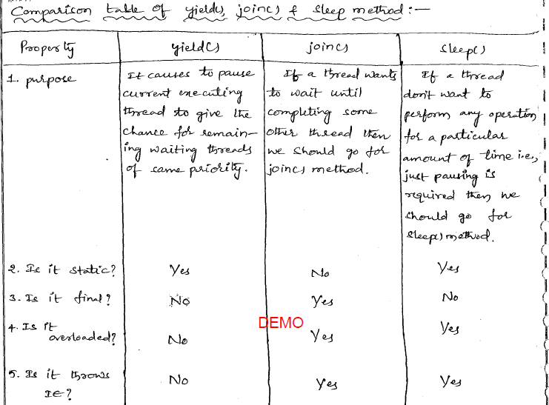

## Interthread communication?

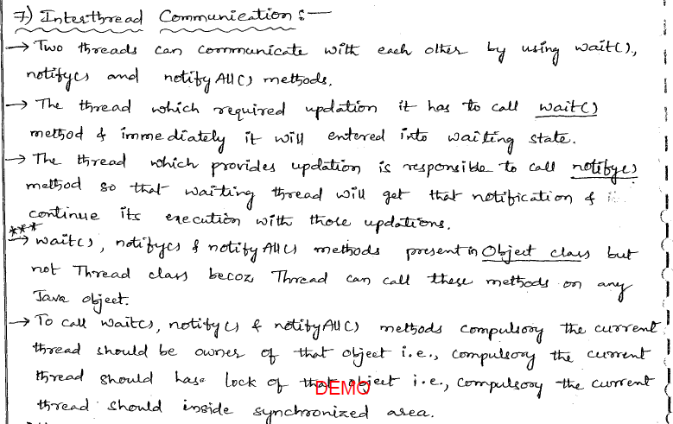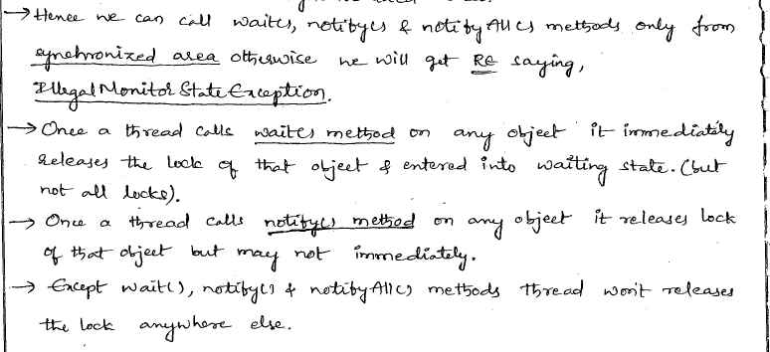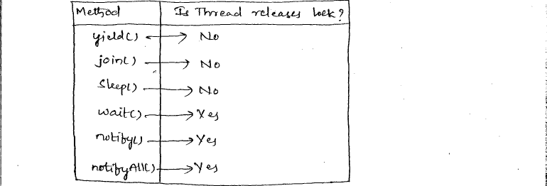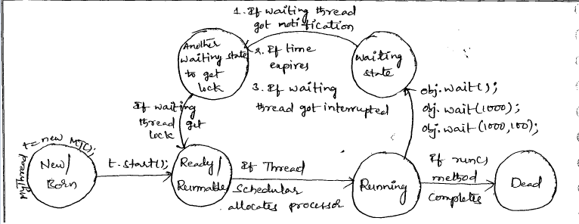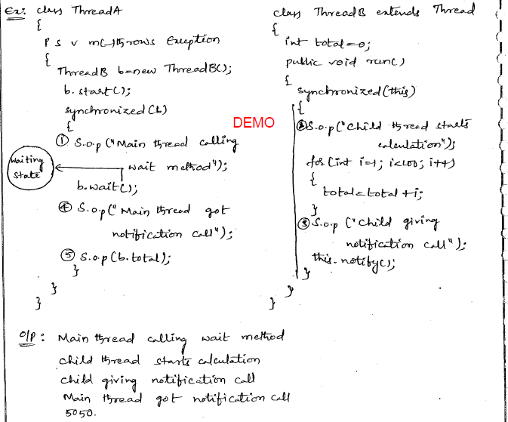

## Diff b/w sleep(),wait()?



## Diff b/w notify() and notifyAll() method?



## Producer Consumer Problem?

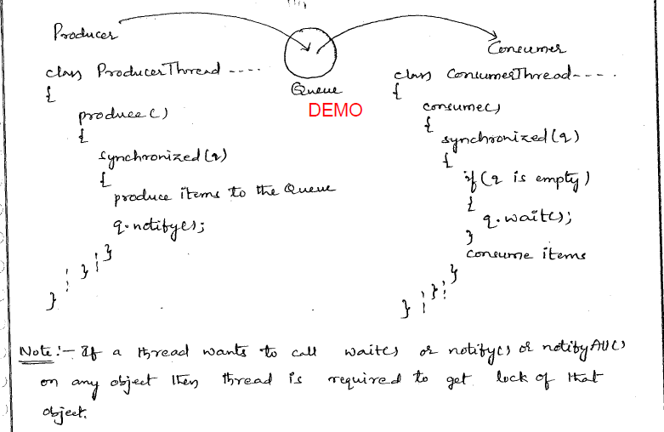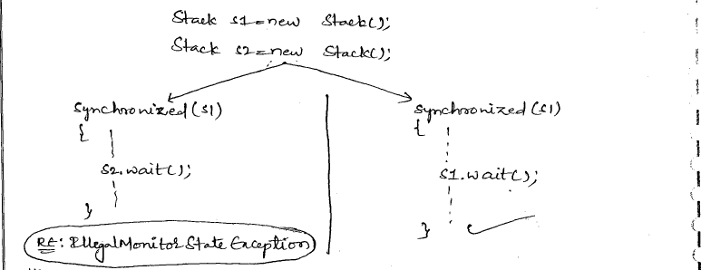

## Thread Scheduler:

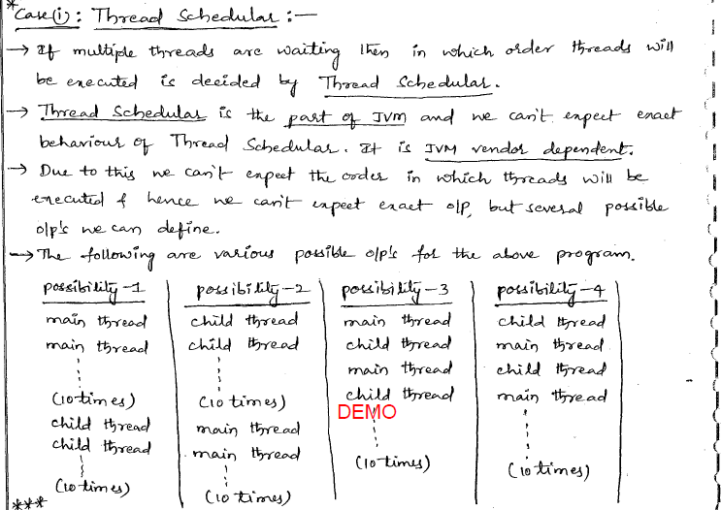

## Diff b/w t.start() and t.run() method?

## Importance of Thread class start() method?

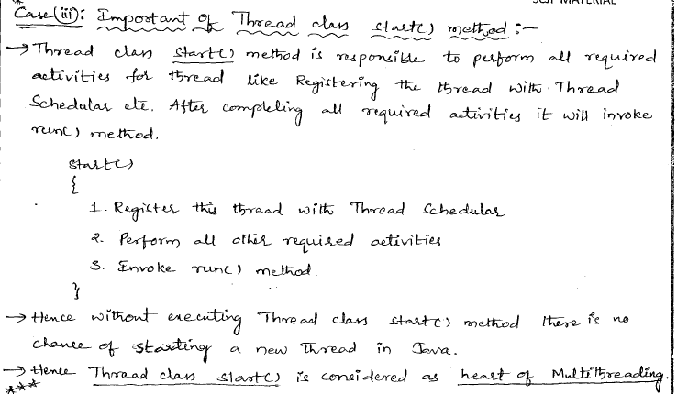

## Overloading of run() method?

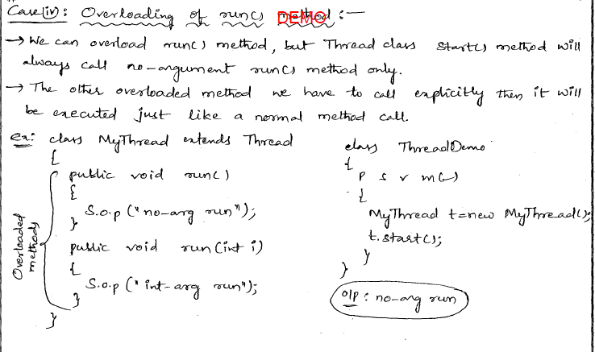

## Life cycle of Thread?

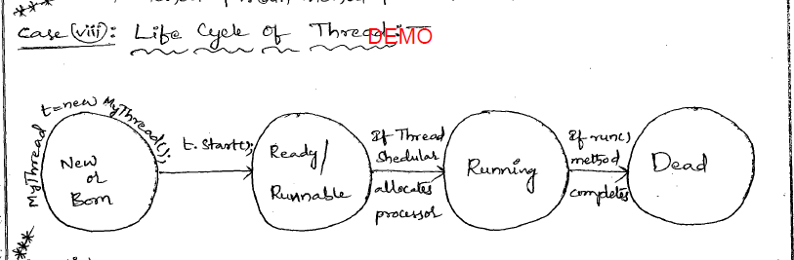

## IllegalThreadStateException when we are getting?

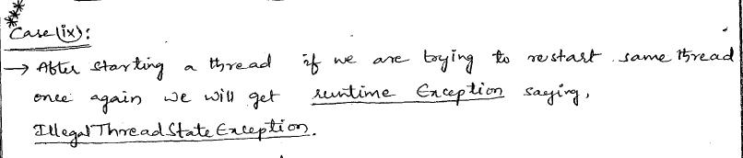

## Default Priority of a thread?

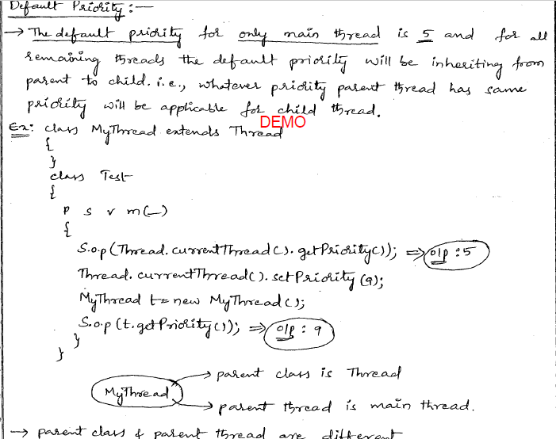

## interrupt() method?

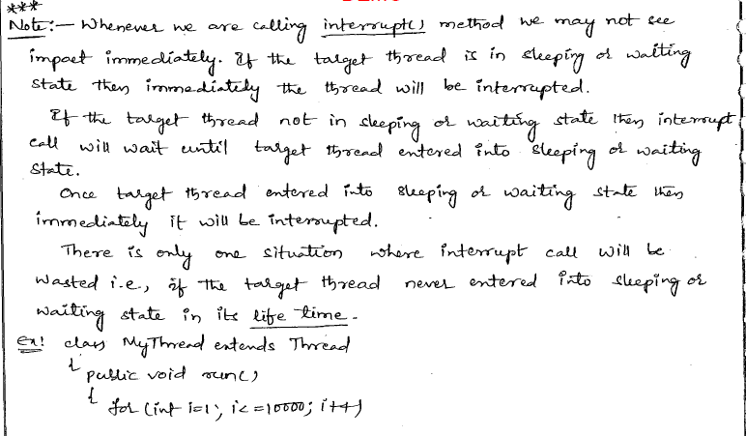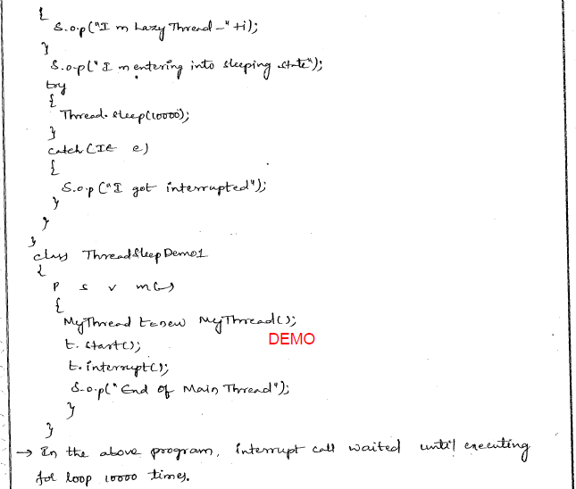

## Comparision b/w yield(),join() & sleep() method?

## Default Nature of thread?

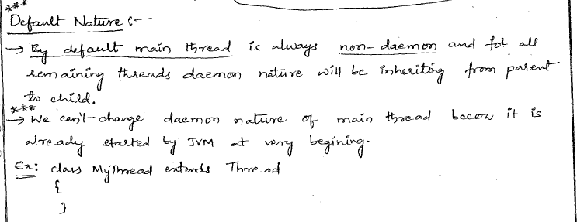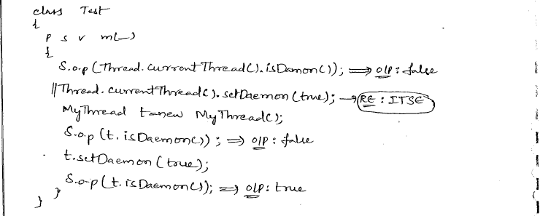

## ThreadLocal?

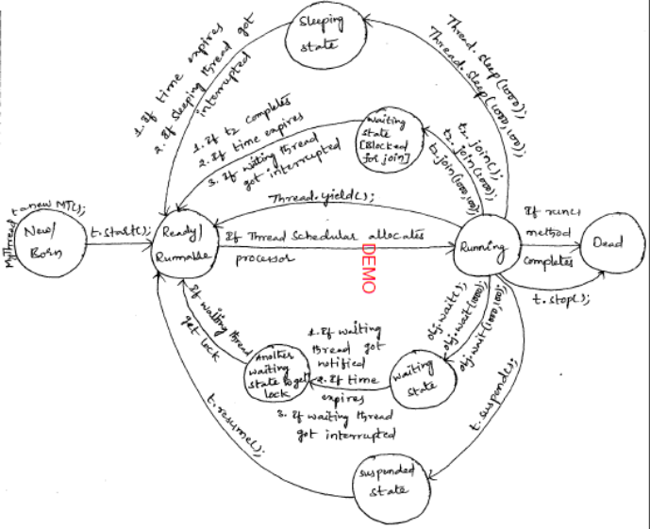

## Class Level Lock?

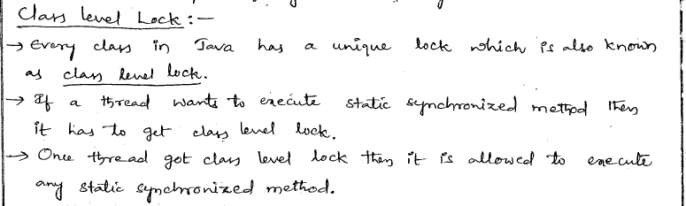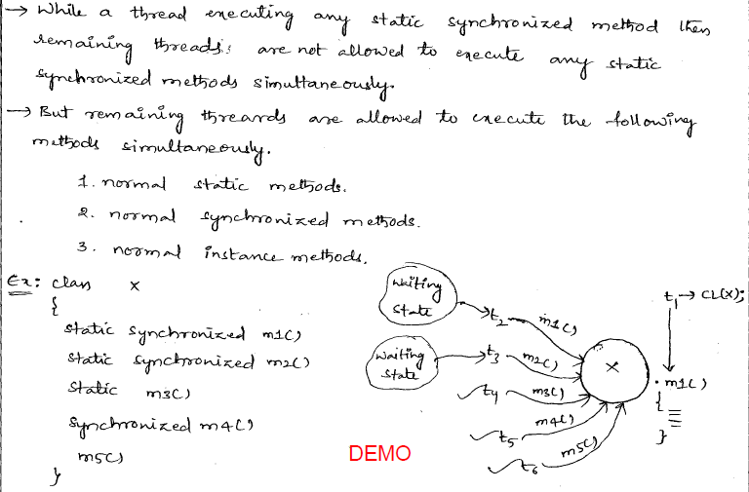

## How to use the synchronized keyword?

There are two syntactic forms based on the synchronized keyword, methods and blocks. A synchronized method acquires a lock before it executes. For example, the following synchronized method

class MyClass {

   public synchronized void function() {

          ....

   }

}

is equivalent to the following synchronized block

class MyClass {

   public void function() {

        synchronized(this) {

          ....

        }

   }

}

Few notes about *synchronized* keyword:

* The constructors and initializers cannot be synchronized and a compiler error will occur if you put *synchronized* front of a constructor. But constructors and initializers of a class can contain synchronized blocks. For example,

class MyClass {

 static int x = 0;

 static int y = 0;

   {

        synchronized (MyClass.class) {

          x++;

        }

   }

   public MyClass() {

        synchronized(MyClass.class) {

          y++;

        }

   }

}

* Although the synchronized keyword can appear in a method header, the synchronized keyword is not part of the method signature. Therefore, it is not automatically inherited when subclasses override superclass methods. The synchronized methods can be overrided  to be non-synchronous. The synchronized instance methods in subclasses use the same locks as their superclasses.
* The interface's methods cannot be declared synchronized. The Synchronization is part of the implementation but not part of the interface.
* The synchronization of an Inner Class is independent on it's outer class. That means locks on inner/outer objects are independent. Getting a lock on outer object doesn??t mean getting the lock on an inner object as well, that lock should be obtained separately
* A non-static inner class method can lock it's containing class by using a synchronized block. The inner class can reference the outer class with *OuterClass.this*:

    synchronized(OuterClass.this) {

        ....

    }

## What are the differences between synchronized method and synchronized block (statement)?

The synchronization is the capability to control the access of multiple threads to shared resources. Without synchronization, it is possible for one thread to modify a shared resource while another thread is in the process of using or updating that resource.  
There two-synchronization syntax in Java Language. The practical differences are in controlling scope and the monitor. With a synchronized method, the lock is obtained for the duration of the entire method. With synchronized blocks you can specify exactly when the lock is needed.  
Basically, synchronized blocks are more general, and synchronized methods can be rewritten to use synchronized blocks:

class Program {

  public **synchronized** void f() {

   .........

  }

}

is equivalent to

class Program {

  public void f() {

**synchronized(this){**

**...**

**}**

  }

}

For example, You have a method with some parts that need synchronized and others don't. The synchronized block lets you synchronize only the partial line codes that really need it.

public class Program {

  private static Object locker1 = new Object();

  private static Object locker1 = new Object();

  public void doSomething1() {

    ...

    synchronized(locker1) {

      ......... //do something protected;

    }

    ....

  }

  public void doSomething2() {

    ...

    synchronized(locker2) {

      ......... //do something protected;

    }

    ....

  }

}

The synchronized block can only be executed after a thread has acquired the lock for the object or class referenced, for example the "locker1" or "locker2" in above code, in the synchronized statement.  
The above code shows that synchronized block can be holding different object monitors. Maybe it's necessary to protect doSomething1() method and doSomething2() method from multiple threads, but it's fine if one thread is in the doSomething1() method and another is in the doSomething2() method. But the synchronized method can not do it.  
A synchronized method synchronizes on the object instance or the class. A thread only executes a synchronized method after it has acquired the lock for the method's object or class.

* *static* synchronized methods synchronize on the class object. If one thread is executing a static synchronized method, all other threads trying to execute any static synchronized methods, in the same class, will block.
* *non-static* synchronized methods synchronize on "this" (the instance object). If one thread is executing a synchronized method, all other threads trying to execute any synchronized methods, in the same class, will block.

These are very public monitors, meaning some other thread could synchronize on them for the wrong reason, leading to slowdowns or deadlocks.

## Why wait(), notify(), notifyAll() must be called inside a synchronized method/block?

In Java, any object can act as a **monitor** - that's an entity with a *single lock*, an *entry queue*, and a *waiting queue*. An object's method without qualifed by the keyword *synchronized*  can be invoked by any number of  threads at any time, the *lock* is ignored. The *synchronized* method of an object, *one and only one* thread, who owns the *lock* of that object, can be permitted to run that method at any time;i.e. a *synchronized* method is *mutually exclusive* . If, at the time of invocation, another thread owns the *lock*, then the calling thread will be put in the Blocked state and is added to the *entry queue*.  
The *wait()*, *notify()*, and *notifyAll()* methods should be called for an object only when the current thread has already locked the object's **lock**. This point sometimes goes unnoticed because programmers are used to calling these methods from within *synchronized* methods or blocks. Otherwise, you will get "java.lang.IllegalMonitorStateException: current thread not owner" at runtime.  
When a thread running in a *synchronized* method of an object is calling the *wait()* method of the *same* object, that thread releases the *lock* of the object and is added to that object's *waiting queue*. As long as it's there, it sits idle. Note also that *wait()* forces the *thread* to release its *lock*. This means that it **must own** the *lock* of an object before calling the *wait()*method of that (same) object. Hence the *thread* must be in one of the object's *synchronized* methods or *synchronized block* before calling *wait()*.  
When a thread invokes an object's *notify()* or *notifyAll()* method, one (an arbitrary thread) or all of the threads in its *waiting queue* are removed from the *waiting queue* to the *entry queue*. They then actively contend for the object's *lock*, and the one that gets the *lock* goes on to execute. If no threads are waiting in the waiting queue, then *notify()* and *notifyAll()* have no effect. Before calling the *notify()* or *notifyAll()* method of an object, a thread **must own** the *lock* of the object. Hence it must be in one of the object's  *synchronized* methods or *synchronized block*.  
A thread in the *waiting queue* of an object can run again only when some other thread calls the *notify()* (or the *notifyAll*) method of the *same* object.  
The reason to call *wait()* is that the thread does not want to execute a block of code until a particular state to be achieved. It wants to wait until a particular state to be achieved. The reason to call *notify()* or *notifyAll()* method is that the thread will signal others that "*a particular state has been achieved*". The *state* is a communication channel between threads and it must be shared *mutable state*.  
For example, one thread read data from a buffer and one thread write data into buffer. The reading data thread needs to wait until the writing data thread completly write a block data into the buffer. The wirting data thread needs to wait until the reading data thread completly read the data from the buffer. **If *wait()*, *notify()*, and *notifyAll()* methods can be called by a ordinary method** , the reading thread calls *wait()* and the thread is being added to *waiting queue* . At just the same moment, the writing thread calls *notify()* to signal the condition changes. The reading thread misses the change and waits forever. Hence, they must be called inside a *synchronized* method or block which is *mutually exclusive*.

## What is the difference between implementing Runnable and extending Thread?

One difference between implementing *Runnable* and extending *Thread* is that by extending *Thread*, each of your threads has a unique object associated with it, whereas implementing *Runnable*, many threads can share the same object instance. For example,

public class Program {

  public static void main (String[] args) {

    Runner r = new Runner();

    Thread t1 = new Thread(r, "Thread A");

    Thread t2 = new Thread(r, "Thread B");

    Thread s1 = new Strider("Thread C");

    Thread s2 = new Strider("Thread D");

    t1.start();

    t2.start();v

    s1.start();

    s2.start();

  }

}

class Runner implements Runnable {

  private int counter;

  public void run() {

    try {

      for (int i = 0; i != 2; i++) {

        System.out.println(Thread.currentThread().getName() + ": "

              + counter++);

        Thread.sleep(1000);

      }

    }

    catch(InterruptedException e) {

      e.printStackTrace();

    }

  }

}

class Strider extends Thread {

  private int counter;

  Strider(String name)    {

    super(name);

  }

  public void run()   {

    try {

      for (int i = 0; i != 2; i++) {

        System.out.println(Thread.currentThread().getName() + ": "

            + counter++);

        Thread.sleep(1000);

      }

    }

    catch(InterruptedException e)     {

       e.printStackTrace();

    }

  }

}

The output result is

Thread A: 0

Thread B: 1

Thread C: 0

Thread D: 0

Thread A: 2

Thread B: 3

Thread C: 1

Thread D: 1

A class that implements *Runnable* is not a thread and just a class. For a *Runnable* to become a Thread, You need to create an instance of *Thread* and passing itself in as the target.  
In most cases, the *Runnable* interface should be used if you are only planning to override the *run()* method and no other *Thread* methods. This is important because classes should not be subclassed unless the programmer intends on modifying or enhancing the fundamental behavior of the class.  
When there is a need to extend a superclass, implementing the *Runnable* interface is more appropriate than using the *Thread* class. Because we can extend another class while implementing *Runnable* interface to make a thread. But if we just extend the *Thread* class we can't inherit from any other class.

# I/O:[C]

## 1 Serialization and deserialization?

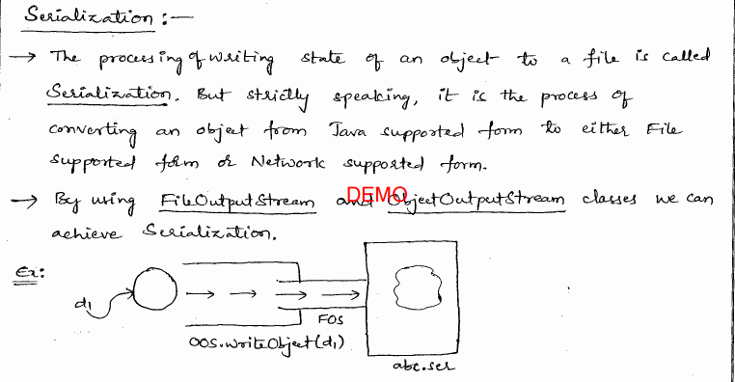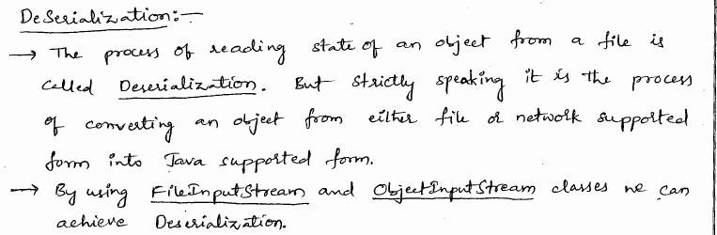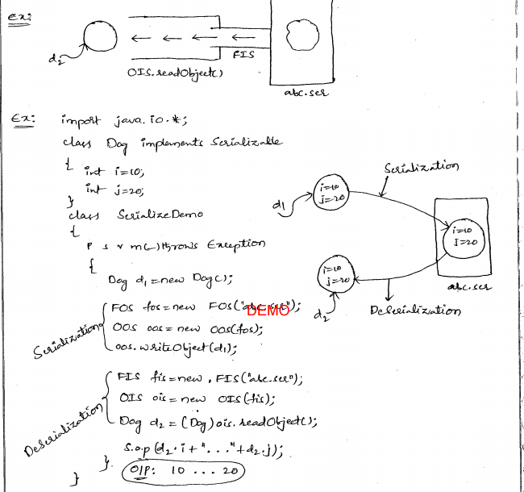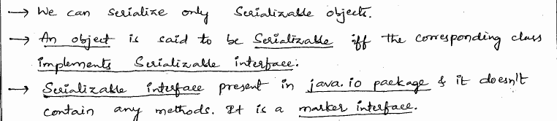

## 2 Transient,volatile,strictfp keyword.

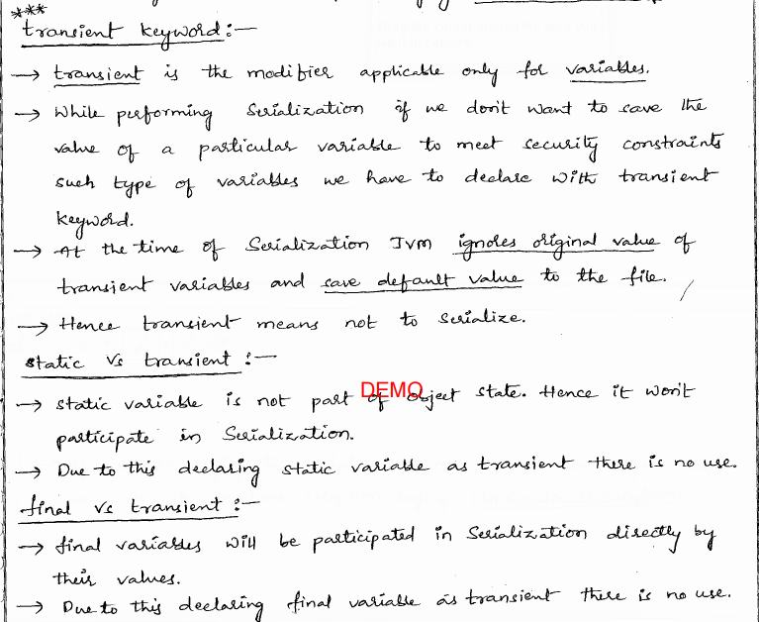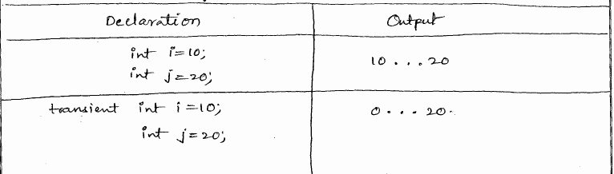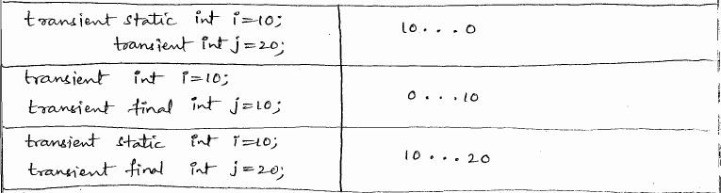

### volatile:

A variable that might be concurrently modified by multiple threads (without locks or a similar form of mutual exclusion) should be declared volatile.  
The volatile modifier can be used to inform the compiler that it should not attempt to perform optimizations on the field, which could cause unpredictable results when the field is accessed by multiple threads. For example, A multiprocessor system(>2 CPUs) with 2 threads sharing a single variable in memory.

* Thread 1 reads the variable and caches it in one of the registers for efficient access.
* Thread 2 reads the memory and changes its value.
* Now if Thread 1 wants to access the value, it may get it from its cache and thus end up with a wrong value.

To avoid these scenarios a variable can be declared as volatile, thus informing the JVM that the value can change asynchronously and has to be fetched always from memory or in other words it is like saying to JVM "Please do not optimize this variable for any reason".

### strictfp:

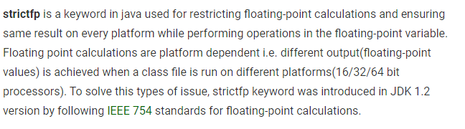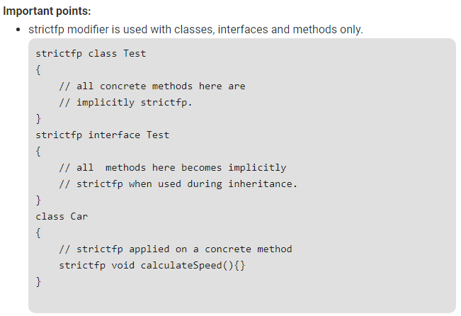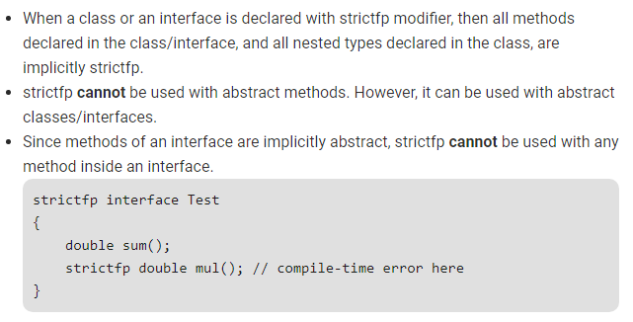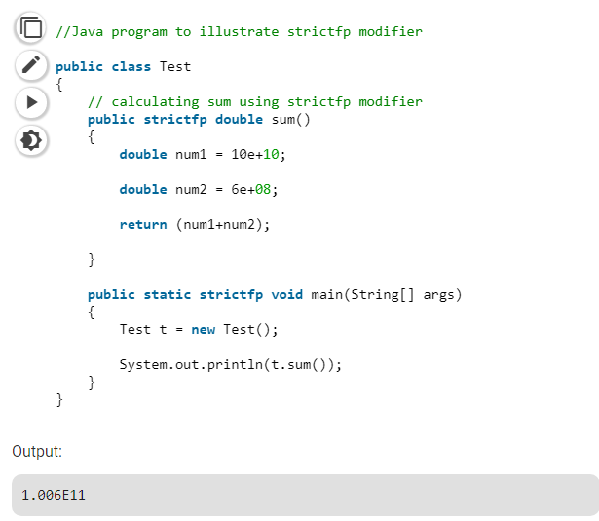

## 3 Marker Interface?

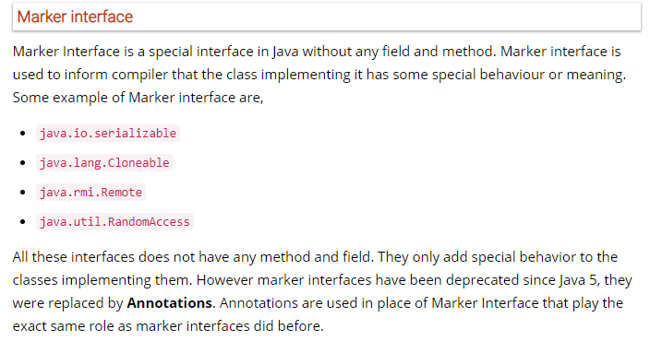

## 4 serialVersionUID?

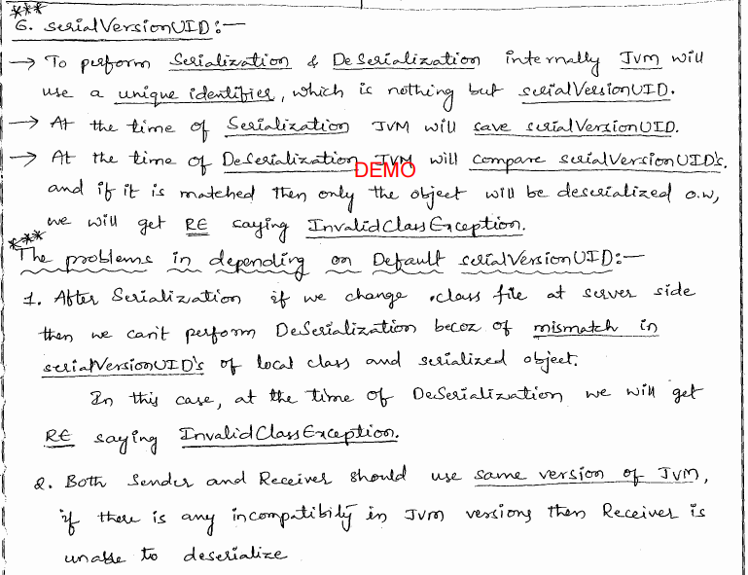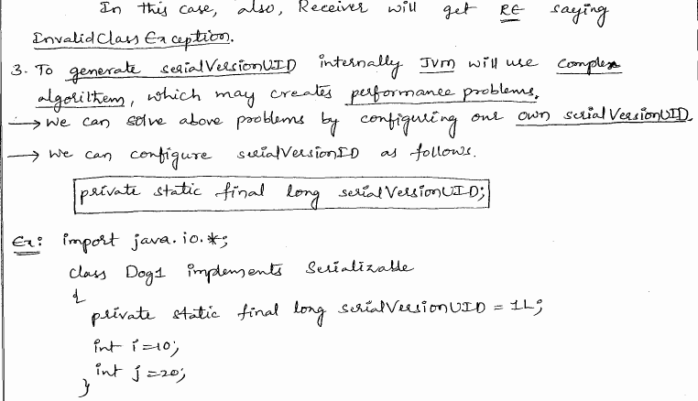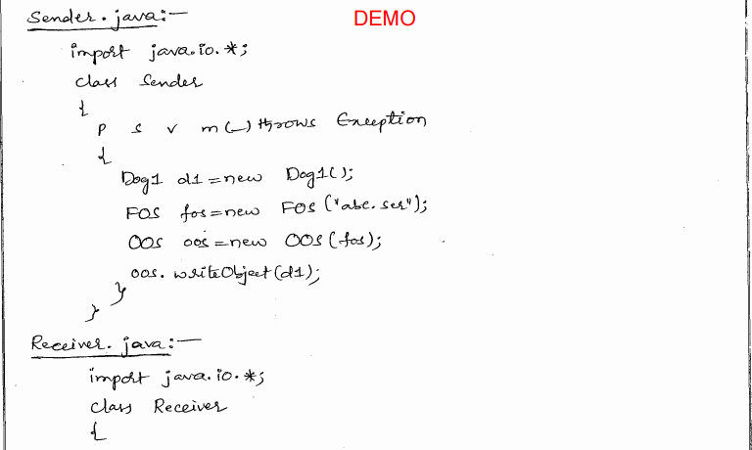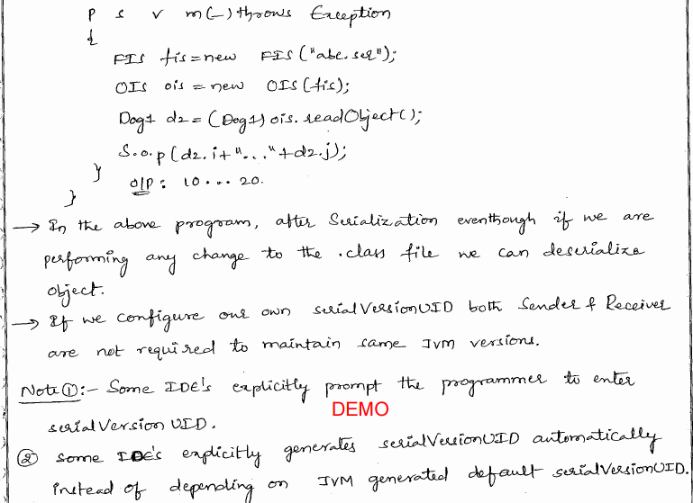

## Diff b/w Serialization and Externalization

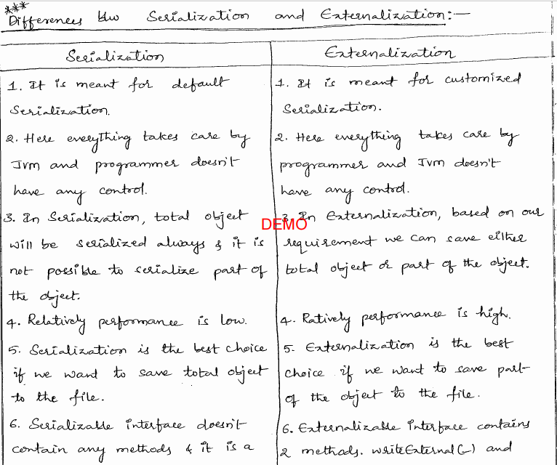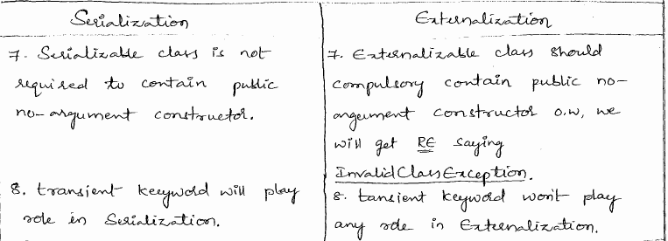

## When should I use volatile modifier?

A variable that might be concurrently modified by multiple threads (without locks or a similar form of mutual exclusion) should be declared volatile.  
The volatile modifier can be used to inform the compiler that it should not attempt to perform optimizations on the field, which could cause unpredictable results when the field is accessed by multiple threads. For example, A multiprocessor system(>2 CPUs) with 2 threads sharing a single variable in memory.

* Thread 1 reads the variable and caches it in one of the registers for efficient access.
* Thread 2 reads the memory and changes its value.
* Now if Thread 1 wants to access the value, it may get it from its cache and thus end up with a wrong value.

To avoid these scenarios a variable can be declared as volatile, thus informing the JVM that the value can change asynchronously and has to be fetched always from memory or in other words it is like saying to JVM "Please do not optimize this variable for any reason".

### synchronized vs. volatile

It is important to understand that atomic operations do not automatically mean thread-safe operations. In addition, whenever multiple threads share variables, it is important that they are accessed in a synchronized method or block, or are declared with the volatile keyword. This ensures that the variables are properly reconciled with main memory, thereby guaranteeing correct values at all times.  
Whether you use volatile or synchronized depends on several factors. If concurrency is important and you are not updating many variables, consider using volatile. If you are updating many variables, however, using volatile might be slower than using synchronization. Remember that when variables are declared volatile, they are reconciled with main memory on every access. By contrast, when synchronized is used, the variables are reconciled with main memory only when the lock is obtained and when the lock is released.  
Consider using synchronized if you are updating many variables and do not want the cost of reconciling each of them with main memory on every access, or you want to eliminate concurrency for another reason.  
The following summarizes the differences between the synchronized and volatile keywords.

* **synchronized**
* Pro: Private working memory is reconciled with main memory when the lock is obtained and when the lock is released.
* Con: Eliminates concurrency.
* **volatile**
* Pro: Allows concurrency. The visibility of the changes made by a thread to the **content** of the variable respect others threads
* Con: Private working memory is reconciled with main memory on each variable access.

The volatile has nothing to do with preventing simultaneous execution of a portion of code but synchronized does.

### Why can not a variable be volatile and final?

A volatile variable means it could be changed by several threads so a thread should always reconcile the value with what is saved in memory rather than assume that the variable it finds is valid. If a variable is final it can't be changed so there is no reason to need to reconcile values. Thus volatile and final are contradictory in a way. It doesn't make sense to be able to combine them thus java does not allow it.

# JDBC:[C]

## 1 Establishing JDBC Connection in Java?

Before establishing a connection between front end i.e your Java Program and back end i.e the database we should learn what precisely a JDBC is and why it came to existence.

**What is JDBC ?**

JDBC is an acronym for Java Database Connectivity. It’s an advancement for ODBC ( Open Database Connectivity ). JDBC is an standard API specification developed in order to move data from frontend to backend. This API consists of classes and interfaces written in Java. It basically acts as an interface (not the one we use in Java) or channel between your Java program and databases i.e it establishes a link between the two so that a programmer could send data from Java code and store it in the database for future use.

**Why JDBC came into existence ?**  
As previously told JDBC is an advancement for ODBC, ODBC being platform dependent had a lot of drawbacks. ODBC API was written in C,C++, Python, Core Java and as we know above languages (except Java and some part of Python )are platform dependent . Therefore to remove dependence, JDBC was developed by database vendor which consisted of classes and interfaces written in Java.

**Steps for connectivity between Java program and database**

**1. Loading the Driver**  
To begin with, you first need load the driver or register it before using it in the program . Registration is to be done once in your program. You can register a driver in one of two ways mentioned below :

* **Class.forName() :**Here we load the driver’s class file into memory at the runtime. No need of using new or creation of object .The following example uses Class.forName() to load the Oracle driver –

Class.forName(“oracle.jdbc.driver.OracleDriver”);

* **DriverManager.registerDriver():**DriverManager is a Java inbuilt class with a static member register. Here we call the constructor of the driver class at compile time . The following example uses DriverManager.registerDriver()to register the Oracle driver –

DriverManager.registerDriver(new oracle.jdbc.driver.OracleDriver())

2.**Create the connections**  
After loading the driver, establish connections using :

Connection con = DriverManager.getConnection(url,user,password)

**user** – username from which your sql command prompt can be accessed.  
**password** – password from which your sql command prompt can be accessed.

**con:** is a reference to Connection interface.  
**url** : Uniform Resource Locator. It can be created as follows:

String url = “ jdbc:oracle:thin:@localhost:1521:xe”

Where oracle is the database used, thin is the driver used , @localhost is the IP Address where database is stored, 1521 is the port number and xe is the service provider. All 3 parameters above are of String type and are to be declared by programmer before calling the function. Use of this can be referred from final code.

**3. Create a statement**  
Once a connection is established you can interact with the database. The JDBCStatement, CallableStatement, and PreparedStatement interfaces define the methods that enable you to send SQL commands and receive data from your database.  
Use of JDBC Statement is as follows:

Statement st = con.createStatement();

Here, con is a reference to Connection interface used in previous step .

**4. Execute the query**  
Now comes the most important part i.e executing the query. Query here is an SQL Query . Now we know we can have multiple types of queries. Some of them are as follows:

* Query for updating / inserting table in a database.
* Query for retrieving data .

The executeQuery() method of Statement interface is used to execute queries of retrieving values from the database. This method returns the object of ResultSet that can be used to get all the records of a table.  
The executeUpdate(sql query) method ofStatement interface is used to execute queries of updating/inserting .

Example:

int m = st.executeUpdate(sql);

if (m==1)

System.out.println("inserted successfully : "+sql);

else

System.out.println("insertion failed");

Here sql is sql query of the type String

**5.Close the connections**  
So finally we have sent the data to the specified location and now we are at the verge of completion of our task .  
By closing connection, objects of Statement and ResultSet will be closed automatically. The close() method of Connection interface is used to close the connection.  
Example :

con.close();

importjava.sql.*;

importjava.util.*;

class Main

{

public static void main(String a[])

{

//Creating the connection

String url = "jdbc:oracle:thin:@localhost:1521:xe";

String user = "system";

String pass = "12345";

//Entering the data

Scanner k = new Scanner(System.in);

System.out.println("enter name");

String name = k.next();

System.out.println("enter roll no");

int roll = k.nextInt();

System.out.println("enter class");

String cls = k.next();

//Inserting data using SQL query

String sql = "insert into student1 values('"+name+"',"+roll+",'"+cls+"')";

Connection con=null;

try

{

DriverManager.registerDriver(new oracle.jdbc.OracleDriver());

//Reference to connection interface

con = DriverManager.getConnection(url,user,pass);

Statement st = con.createStatement();

int m = st.executeUpdate(sql);

if (m == 1)

System.out.println("inserted successfully : "+sql);

else

System.out.println("insertion failed");

con.close();

}

catch(Exception ex)

{

System.err.println(ex);

}

}

}

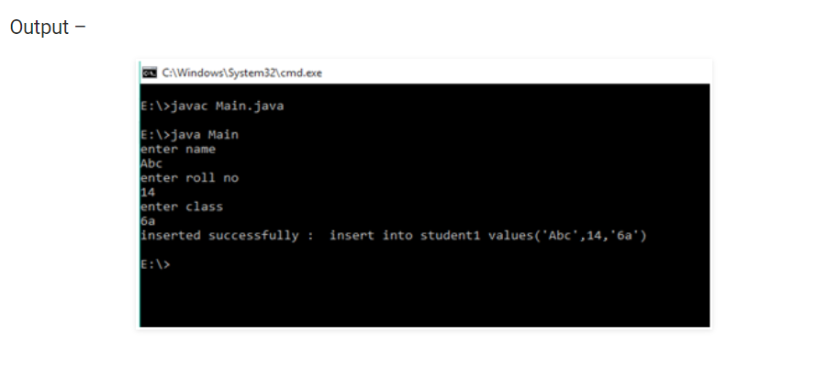

## 2 Steps to connect to db

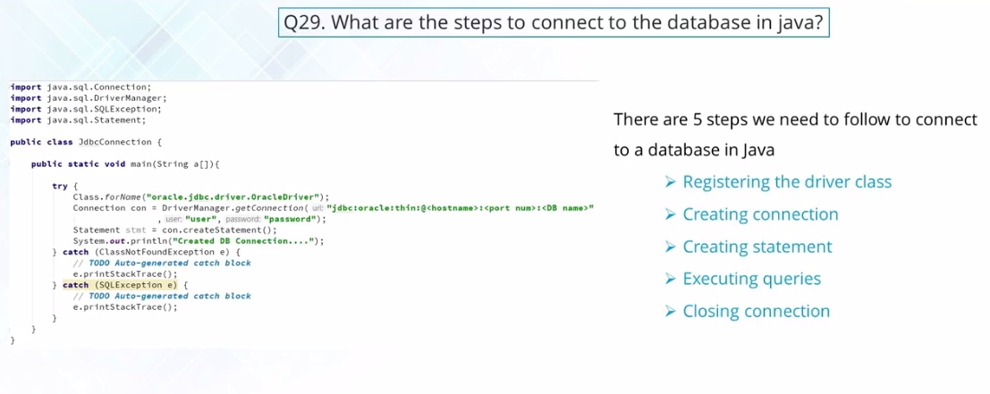

## 3 JDBC API components

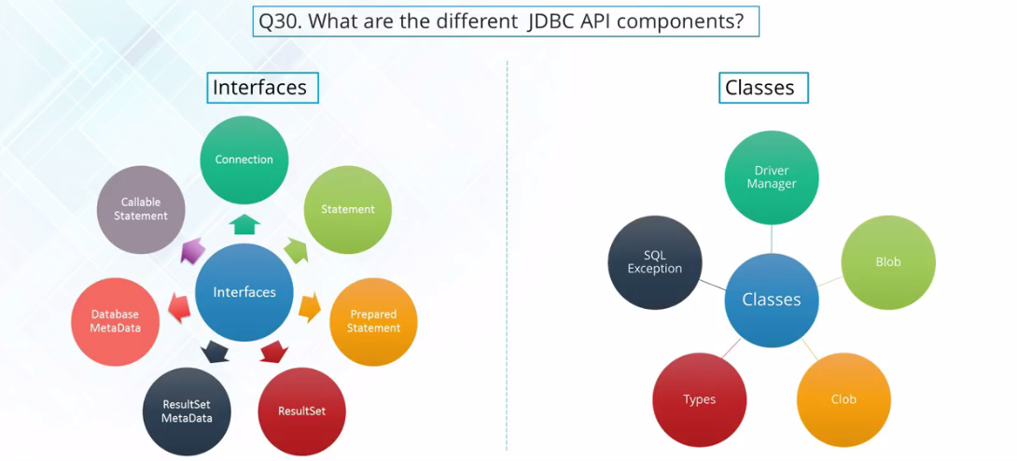

* **ResultSet** is a retrieve data from the database.
* The Data about the retrieve data is known as **ResultSetMetaData.**
* The data about the database is known as **DatabaseMetaData**.
* **Callable Statement** is used so that you can execute the stored procedures of your databases.
* **DriverManager** which is used to get the connection.
* **Blob/Clob** are the two apis, where you can manage the binary large objects and the character large object. Binary large objects means the audio files, the videos file. Whereas character large objects means textual files.

## 4 JDBC Connection Interface

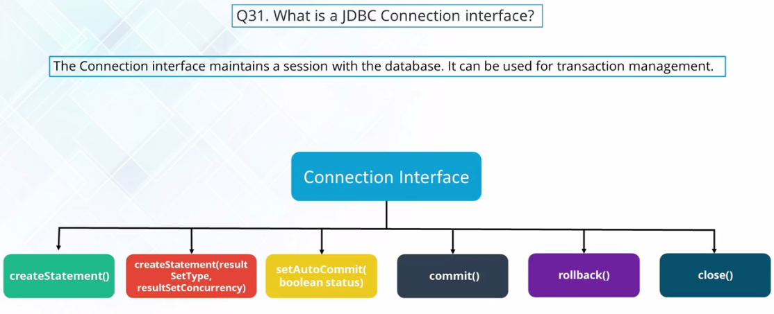

## 5 execute,executeQuery,executeUpdate

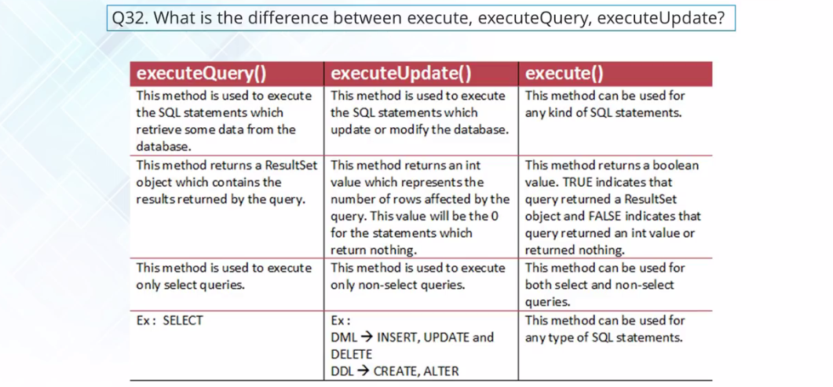

## What does Class.forname method do?

A call to *Class.forName("X")* causes the class named *X* to be dynamically loaded (at runtime). A call to forName("X") causes the class named X to be initialized (i.e., JVM executes all its static block after class loading). *Class.forName("X")*returns the *Class* object associated with the "X" class. The returned *Class* object is not an instance of the "x" class itself.  
*Class.forName("X")* loads the class if it not already loaded. The JVM keeps track of all the classes that have been previously loaded. This method uses the *classloader* of the class that invokes it. The "X" is the fully qualified name of the desired class.  
For example,

package com.xyzws;

class AClass {

    static {

        System.out.println("static block in AClass");

    }

}

public class Program {

    public static void main(String[] args) {

        try {

            Class c   = Class.forName("com.xyzws.AClass");

        } catch (ClassNotFoundException e) {

        }

    }

}

The output is

static block in AClass

Here is one example that uses returned *Class* to create an instance of *AClass*:

package com.xyzws;

class AClass {

  public AClass() {

    System.out.println("AClass's Constructor");

  }

  static {

    System.out.println("static block in AClass");

  }

}

public class Program {

  public static void main(String[] args) {

    try {

      System.out.println("The first time calls forName:");

      Class c   = Class.forName("com.xyzws.AClass");

      AClass a = (AClass)c.newInstance();

      System.out.println("The second time calls forName:");

      Class c1 = Class.forName("com.xyzws.AClass");

    } catch (ClassNotFoundException e) {

            ...

    } catch (InstantiationException e) {

            ...

    } catch (IllegalAccessException e) {

            ...

    }

  }

}

The output is

The first time calls forName:

static block in AClass

AClass's Constructor

The second time calls forName:

//Calss has been loaded so there is not "static block in AClass" printing out

### JDBC Driver Is a Good Example

You may have experience working with JDBC Drivers. For example, the classloader attempts to load and link the Driverclass in the "org.gjt.mm.mysql" package. If successful, the static initializer is called.

Class.forName("org.gjt.mm.mysql.Driver");

Connection con = DriverManager.getConnection(url,?myLogin", "myPassword");

Let's see why you need Class.forName() to load a driver into memory. All JDBC Drivers have a static block that registers itself with *DriverManager* and *DriverManager* has static an initializer only.  
The MySQL *JDBC Driver* has a static initializer looks like this:

static {

    try {

        java.sql.DriverManager.registerDriver(new Driver());

    } catch (SQLException E) {

        throw new RuntimeException("Can't register driver!");

    }

}

JVM executes the static block and the Driver registers itself with the *DriverManager*.  
You need a database connection to manipulate the database. In order to create the connection to the database, the *DriverManager* class has to know which database driver you want to use. It does that by iterating over the array (internally a Vector) of drivers that have registered with it and calls the *acceptsURL(url)* method on each driver in the array, effectively asking the driver to tell it whether or not it can handle the JDBC URL.

## JDBC Driver

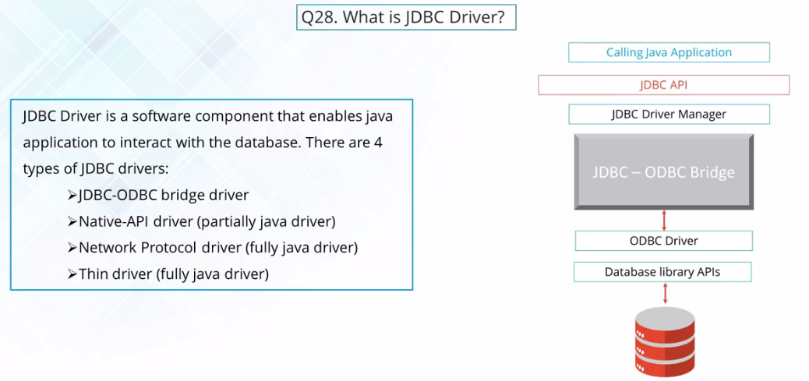

# Memory/Performance:[C]

## 1 How to get memory information in Java program?

In Java, memory is allocated in various places such as the stack, heap, etc. While your application is running, you can sniff out the memory using: Runtime.getRuntime().freeMemory() and Runtime.getRuntime().totalMemory().

public class Program {

    public static void main(String... args)  {

        System.out.println("Max Memory   : " +

                   Runtime.getRuntime().maxMemory());

        System.out.println("Total Memory : " +

                    Runtime.getRuntime().totalMemory());

        System.out.println("Free Memory  : " +

                Runtime.getRuntime().freeMemory());

    }

}

# Unix Commands:

## ****Which command can you use to find the currently running process in Unix Server?****

***ps –ef***is a command used to find the current running process. Also, using ***grep*** with a pipe can find specific processes.

**Output**

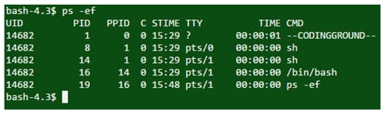

## ****Which command should you use to find the remaining disk space in UNIX server?****

The command ***df -kl*** is used to get a detailed description of disk space usage.

**Output**

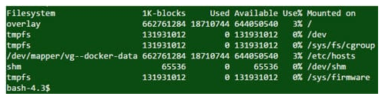

                                                   question 31 – UNIX Interview Questions – Edureka

## ****Which UNIX command to make a new directory?****

The command **mkdir directory_name** is used to create a new directory.

## ****What is the UNIX command to confirm a remote host is alive or not?****

You can use either **ping** or **telnet** to confirm a remote host is alive or not.

## ****How can you see the command line history?****

The ***history*** command displays all the commands used previously in the current session.

**Output**

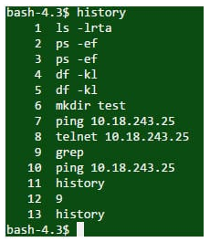

                                                   question 34 – UNIX Interview Questions – Edureka

## ****Name the UNIX command to find how many days the server has been up.****

The **uptime** command returns the number of days that the server has been up.

**Output**

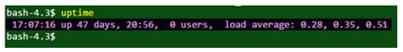

## ****What does the “echo” command do?****

The ***echo*** command outputs the strings it is being passed as arguments.

## ****Can you write a command to erase all files in the current directory including all its sub-directories?****

***rm –r\****is the command used to erase all files in the current directory including all its sub-directories.

* **rm:** this command is used for deleting files.
* **-r:** this option will erase all files in directories and sub-directories.
* **\*:** this represents all entries.

## ****Enlist some filename manipulation commands in UNIX.****

Here are some filename manipulation commands along with their description, enlisted in the table below;

|  |  |
| --- | --- |
| **Command** | **Description** |
| **cat filename** | Displays contents of the file |
| **cp source destination** | Used to copy the source file into the destination |
| **mv old name new name** | Move/rename and old name to the new name |
| **rm filename** | Remove/delete filename |
| **Touch filename** | Changing modification time |
| **In [-s] old name new name** | Creates soft link on old name |
| **Is –F** | Displays information about file type |

## ****What is “chmod” command?****

Chmod command is used to change file or directory access permission and is the most frequently used command in Unix. According to mode, chmod command changes the permission of each given file.

**The syntax of chmod command is:**

Chmod [options] mode filename.

**Here in the above format, options could be:**

* -R: recursively change the permission of file or directory.
* -v: verbose, i.e. output a diagnostic for every file processed.
* -c: report only when the change is made.

## ****Describe the usage and functionality of the command****rm –r \*****in UNIX?****

The command **rm –r \*** erases all files in a directory with its subdirectories.

* **rm**is for deleting files
* **-r**is to delete directories and subdirectories with files within
* **\***is indicate all entries

## ****Describe the zip/unzip command using gzip.****

The gzip command creates a zip file using given the filename in the same directory.

gunzip command unzip the file.

## ****How would you display the last line of a file?****

The last line of a file is displayed using either “tail” or “sed” commands.

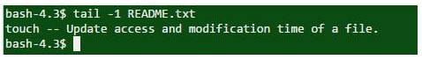

## ****How can you kill a process in UNIX?****

The Kill command accepts process ID (PID) as an in a parameter. This is applicable only for the processes owned by the command executor.

**Syntax –** kill PID